**MINISTRY OF EDUCATION AND TRAINING**

|  |  |
| --- | --- |
| **FPT UNIVERSITY** | |
| Capstone Project Document | |
| **Kukki** | |
|  | |
| **Kukki Team** | |
| **Group Member** | Lê Anh Quang – SE02628  Nguyễn Hồng Linh - SE02631  Đỗ Minh Trí - SE02681  Trần Văn Tiệp - SE02725  Nguyễn Hoàng Anh – SE02858 |
| **Supervisor** | Lecturer : Trần Đình Trí |
| **Capstone Project code** | Kukki |

Hanoi, 15/08/2015

Table of Contents

**Acknowledgements** 5

**Chapter 1: INTRODUCTION** 6

**1.1** **Purpose** 6

**1.2 Project Information** 6

**1.2** **People** 6

**1.3.1 Supervisor** 6

**1.3.2 Team Member** 6

**1.4 Background** 6

**1.5 Literature review** 7

**1.5.1 Existed systems** 7

**1.5.2 Conclusion** 9

**1.6 Our proposal** 10

**1.6.1: Idea** 10

**1.6.2: Our proposal system** 10

**1.6.3 Main objectives:** 10

**1.7 References** 10

**Chapter 2: PROJECT MANAGEMENT PLAN** 11

**2.1 Purpose** 11

**2.2 Problem Definition** 11

**2.2.1 Name of this capstone project** 11

**2.2.2 Project Overview** 11

**2.3 Project Organization** 12

**2.3.1 Software Process Model** 12

**2.3.2 Role and Responsibility** 13

**2.3.3 Tools and Techniques** 14

**2.4.1 Task Sheet: Assignments and Timetable** 14

**2.4.2 Meeting Minutes** 16

**2.5 Risk Management Plan** 16

**2.6 Communication Plan** 17

**2.6.1 Team Project Communication** 17

**2.6.2 Communicate with supervisor** 17

**Chapter 3: SYSTEM REQUIREMENTS SPECIFICATION** 18

**3.1 Purpose** 18

**3.2 Function Requirement** 18

**3.2.1 List of function** 18

**3.2.2 Use Case Diagram** 20

**3.3 Non-Functional Requirement** 55

**3.3.1 Security** 55

**3.3.2 Usability** 56

**3.3.2 Performance** 56

**3.4 Entity Relationship Diagram** 57

**3.4.1 Web Application ERD** 57

**3.4.2 Mobile Application ERD** 58

**Chapter 4: SYSTEM DESIGN DESCRIPTION** 59

**4.1 Purpose** 59

**4.2 Software Architecture Design** 59

**4.2.1 Overall System Architecture** 59

**4.3 System Architectural Design** 60

**4.4 Web Application** 63

**4.4.1 Architectural Design** 63

**4.4.2 Detail Design** 64

**4.5 Mobile Application** 65

**4.5.1 Architectural design** 65

**4.4.2 Detail Design** 66

**4.6 Web service** 97

**4.6.1 Architecture design** 97

**4.6.2 Detail Design** 98

**4.7 Sequence Diagram** 99

**4.7.1 Web Application** 99

**4.7.2 Mobile Application** 102

**4.8 User Interface Design** 104

**4.8.1 Web Application** 104

**4.8.2 Mobile Application** 123

**4.9 Algorithms** 147

**4.9.1 Upload image to Server** 147

**4.9.2 Search recipe by typing ingredient** 148

**Chapter 5: SYSTEM IMPLEMENTATION & TEST** 149

**5.1 Introduction** 149

**5.1.1 Purpose** 149

**5.1.2 System Overview** 149

**5.1.3 Test Approach** 149

**5.2 Test Plan** 150

**5.2.1 Features to be tested** 150

**5.2.2 Features not to be tested** 153

**5.2.3 Testing Tools & Environment** 153

**5.2.4 Test Milestone** 153

**5.3 Test Case** 154

**5.3.1 Unit Test** 154

**5.3.2 System Test** 169

**5.3.4 Acceptance Test** 185

**5.3.5 Defect log** 186

**Chapter 6: SYSTEM USER’S MANUAL** 189

**6.1 User’s guide** 189

**6.3.1 Mobile Application** 189

**6.3.2** **Web Application** 227

**6.2 Installation guide** 241

# **Acknowledgements**

It has been 4 months since we worked together and our Capstone project has been completed. That was a chance to prove that we can work together as a team. The time and effort we put in were certainly worthwhile.

These past 4 months have been incredible and helped us a lot to get where we are today. We would like to give our sincere thanks to our teacher and guide, Mr. Tran Dinh Tri. We have no words to express our gratitude to you. You were able to create an environment in our meeting where everyone could feel comfortable with. Maybe that’s because you taught with so much love and passion. Your gift was making us feel comfortable about our abilities. You were full of support and encouragement. Thank you for the impact you have made on our Capstone project. We wouldn’t have been able to do this without your help.

**Thanks & Best regards.**

Hanoi, 26th August 2015

**Kukki Team**

# **Chapter 1: INTRODUCTION**

## **Purpose**

This chapter provides an overview of project which includes objectives, system features and system architecture overview. This document provides background information, literature review of existing system and idea proposal for both developers and stakeholders.

## **1.2 Project Information**

* Project name: **Kukki**
* Project code: **Kukki**
* Project group name: **Kukki**
* Product type: **Web application** and **Mobile application**
* Timeline: **From 30thApirl 2015 to 27thAugust 2015**

## **People**

### **1.3.1 Supervisor**

|  |  |  |  |  |
| --- | --- | --- | --- | --- |
|  | **Full name** | **Phone** | **E-Mail** | **Title** |
| Supervisor | Trần Đình Trí | 0913091952 | [TriTD@fpt.edu.vn](mailto:TriTD@fpt.edu.vn) | Lecturer |

**Table 1-1***:* Supervisor information

### **1.3.2 Team Member**

|  |  |  |  |  |  |
| --- | --- | --- | --- | --- | --- |
|  | **Full name** | **Student code** | **Phone** | **E-mail** | **Role in Group** |
| 1 | Lê Anh Quang | SE02628 | 01683997493 | [QuangLAse02628@fpt.edu.vn](mailto:QuangLAse02628@fpt.edu.vn) | Leader |
| 2 | Nguyễn Hồng Linh | SE02631 | 01687458303 | [LinhNHSE02631@fpt.edu.vn](mailto:LinhNHSE02631@fpt.edu.vn) | Member |
| 3 | Đỗ Minh Trí | SE02681 | 0974021737 | [TriDMSE02681@fpt.edu.vn](mailto:TriDMSE02681@fpt.edu.vn) | Member |
| 4 | Trần Văn Tiệp | SE02725 | 01679449776 | [TiepTVSE02725@fpt.edu.vn](mailto:TiepTVSE02725@fpt.edu.vn) | Member |
| 5 | Nguyễn Hoàng Anh | SE02858 | 01238248747 | [AnhNHSE02858@fpt.edu.vn](mailto:AnhNHSE02858@fpt.edu.vn) | Member |

**Table 1-2**: Team member’s information

## **1.4 Background**

In culture of a country, cuisine is beautiful, exciting and very important for people. Everyone need food, loves food and can be attracted by good looking dishes. Behind the beautiful dishes, the recipes make people very curious and want to explore. Because of diversity, the style or method of cooking become characteristic of a particular country, region, or establishment. They are a big world to discover.

Cooking a dinner, a breakfast for family by yourself is a happy activities. To many people, cooking can help theme release stress and inspire theme to have more ideas at work. Mothers really see their children eating food which is only things they cooked.

Every dishes you cook, they are deserved to share and receive compliment from your family and friends.

## **1.5 Literature review**

### **1.5.1 Existed systems**

There are some popular applications with similar functions. We explain why “Kukki” would be a potential successful application among those applications.

**Cook book**

Cook book is an application provides many recipes. There are some helpful functions: shopping list, favorite, searching.

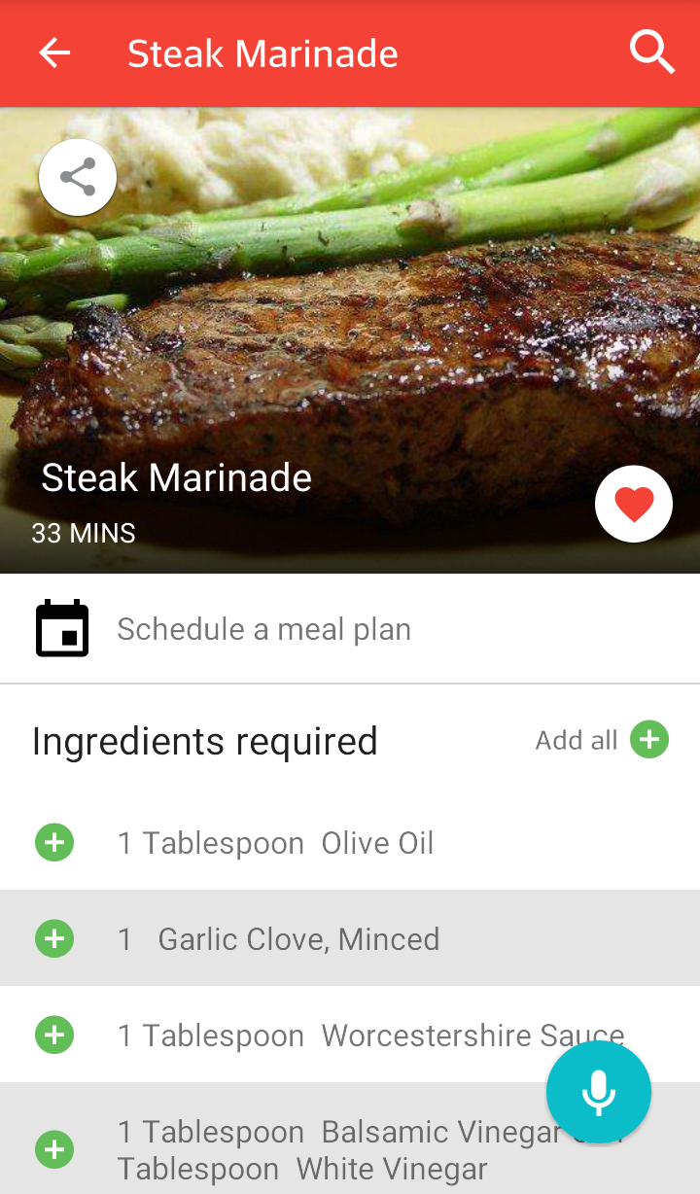 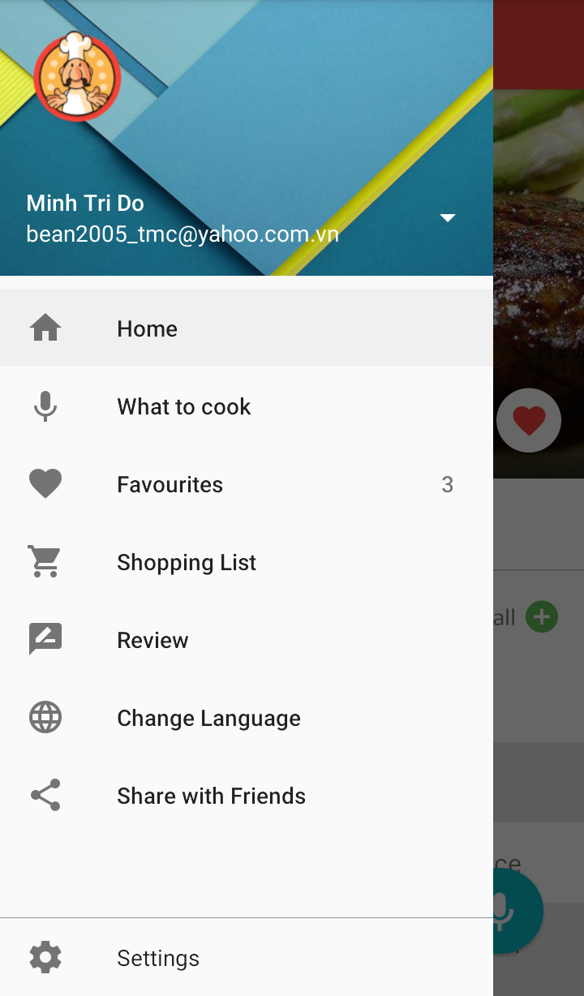

**Advantage**:

* Good looking GUI
* Easy to use
* Recipes are ordered by clearly
* Transfer recipe to smart watch
* Search by voice

**Disadvantage**:

* Loading list slowly
* Limited recipes
* No review, no comment on receipt
* Not support Vietnamese

**Healthy recipe**

Cook book is an application provides many recipes. There are some helpful functions: shopping list, favorite, searching. In addition, they suggest recipes day by day and have a menu for new recipe

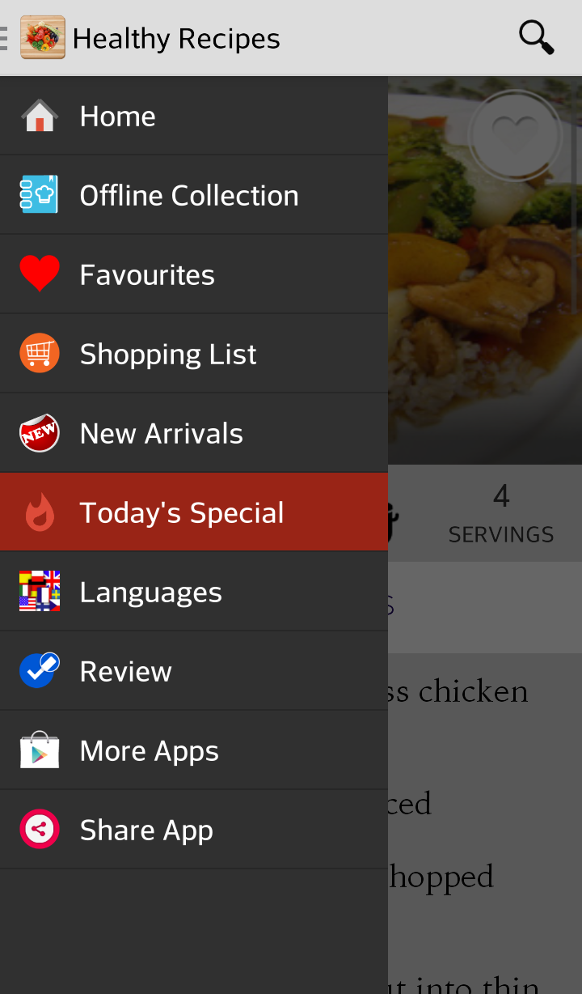 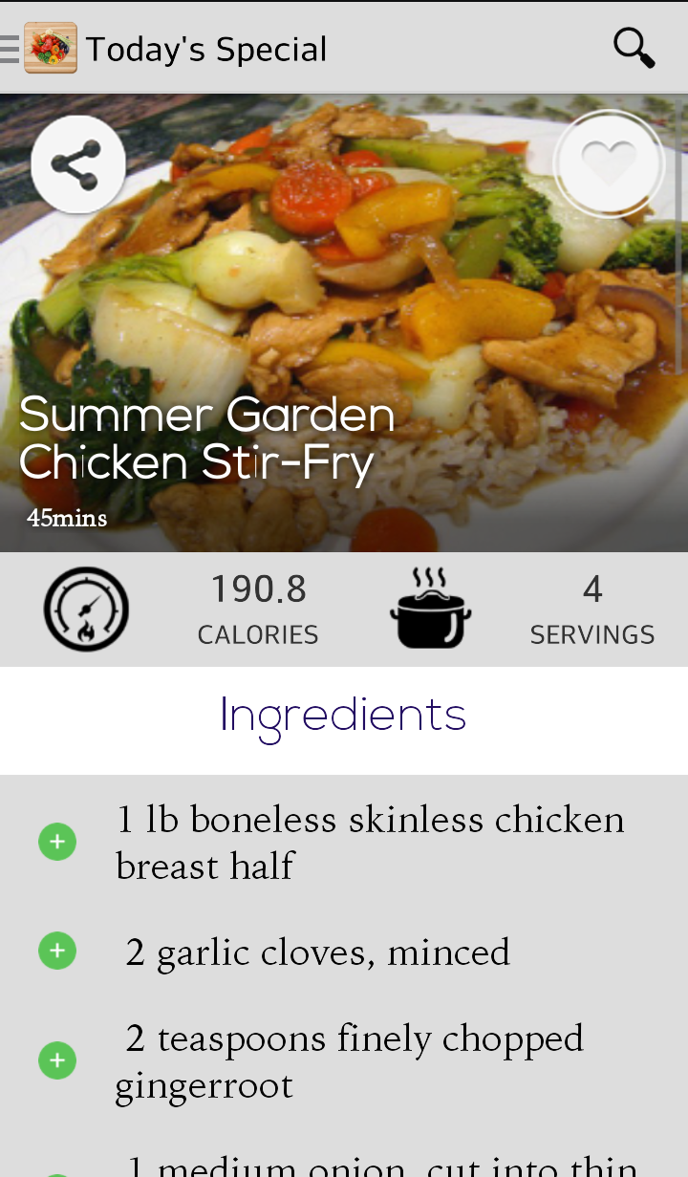

**Advantage**:

* Easy to use
* Recipes are ordered by clearly

**Disadvantage**:

* Bad looking GUI
* Limited recipes
* No review, no comment on receipt
* Not support Vietnamese

**Món ăn ngon**

Món ăn ngon is an application provides many recipes. Recipes are ordered by clearly.

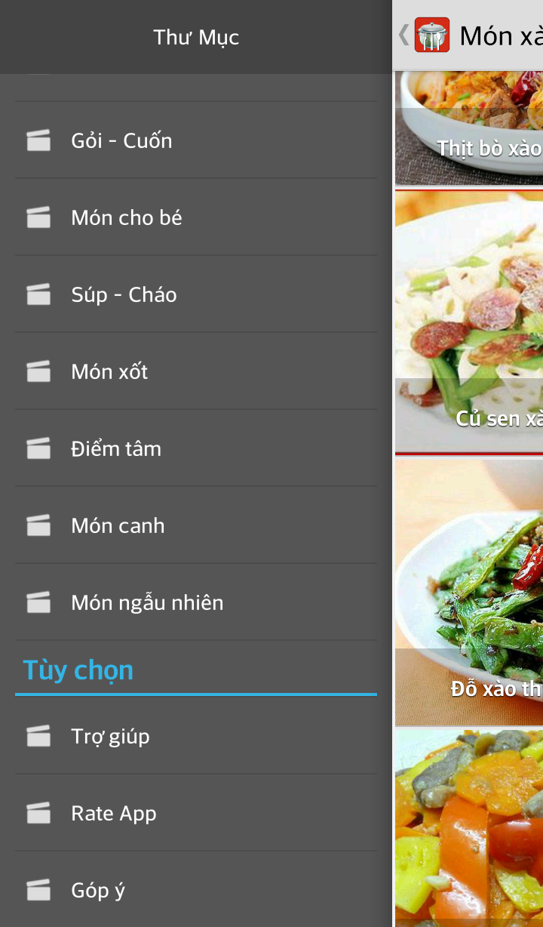 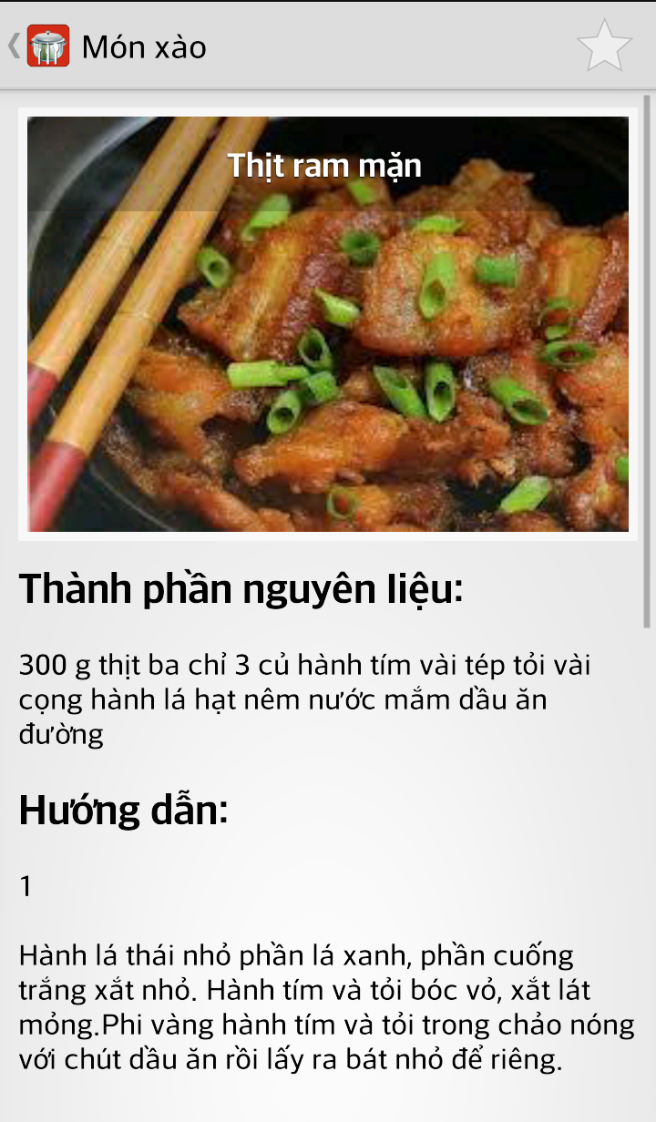

**Advantage**:

* Support Vietnamese
* Recipes are ordered by clearly

**Disadvantage**:

* Bad looking GUI
* No review, no comment on receipt
* Limited functions
* Limited recipes

### **1.5.2 Conclusion**

After review those characteristics of other applications, they have advantages and disadvantages, so we came to an agreement about which functions our application should inherit their strong points and reduce their limitations.

## **1.6 Our proposal**

### **1.6.1: Idea**

A network connects people who care about cousin. It helps people to explore recipes, share their recipes and interact with recipes.

### **1.6.2: Our proposal system**

The life is change every day. The people exposed to more and more culture. The intercultural makes cuisine change and many recipe is invented day by day. It connect people and they can share their recipes. User can interact to recipes: like, comment, share, save, group. Besides, the recipes is ordered by clearly, suggested in helpful way.

Our application also has functions to support cooking such as: shopping list, offline view mode.

### **1.6.3 Main objectives:**

* Easy to use
* Connect people, upload recipes, and interact to recipe effectively.
* Provide many recipe in details, suggest recipes in helpful list
* Easy to search, result of recipes is ordered by clearly

**System functions:**

**Mobile application**

* Allows people share their recipe with other by upload recipe, share function.
* Allows people search to find a suitable recipe for their meal.
* Allows people to connect with other by like, comment in a recipe.
* Allows people to keep update with someone they like their recipe by follow, view profile function
* Allows people to save their favorite recipe by favorite function
* Additional functions support cooking dishes: shopping list, offline view

**Web application**

* Show recipe or group of recipes

**Web service**

* Transfer and storage user information, recipe data.

## **1.7 References**

**Cook book:**

[*HTTPs://play.google.com/store/apps/details?id=com.riatech.cookbook*](https://play.google.com/store/apps/details?id=com.riatech.cookbook)

**Healthy recipes:**

[*HTTPs://play.google.com/store/apps/details?id=com.endless.healthyrecipes*](https://play.google.com/store/apps/details?id=com.endless.healthyrecipes)

**Món ăn ngon:**

[*HTTPs://play.google.com/store/apps/details?id=com.dungelin.funcooking*](https://play.google.com/store/apps/details?id=com.dungelin.funcooking)

# **Chapter 2: PROJECT MANAGEMENT PLAN**

## **2.1 Purpose**

The purpose of this chapter is to describe the organization and plan of the project. All team members must use this chapter as a guideline for tracking assigned tasks and deadlines.

## **2.2 Problem Definition**

### **2.2.1 Name of this capstone project**

* Project Name: **Kukki**
* Project code: **Kukki**
* Project group name: **Kukki**
* Product type: **Web application** and **Mobile application**
* Timeline: **30/4/2015 – 27/8/2015**

### **2.2.2 Project Overview**

#### **2.2.2.1 Boundaries of the System**

Due to the time constraint of a capstone project, the scope of our system includes:

- Build a system with detailed SRS is documented in Chapter 3.

- Create detailed document of the software product. It includes 6 chapters that follows the FPT University Capstone Project Report Template.

- Coding & unit testing.

- Develop test cases & execute system test.

#### **2.2.2.2 Development Environment**

* Hardware requirement:
* **Develop:**
* Laptop (Windows 8.1), MacBook.
* Smartphone running Android 4.0.4 using Wi-Fi, 3G.
* **Test:**
* Laptop, MacBook, Smartphone, Server
* Software requirement:
* **File Manage:** Dropbox
* **Code Manage:** Github
* **Document:** Microsoft Office 2013 (Word, Excel, Project, PowerPoint)
* **Code:** Android Studio, PHP 5.4.12, Netbean 7.2.1, Wampserver 2.4, JDK 8u23
* **Design:** Microsoft Office Visio 2013, Astah Professional, Photoshop CS6
* **Running and test:** Chrome, Android 4.0.4

## **2.3 Project Organization**

### **2.3.1 Software Process Model**

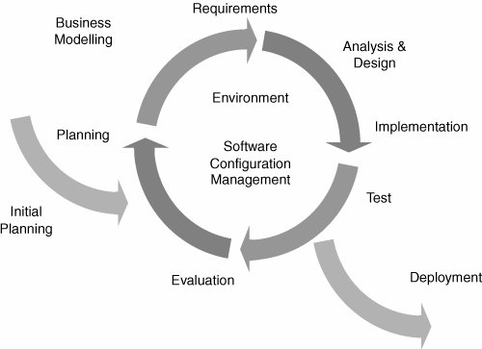

**Figure 2.1** – Iterative Software Process Model

* Less time is spent on documenting and more time is given for designing
* Can create high-level design of the application before actually begin to build the product and define the design solution for the entire product. Later on we can design and built a skeleton version of that, and then evolved the design based on what had been built.
* Easier to manage risk because risky pieces are identified and handled during it’d iteration.
* In iterative model we are building and improving the product step by step. Hence we can track the defects at early stages

### **2.3.2 Role and Responsibility**



**Figure 2.1** – Organization Structure

**Project Team Member**

|  |  |
| --- | --- |
| **Team Member** | **Role** |
| QuangLA | Project Manager, Developer, Designer |
| LinhNH | Technical Leader, Developer, Designer |
| TriDM | Designer Leader, Tester |
| TiepTV | Developer, Tester |
| AnhNH | Developer, Tester |

### **2.3.3 Tools and Techniques**

* **Programming languages**: PHP, Java, HTML, CSS, Java Script.
* **Framework**: Laravel 4.2
* **Process Model**: Iterative and Incremental Software Process Model
* **IDE**: Android Studio, Netbeans
* **Web Server**: Wamp
* **UML Tools**: Astah Professional, Enterprise Architect
* **Other:**
  + Microsoft Office 2013
  + Microsoft Visio 2013
  + Microsoft Project 2013

**2.4 Project Management Plan**

### **2.4.1 Task Sheet: Assignments and Timetable**

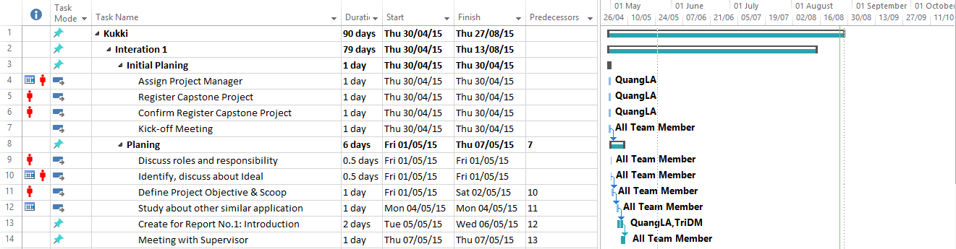

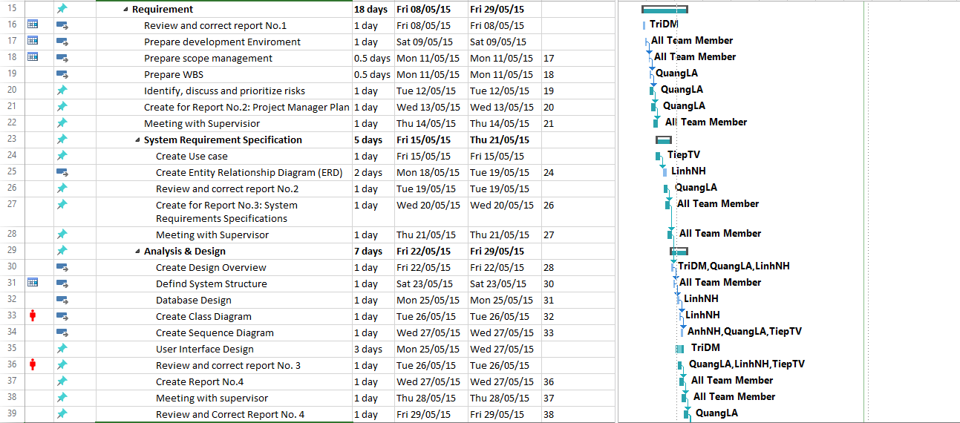

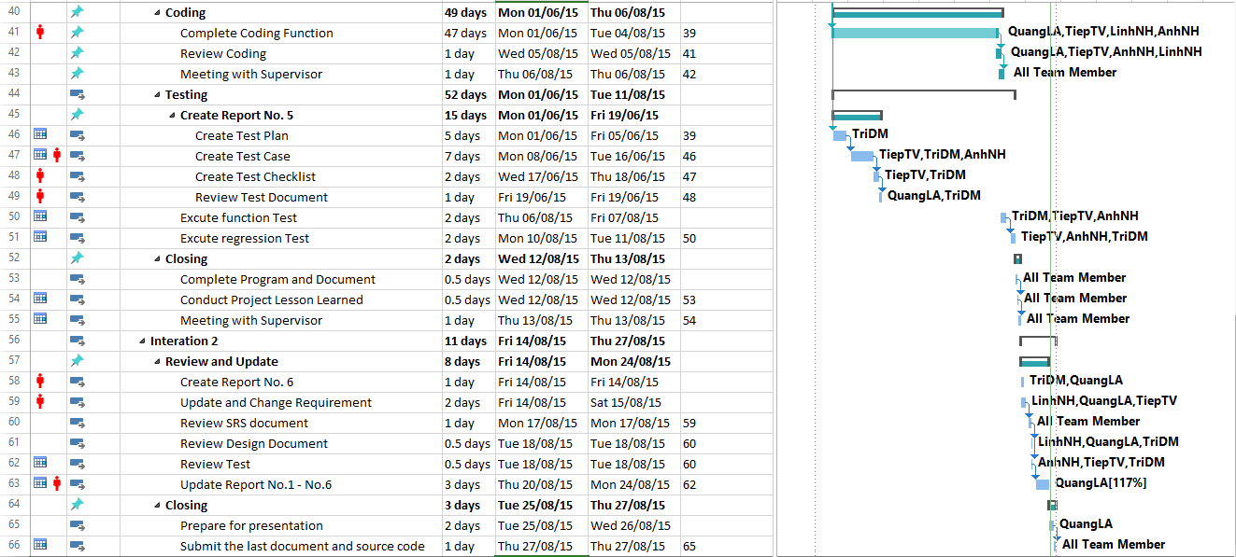

### **2.4.2 Meeting Minutes**

All meeting minutes will be written follow this template:

|  |  |  |  |  |  |  |
| --- | --- | --- | --- | --- | --- | --- |
|  |  | | | | |  |
| **Date** | 30/04/2015 | **Time** | 10h15 | **Location** | P205 - FPT Hòa Lạc | |
| **Meeting Called By** | Mr. TriTD | | | | | |
| **Team Member** | Supervisior: Mr. TriTD  Team Member: QuangLA, LinhNH, TriDM, TiepTV, AnhNH | | | | | |
| **Note:** |  | | | | | |

| **NO** | **ISSUE** | **CONTENT** | **REPONSIBLE PERSON** |
| --- | --- | --- | --- |
| **1** | Kick-off Meeting | 1. Determining capstone project and first building-up Team | Mr. TriTD |

## **2.5 Risk Management Plan**

|  |  |  |  |  |
| --- | --- | --- | --- | --- |
| **NO** | **Problem Description** | **Solve Plan** | **Probability** | **Impact** |
| **1** | **The project is not on time** | Work over time. | High | High |
| **2** | **Data Lost** | Use Dropbox, SVN or One Driver to back up data | Medium | High |
| **3** | **Miscommunication** | Create meeting report after each every meeting and send it to all member of team. If member finds anything unclear or want to be change, meet together to discuss and clear things up. | Medium | Medium |
| **4** | **Requirement changed** | Meeting and discuss carefully again about the requirement. The system design should be made carefully with all the cases covered as many as possible to minimize the change. | Low | Low |
| **5** | **Illness or absence of team members** | Team member should warn their team leader a planned period of absence if they had bad heath condition. Reduce task of this member and assign it for other to cover. | Medium | Medium |
| **6** | **Team member failed to complete assigned task** | Estimate the task again, if it too difficult for this member, reassign for suitable member or ask Supervisor for help. | High | High |

## **2.6 Communication Plan**

### **2.6.1 Team Project Communication**

* **Daily working schedule:** Team members attend to work together
* **Unscheduled meeting**: If someone or project has emergency issue should be solve, a meeting will be arranged as soon as possible.
* **Communication channel**: Team member meeting face-to-face, use Email, Skype, Facebook or Mobile to communicate to other.

### **2.6.2 Communicate with supervisor**

* **Weekly working schedule***:* team has weekly meeting with supervisor to review task, document and help solve problem.
* **Communicate channel***:* team member meeting face-to-face with supervisor.

# **Chapter 3: SYSTEM REQUIREMENTS SPECIFICATION**

## **3.1 Purpose**

This chapter outlines functional and non-functional requirements of our website. It also provides some format constraints in common requirements and project success criteria. All members will work (design, code, test) based on the information provided in this chapter.

## **3.2 Function Requirement**

### **3.2.1 List of function**

#### **3.2.1.1 User group**

|  |  |
| --- | --- |
| **Term** | **Description** |
| Guest | Visitor who has not logged in the system |
| Member | Person who has logged in the system |
| Admin | Person who can manage the system |

##### **3.2.1.1.1 Admin**

* + - Web Application:

Login

Logout

View Member List

View Member Profile

Search Member

Ban/Unban Member

Set Member as Admin

View Recipe List

View Recipe detail

Search Recipe

Delete Recipe

Search Album

View Album List

View Album Detail

View Report List

Search Report

Delete Report

##### **3.2.1.1.2 Guest**

* + - Mobile application:

Register

##### **3.2.1.1.3 Member**

* + - Mobile application:

Login

Logout

Forget password

Edit profile

View profile

View list people following

View list people were followed

Search member

Unfollow

Follow

Unlike recipe

Like recipe

Comment

View notification

Report recipe

Like album

Unlike album

View list all recipe

View list all recipe of following people

Search recipe

Edit recipe

View recipe detail

Download recipe

Create recipe

Draft

Delete recipe

Add recipes to reminders

View album

Edit album

Delete album

Search album

Create album

Check/uncheck item were bought or not

Add ingredient to shopping list

View shopping list

### **3.2.2 Use Case Diagram**

#### **3.2.2.1 Web Application**

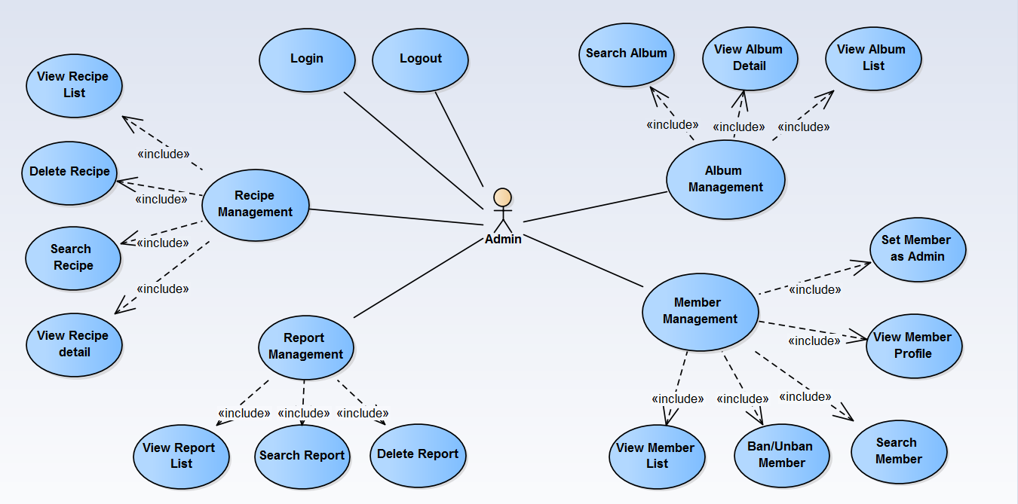

#### **3.2.2.2 Mobile Application**

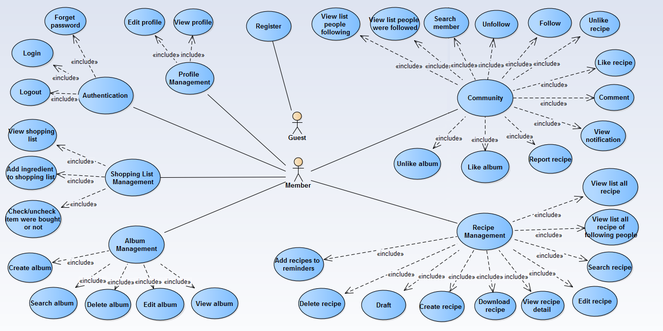

#### **3.2.2.3 Use Case List**

##### **3.2.2.3.1 Web Application**

|  |  |  |
| --- | --- | --- |
| **Use Case ID** | **Primary Actor** | **Use Cases** |
| UCW-01 | Admin | Login |
| UCW-02 | Admin | Logout |
| UCW-03 | Admin | View Member List |
| UCW-04 | Admin | View Member Profile |
| UCW-05 | Admin | Search member |
| UCW-06 | Admin | Ban/Unban member |
| UCW-07 | Admin | Set Member as Admin |
| UCW-08 | Admin | View Recipe List |
| UCW-09 | Admin | View Recipe detail |
| UCW-10 | Admin | Search Recipe |
| UCW-11 | Admin | Delete Recipe |
| UCW-12 | Admin | Search Album |
| UCW-13 | Admin | View Album List |
| UCW-14 | Admin | View Album Detail |
| UCW-15 | Admin | View Report List |
| UCW-16 | Admin | Search Report |
| UCW-17 | Admin | Delete Report |

##### **3.2.3.3.2 Mobile Application**

|  |  |  |
| --- | --- | --- |
| **Use Case ID** | **Primary Actor** | **Use Cases** |
| UCM-01 | Guest | Register |
| UCM-02 | Member | Login |
| UCM-03 | Member | Logout |
| UCM-04 | Member | Forget Password |
| UCM-05 | Member | Edit profile |
| UCM-06 | Member | View profile |
| UCM-07 | Member | View list people following |
| UCM-08 | Member | View list people were followed |
| UCM-09 | Member | Search member |
| UCM-10 | Member | Unfollow |
| UCM-11 | Member | Follow |
| UCM-12 | Member | Unlike recipe |
| UCM-13 | Member | Like recipe |
| UCM-14 | Member | Comment |
| UCM-15 | Member | View notification |
| UCM-16 | Member | Report recipe |
| UCM-17 | Member | Like album |
| UCM-18 | Member | Unlike album |
| UCM-19 | Member | View list all recipe |
| UCM-20 | Member | View list all recipe of following people |
| UCM-21 | Member | Search recipe |
| UCM-22 | Member | Edit recipe |
| UCM-23 | Member | View recipe detail |
| UCM-24 | Member | Download recipe |
| UCM-25 | Member | Create recipe |
| UCM-26 | Member | Draft |
| UCM-27 | Member | Delete recipe |
| UCM-28 | Member | Add recipes to reminders |
| UCM-29 | Member | View album |
| UCM-30 | Member | Edit album |
| UCM-31 | Member | Delete album |
| UCM-32 | Member | Search album |
| UCM-33 | Member | Create album |
| UCM-34 | Member | Check/uncheck item were bought or not |
| UCM-35 | Member | Add ingredient to shopping list |
| UCM-36 | Member | View shopping list |

#### **3.2.2.4 Use Case Specification**

##### **3.2.2.4.1 Web Application**

###### **3.2.2.4.1.1 Login**

|  |  |  |  |  |
| --- | --- | --- | --- | --- |
| **Use Case ID** | | | **UCW-01** | |
| **Use Name** | | | **Login** | |
| **Actor** | | | Admin | |
| **Description** | | | The function allows an admin to be able to login in the software when he/she have registered an account and his/her account is still active. | |
| **Precondition** | | | Account must be valid. Using the correct email and password | |
| **Trigger** | | | Input email and password correctly in the right textbox then click “Login” button | |
| **Post-Condition** | | | Login successfully | |
| **Main flows** | | | | |
| ***Step*** | ***Actor*** | | ***Action*** | |
| *1* | Admin | | Type URL into location field of internet browser and then press enter | |
| *2* | Kukki | | Display Login screen with the following fields:  - Email  - Password  - Login button | |
| *3* | Admin | | Enter email & password into Email & Password fields on the Login screen, then click on Login button. | |
| *4* | Kukki | | Validate the entered email & password and then display Home screen | |
| **Alternative flows** | | | | |
| **AT1** | | At step 4 in the main flows**,** if Kukki failed to validate user name & password | | |
| **Sub step** | | **Actor** | | **Action** |
| 4.1 | | Kukki | | Display "Login" page with message "Email or Password is not Valid!” |

***Business Rules***

|  |  |
| --- | --- |
| ***#*** | ***Rule Description*** |
| *BR01* | Email must match [*XXX@XXX.XXX*](mailto:XXX@XXX.XXX) form. |
| *BR02* | “Password” must be show as asterisk (**······**) type. |
| *BR03* | Need Internet connection. |

###### **3.2.2.4.1.2 Logout**

|  |  |  |
| --- | --- | --- |
| **Use Case ID** | | **UCW-02** |
| **Use Name** | | **Logout** |
| **Actor** | | Admin |
| **Description** | | Admin log out from Kukki |
| **Precondition** | | Login |
| **Trigger** | | Admin click on logout link on the right of header |
| **Post-Condition** | | Logout successfully, display login page |
| **Main flows** | | |
| ***Step*** | ***Actor*** | ***Action*** |
| *1* | Admin | Click on logout link on the right of header |
| *2* | Kukki | Log admin out and then display Login screen |
| **Alternative flows** | | |
| **N/A** | | |

***Business Rules***

|  |  |
| --- | --- |
| ***#*** | ***Rule Description*** |
| *BR01* | Need Internet connection. |

###### **3.2.2.4.1.3 Member Management**

**3.2.2.4.1.3.1 View Member List**

|  |  |  |
| --- | --- | --- |
| **Use Case ID** | | **UCW-04** |
| **Use Name** | | **View Member List** |
| **Actor** | | Admin |
| **Description** | | The function allows an admin to be able to view member list |
| **Precondition** | | Login |
| **Trigger** | | Click on member management link on vertical menu on the left of screen |
| **Post-Condition** | | Display Home screen with member list inside |
| **Main flows** | | |
| ***Step*** | ***Actor*** | ***Action*** |
| *1* | Admin | Click on member management link on vertical menu on the left of screen |
| *2* | Kukki | Display Home screen with member list inside |
| **Alternative flows** | | |
| **N/A** | | |

***Business Rules***

|  |  |
| --- | --- |
| ***#*** | ***Rule Description*** |
| *BR01* | Need Internet connection. |

**3.2.2.4.1.3.2 View Member Profile**

|  |  |  |
| --- | --- | --- |
| **Use Case ID** | | **UCW-04** |
| **Use Name** | | **View Member Profile** |
| **Actor** | | Admin |
| **Description** | | The function allows an admin to be able to view member profile |
| **Precondition** | | Login |
| **Trigger** | | Click on member name that display as hyperlink on Home screen |
| **Post-Condition** | | Display Member profile screen |
| **Main flows** | | |
| ***Step*** | ***Actor*** | ***Action*** |
| *1* | Admin | Click on member name that display as hyperlink on Home screen |
| *2* | Kukki | Display Member profile with the following fields:  - Name  - Gender  - Date of birth  - Email  - Joined date  - Last updated  - Show recipes button  - Show album button  - List of recipe (table) |
| **Alternative flows** | | |
| **N/A** | | |

***Business Rules***

|  |  |
| --- | --- |
| ***#*** | ***Rule Description*** |
| *BR01* | Need Internet connection. |

**3.2.2.4.1.3.3 Search Member**

|  |  |  |  |  |
| --- | --- | --- | --- | --- |
| **Use Case ID** | | | **UCW-05** | |
| **Use Name** | | | **Search Member** | |
| **Actor** | | | Admin | |
| **Description** | | | The function allows an admin to be able to search member | |
| **Precondition** | | | Login | |
| **Trigger** | | | Enter keyword on search textbox on Home screen | |
| **Post-Condition** | | | Display Member list result on Home screen | |
| **Main flows** | | | | |
| ***Step*** | ***Actor*** | | ***Action*** | |
| *1* | Admin | | Enter keyword on search textbox on Home screen | |
| *2* | Kukki | | Search in the database and then display Member list result on Home screen | |
| **Alternative flows** | | | | |
| **AT1** | | At step 2 in the main flows**,** if the system cannot find anyone who have an information match with keyword | | |
| **Sub step** | | **Actor** | | **Action** |
| 4.1 | | Kukki | | Display message " No matching records found” |

***Business Rules***

|  |  |
| --- | --- |
| ***#*** | ***Rule Description*** |
| *BR01* | Need Internet connection. |

**3.2.2.4.1.3.4 Ban/Unban Member**

|  |  |  |  |
| --- | --- | --- | --- |
| **Use Case ID** | | | **UCW-06** |
| **Use Name** | | | **Ban/Unban Member** |
| **Actor** | | | Admin |
| **Description** | | | The function allows an admin to be able to ban/unban member |
| **Precondition** | | | Login |
| **Trigger** | | | Click on button in column “status” |
| **Post-Condition** | | | Change status of member |
| **Main flows** | | | |
| ***Step*** | ***Actor*** | | ***Action*** |
| *1* | Admin | | Click on button In column “status” |
| *2* | Kukki | | Check in database if member has been banned then display “Deactivate” on the button in column “status”. If not then display “Active” on the button in column “status” |
| **Alternative flows** | | | |
| **AT1** | | **N/A** | |

***Business Rules***

|  |  |
| --- | --- |
| ***#*** | ***Rule Description*** |
| *BR01* | Need Internet connection. |

**3.2.2.4.1.3.5 Set Member as Admin**

|  |  |  |  |
| --- | --- | --- | --- |
| **Use Case ID** | | | **UCW-07** |
| **Use Name** | | | **Set User as Admin** |
| **Actor** | | | Admin |
| **Description** | | | The function allows an admin to be able to set role for user |
| **Precondition** | | | Login |
| **Trigger** | | | Click on email that display as hyperlink in table on Set admin screen |
| **Post-Condition** | | | Show popup to set role of user |
| **Main flows** | | | |
| ***Step*** | ***Actor*** | | ***Action*** |
| *1* | Admin | | Click on Set Admin link on sidebar |
| *2* | Kukki | | Display Set Admin screen |
| *3* | Admin | | Click on email that display as hyperlink in table on Set admin screen |
| *4* | Kukki | | Display Email Detail popup |
| *5* | Admin | | Select role “Admin” or “Member” then click Set |
| *6* | Kukki | | Display Alert message “Do you want to change role of this email?” |
| *7* | Admin | | Click Ok to set role |
| *8* | Kukki | | Display Set admin screen with email has been change role |
| **Alternative flows** | | | |
| **AT1** | | N/A | |

***Business Rules***

|  |  |
| --- | --- |
| ***#*** | ***Rule Description*** |
| *BR01* | Need Internet connection. |

###### **3.2.2.4.1.4 Recipe Management**

**3.2.2.4.1.4.1 View Recipe List**

|  |  |  |
| --- | --- | --- |
| **Use Case ID** | | **UCW-08** |
| **Use Name** | | **View Recipe List** |
| **Actor** | | Admin |
| **Description** | | The function allows an admin to be able to view recipe list |
| **Precondition** | | Login |
| **Trigger** | | Click on recipe management link on sidebar menu |
| **Post-Condition** | | Display Recipe Management screen with list of recipes inside |
| **Main flows** | | |
| ***Step*** | ***Actor*** | ***Action*** |
| *1* | Admin | Click on recipe management link on sidebar menu |
| *2* | Kukki | Display Recipe Management screen with list of recipes inside |
| **Alternative flows** | | |
| **N/A** | | |

***Business Rules***

|  |  |
| --- | --- |
| ***#*** | ***Rule Description*** |
| *BR01* | Need Internet connection. |

**3.2.2.4.1.4.2 View Recipe Detail**

|  |  |  |
| --- | --- | --- |
| **Use Case ID** | | **UCW-09** |
| **Use Name** | | **View Recipe Detail** |
| **Actor** | | Admin |
| **Description** | | The function allows an admin to be able to view recipe detail |
| **Precondition** | | Login |
| **Trigger** | | Click on recipe name that display as hyperlink in the table on Recipe Management screen or on Member profile screen or on Album Management Detail screen or Report Management screen. |
| **Post-Condition** | | Display recipe detail screen |
| **Main flows** | | |
| ***Step*** | ***Actor*** | ***Action*** |
| *1* | Admin | Click on recipe name that display as hyperlink in the table on Recipe Management screen or on Member profile screen or on Album Management Detail screen or Report Management screen. |
| *2* | Kukki | Display recipe detail with the following fields:  - Recipe name  - Image Cover  - Member name  - Information of recipe  - Step to cook the meal |
| **Alternative flows** | | |
| **N/A** | | |

***Business Rules***

|  |  |
| --- | --- |
| ***#*** | ***Rule Description*** |
| *BR01* | Need Internet connection. |

**3.2.2.4.1.4.3 Search Recipe**

|  |  |  |  |  |
| --- | --- | --- | --- | --- |
| **Use Case ID** | | | **UCW-010** | |
| **Use Name** | | | **Search Recipe** | |
| **Actor** | | | Admin | |
| **Description** | | | The function allows an admin to be able to search recipe | |
| **Precondition** | | | Login | |
| **Trigger** | | | Enter keyword on search textbox on Recipe Management screen or on Member profile screen or on Album Management Detail screen or Report Management screen | |
| **Post-Condition** | | | Display Recipe list result on Recipe Management screen or on Member profile screen or on Album Management Detail screen or Report Management screen. | |
| **Main flows** | | | | |
| ***Step*** | ***Actor*** | | ***Action*** | |
| *1* | Admin | | Enter keyword on search textbox on Recipe Management screen or on Member profile screen or on Album Management Detail screen or Report Management screen. | |
| *2* | Kukki | | Search in the database and then display recipe list result on Recipe Management screen or on Member profile screen or on Album Management Detail screen or Report Management screen | |
| **Alternative flows** | | | | |
| **AT1** | | At step 2 in the main flows**,** if the system cannot find any recipe which have an information match with keyword | | |
| **Sub step** | | **Actor** | | **Action** |
| 4.1 | | Kukki | | Display message " No matching records found” |

***Business Rules***

|  |  |
| --- | --- |
| ***#*** | ***Rule Description*** |
| *BR01* | Need Internet connection. |

**3.2.2.4.1.4.4 Delete Recipe**

|  |  |  |  |  |
| --- | --- | --- | --- | --- |
| **Use Case ID** | | | **UCW-011** | |
| **Use Name** | | | **Delete Recipe** | |
| **Actor** | | | Admin | |
| **Description** | | | The function allows an admin to be able to delete recipe when the recipe was reported | |
| **Precondition** | | | Login | |
| **Trigger** | | | Click “Delete” button in recipe row on Report Management screen | |
| **Post-Condition** | | | Display message “Delete Success” on Report Management screen | |
| **Main flows** | | | | |
| ***Step*** | ***Actor*** | | ***Action*** | |
| *1* | Admin | | Click “Delete” button in recipe row on Report Management screen | |
| *2* | Kukki | | Delete recipe in database and display message “Delete Success” on Report Management screen | |
| **Alternative flows** | | | | |
| **AT1** | | At step 2 in the main flows**,** if the system cannot delete recipe in database | | |
| **Sub step** | | **Actor** | | **Action** |
| 4.1 | | Kukki | | Display message " Delete Failed” |

***Business Rules***

|  |  |
| --- | --- |
| ***#*** | ***Rule Description*** |
| *BR01* | Need Internet connection. |

###### **3.2.2.4.1.5 Album Management**

**3.2.2.4.1.5.1 Search Album**

|  |  |  |  |  |
| --- | --- | --- | --- | --- |
| **Use Case ID** | | | **UCW-012** | |
| **Use Name** | | | **Search Album** | |
| **Actor** | | | Admin | |
| **Description** | | | The function allows an admin to be able to search album | |
| **Precondition** | | | Login | |
| **Trigger** | | | Enter keyword on search textbox on Album Management screen | |
| **Post-Condition** | | | Display Recipe list result on Album Management screen. | |
| **Main flows** | | | | |
| ***Step*** | ***Actor*** | | ***Action*** | |
| *1* | Admin | | Enter keyword on search textbox on Album Management screen. | |
| *2* | Kukki | | Search in the database and then display album list result on Album Management screen | |
| **Alternative flows** | | | | |
| **AT1** | | At step 2 in the main flows**,** if the system cannot find any album which have an information match with keyword | | |
| **Sub step** | | **Actor** | | **Action** |
| 4.1 | | Kukki | | Display message " No matching records found” |

***Business Rules***

|  |  |
| --- | --- |
| ***#*** | ***Rule Description*** |
| *BR01* | Need Internet connection. |

**3.2.2.4.1.5.1 View Album List**

|  |  |  |
| --- | --- | --- |
| **Use Case ID** | | **UCW-013** |
| **Use Name** | | **View Album List** |
| **Actor** | | Admin |
| **Description** | | The function allows an admin to be able to view album list |
| **Precondition** | | Login |
| **Trigger** | | Click on album management link on sidebar menu |
| **Post-Condition** | | Display Album Management screen with list of album inside |
| **Main flows** | | |
| ***Step*** | ***Actor*** | ***Action*** |
| *1* | Admin | Click on album management link on sidebar menu |
| *2* | Kukki | Display Album Management screen with list of album inside |
| **Alternative flows** | | |
| **N/A** | | |

***Business Rules***

|  |  |
| --- | --- |
| ***#*** | ***Rule Description*** |
| *BR01* | Need Internet connection. |

**3.2.2.4.1.5.1 View Album Detail**

|  |  |  |
| --- | --- | --- |
| **Use Case ID** | | **UCW-014** |
| **Use Name** | | **View Album Detail** |
| **Actor** | | Admin |
| **Description** | | The function allows an admin to be able to view album detail |
| **Precondition** | | Login |
| **Trigger** | | Click on recipe name that display as hyperlink in the table on Album Management Detail screen or on Member profile screen |
| **Post-Condition** | | Display album detail screen and list of recipes in album |
| **Main flows** | | |
| ***Step*** | ***Actor*** | ***Action*** |
| *1* | Admin | Click on recipe name that display as hyperlink in the table on Album Management Detail screen or on Member profile screen |
| *2* | Kukki | Display list of recipes in album |
| **Alternative flows** | | |
| **N/A** | | |

***Business Rules***

|  |  |
| --- | --- |
| ***#*** | ***Rule Description*** |
| *BR01* | Need Internet connection. |

###### **3.2.2.4.1.6 Report Management**

**3.2.2.4.1.6.1 View Report List**

|  |  |  |
| --- | --- | --- |
| **Use Case ID** | | **UCW-015** |
| **Use Name** | | **View Report List** |
| **Actor** | | Admin |
| **Description** | | The function allows an admin to be able to view report list |
| **Precondition** | | Login |
| **Trigger** | | Click on report management link on sidebar menu |
| **Post-Condition** | | Display Report Management screen with list of reports inside |
| **Main flows** | | |
| ***Step*** | ***Actor*** | ***Action*** |
| *1* | Admin | Click on report management link on sidebar menu |
| *2* | Kukki | Display Report Management screen with list of reports inside |
| **Alternative flows** | | |
| **N/A** | | |

***Business Rules***

|  |  |
| --- | --- |
| ***#*** | ***Rule Description*** |
| *BR01* | Need Internet connection. |

**3.2.2.4.1.6.2 Search Report**

|  |  |  |  |  |
| --- | --- | --- | --- | --- |
| **Use Case ID** | | | **UCW-016** | |
| **Use Name** | | | **Search Report** | |
| **Actor** | | | Admin | |
| **Description** | | | The function allows an admin to be able to search report | |
| **Precondition** | | | Login | |
| **Trigger** | | | Enter keyword on search textbox on Report Management screen | |
| **Post-Condition** | | | Display Recipe list result on Report Management screen. | |
| **Main flows** | | | | |
| ***Step*** | ***Actor*** | | ***Action*** | |
| *1* | Admin | | Enter keyword on search textbox on Report Management screen. | |
| *2* | Kukki | | Search in the database and then display recipe list result on Report Management screen | |
| **Alternative flows** | | | | |
| **AT1** | | At step 2 in the main flows**,** if the system cannot find any report which have an information match with keyword | | |
| **Sub step** | | **Actor** | | **Action** |
| 4.1 | | Kukki | | Display message " No matching records found” |

***Business Rules***

|  |  |
| --- | --- |
| ***#*** | ***Rule Description*** |
| *BR01* | Need Internet connection. |

**3.2.2.4.1.6.3 Delete Report**

|  |  |  |  |  |
| --- | --- | --- | --- | --- |
| **Use Case ID** | | | **UCW-017** | |
| **Use Name** | | | **Delete Report** | |
| **Actor** | | | Admin | |
| **Description** | | | The function allows an admin to be able to delete report | |
| **Precondition** | | | Login | |
| **Trigger** | | | Click “Remove” button or Click “Delete” button on Report Management screen | |
| **Post-Condition** | | | Display message “Delete Success” on Report Management screen | |
| **Main flows** | | | | |
| ***Step*** | ***Actor*** | | ***Action*** | |
| *1* | Admin | | Click “Remove” button or Click “Delete” button on Report Management screen | |
| *2* | Kukki | | If click “Remove” :  - Delete report in database and display message “Delete Success” on Report Management screen  If click “Delete” :  - Delete report and recipe in database and display message “Delete Success” on Report Management screen | |
| **Alternative flows** | | | | |
| **AT1** | | At step 2 in the main flows**,** if the system cannot delete report in database | | |
| **Sub step** | | **Actor** | | **Action** |
| 4.1 | | Kukki | | Display message " Delete Failed” |

***Business Rules***

|  |  |
| --- | --- |
| ***#*** | ***Rule Description*** |
| *BR01* | Need Internet connection. |

##### **3.2.2.4.2 Mobile Application**

###### **3.2.2.4.2.1 Register**

|  |  |  |  |  |
| --- | --- | --- | --- | --- |
| **Use Case ID** | | | **UCM-01** | |
| **Use Name** | | | **Register** | |
| **Actor** | | | Guest | |
| **Description** | | | Guest can register account to be a valid user in system | |
| **Precondition** | | | Having a valid email address. | |
| **Trigger** | | | Tap on “Đăng ký” button, “tick” icon and click on activation link | |
| **Post-Condition** | | | Member’s account information is stored in database | |
| **Main flows** | | | | |
| ***Step*** | ***Actor*** | | ***Action*** | |
| *1* | Guest | | Tap on “Đăng ký” button on Login screen | |
| *2* | Kukki | | Display Register screen with the following fields:  - Email  - Tên hiển thị  - Mật khẩu  - Nhập lại mật khẩu  - Tick icon | |
| *3* | Guest | | Enter Email, “Tên hiển thị”, “Mật khẩu”, “Nhập lại mật khẩu” into Email, “Tên hiển thị”, “Mật khẩu”, “Nhập lại mật khẩu” fields on the Register screen, then tap on tick icon. | |
| *4* | Kukki | | Check valid data and inform guest to check email box for confirmation | |
| *5* | Guest | | Check email inbox and click on the activation link on email | |
| *6* | Kukki | | Activate user account and give message inform register success | |
| **Alternative flows** | | | | |
| **AT1** | | At step 4 in the main flows, if guest insert wrong “Nhập lại mật khẩu”, wrong email format, or keep mandatory field blank | | |
| **Sub step** | | **Actor** | | **Action** |
| 4.1 | | Kukki | | Display message to warning about wrong information and require enter again |
| **AT2** | | At step 4 in the main flows, if guest insert a email which is existed in system | | |
| **Sub step** | | **Actor** | | **Action** |
| 4.1 | | Kukki | | Display message that email has existed, and require guest to change email |
| **AT3** | | At step 4 in the main flows, there are some internal errors in the system | | |
| **Sub step** | | **Actor** | | **Action** |
| 4.1 | | Kukki | | Display error message and inform guest to register again |

***Business Rules***

|  |  |
| --- | --- |
| ***#*** | ***Rule Description*** |
| *BR01* | Need Internet connection. |
| *BR02* | “Tên hiển thị” is required |
| *BR03* | If an account is not activated, another account can be registered with the same email |

###### **3.2.2.4.2.2 Authentication**

**3.2.2.4.2.2.1 Login**

|  |  |  |  |  |
| --- | --- | --- | --- | --- |
| **Use Case ID** | | | **UCM-02** | |
| **Use Name** | | | **Login** | |
| **Actor** | | | Member | |
| **Description** | | | The function allows a member to be able to login in the software when he/she have registered an account and his/her account is active. | |
| **Precondition** | | | Account must be valid. Using the correct email and password | |
| **Trigger** | | | Input email and password correctly in the right textbox then tap on “Đăng nhập” button | |
| **Post-Condition** | | | Login successfully | |
| **Main flows** | | | | |
| ***Step*** | ***Actor*** | | ***Action*** | |
| *1* | Member | | Run application on their mobile | |
| *2* | Kukki | | Display Login screen with the following fields:  - Email  - Mật khẩu  - “Đăng nhập” button  - “Đăng ký” button  - “Ghi nhớ” check box | |
| *3* | Member | | Enter email & “Mật khẩu” into Email & Password fields on the Login screen, check/uncheck on “Ghi nhớ” check box, and then tap on Login button. | |
| *4* | Kukki | | Validate the entered email & “Mật khẩu” and then display Home screen | |
| **Alternative flows** | | | | |
| **AT1** | | At step 4 in the main flows**,** if Kukki failed to validate user name & password | | |
| **Sub step** | | **Actor** | | **Action** |
| 4.1 | | Kukki | | Display "Login" page with message "Email hoặc mật khẩu không đúng” |
| **AT2** | | At step 3 in the main flows, if member check/uncheck on “Ghi nhớ” check box | | |
| **Sub step** | | **Actor** | | **Action** |
| 3.1 | | Kukki | | Let member don’t need to enter email and “Mật khẩu” in next login |

***Business Rules***

|  |  |
| --- | --- |
| ***#*** | ***Rule Description*** |
| *BR01* | Email must match [*XXX@XXX.XXX*](mailto:XXX@XXX.XXX) form. |
| *BR02* | “Password” must be show as asterisk (**······**) type. |
| *BR03* | Need Internet connection. |

**3.2.2.4.2.2.2 Logout**

|  |  |  |  |  |
| --- | --- | --- | --- | --- |
| **Use Case ID** | | | **UCM-03** | |
| **Use Name** | | | **Logout** | |
| **Actor** | | | Member | |
| **Description** | | | The function allows an member to logout Kukki system | |
| **Precondition** | | | Login | |
| **Trigger** | | | Tap on back button and then tap “Yes” | |
| **Post-Condition** | | | Logout successfully | |
| **Main flows** | | | | |
| ***Step*** | ***Actor*** | | ***Action*** | |
| *1* | Member | | On Home screen, tap on back button | |
| *2* | Kukki | | Display confirm dialog box with message “Bạn có muốn thoát?” | |
| *3* | Member | | Tap “Yes” option on confirm dialog box | |
| *4* | Kukki | | Log user out and display Login screen | |
| **Alternative flows** | | | | |
| **AT1** | | At step 3 in the main flows**,** if member tap “No” option on confirm dialog box | | |
| **Sub step** | | **Actor** | | **Action** |
| 3.1 | | Kukki | | Keep member stay on Home screen |

***Business Rules***

|  |  |
| --- | --- |
| ***#*** | ***Rule Description*** |
| *BR01* | Need Internet connection. |

**3.2.2.4.2.2.3 Forget password**

|  |  |  |  |  |
| --- | --- | --- | --- | --- |
| **Use Case ID** | | | **UCM-04** | |
| **Use Name** | | | **Forget password** | |
| **Actor** | | | Member | |
| **Description** | | | The function allows an member create new password | |
| **Precondition** | | | Start app | |
| **Trigger** | | | Tap on “Quên mật khẩu?” text on Login screen | |
| **Post-Condition** | | | Reset password and create new password | |
| **Main flows** | | | | |
| ***Step*** | ***Actor*** | | ***Action*** | |
| *1* | Member | | On Login screen, tap on “Quên mật khẩu?” text | |
| *2* | Kukki | | Display “QUÊN MẬT KHẨU” screen | |
| *3* | Member | | Enter email to “Email”, tap on “tick” icon | |
| *4* | Kukki | | Send email confirm for member | |
| **Alternative flows** | | | | |
| **AT1** | | At step 3 in the main flows**,** if member tap “back arrow” | | |
| **Sub step** | | **Actor** | | **Action** |
| 4.1 | | Kukki | | Display “Login” screen |

***Business Rules***

|  |  |
| --- | --- |
| ***#*** | ***Rule Description*** |
| *BR01* | Need Internet connection. |

###### **3.2.2.4.2.3 Profile Management**

**3.2.2.4.2.3.1 Edit profile**

|  |  |  |  |  |
| --- | --- | --- | --- | --- |
| **Use Case ID** | | | **UMC-05** | |
| **Use Name** | | | **Edit Profile** | |
| **Actor** | | | Member | |
| **Description** | | | The function allows an member to change their profile | |
| **Precondition** | | | Login | |
| **Trigger** | | | Enter field want to change, tap “tick” icon | |
| **Post-Condition** | | | Changed successfully | |
| **Main flows** | | | | |
| ***Step*** | ***Actor*** | | ***Action*** | |
| *1* | Member | | On Home screen, tap on “CÁ NHÂN” on menu bar | |
| *2* | Kukki | | Display “CÁ NHÂN” screen | |
| *3* | Member | | Tap on “CHỈNH SỬA” button | |
| *4* | Kukki | | Display “SỬA THÔNG TIN” screen | |
| 5 | Member | | Enter on “Tên hiển thị” & “Miêu tả”, tap on “tick” icon | |
| 6 | Kukki | | Display dialog notice changed successfully | |
| **Alternative flows** | | | | |
| **AT1** | | At step 5 in the main flows**,** if member tap “back arrow” icon | | |
| **Sub step** | | **Actor** | | **Action** |
| 4.1 | | Kukki | | Display “CÁ NHÂN” screen |

***Business Rules***

|  |  |
| --- | --- |
| ***#*** | ***Rule Description*** |
| *BR01* | Need Internet connection. |

**3.2.2.4.2.3.2 View profile**

|  |  |  |  |  |
| --- | --- | --- | --- | --- |
| **Use Case ID** | | | **UMC-06** | |
| **Use Name** | | | **View Profile** | |
| **Actor** | | | Member | |
| **Description** | | | The function allows an member to view profile of other member | |
| **Precondition** | | | Login | |
| **Trigger** | | | Tap on name of other member | |
| **Post-Condition** | | | Display other profile’s member | |
| **Main flows** | | | | |
| ***Step*** | ***Actor*** | | ***Action*** | |
| *1* | Member | | On Home screen, tap on image of receipt | |
| *2* | Kukki | | Display “CHI TIẾT” screen | |
| 3 | Member | | Tap on name of author | |
| 4 | Kukki | | Display “CÁ NHÂN” screen of this member | |
| **Alternative flows** | | | | |
| **AT1** | | N/A | | |
| **Sub step** | | **Actor** | | **Action** |
|  | |  | |  |

***Business Rules***

|  |  |
| --- | --- |
| ***#*** | ***Rule Description*** |
| *BR01* | Need Internet connection. |

###### **3.2.2.4.2.4 Community**

**3.2.2.4.2.4.1 View list people following**

|  |  |  |  |  |
| --- | --- | --- | --- | --- |
| **Use Case ID** | | | **UCM-07** | |
| **Use Name** | | | **View list people following** | |
| **Actor** | | | Member | |
| **Description** | | | The function allows an member view list member following | |
| **Precondition** | | | Login | |
| **Trigger** | | | Tap on total number of member following | |
| **Post-Condition** | | | Show list member following | |
| **Main flows** | | | | |
| ***Step*** | ***Actor*** | | ***Action*** | |
| *1* | Member | | On “CÁ NHÂN” screen, tap on total number of member following | |
| *2* | Kukki | | Display “DANH SÁCH NGUƯỜI ĐANG THEO DÕI” screen | |
| **Alternative flows** | | | | |
| **AT1** | | N/A | | |
| **Sub step** | | **Actor** | | **Action** |
|  | |  | |  |

***Business Rules***

|  |  |
| --- | --- |
| ***#*** | ***Rule Description*** |
| *BR01* | Need Internet connection. |

**3.2.2.4.2.4.2 View list people were followed**

|  |  |  |  |  |
| --- | --- | --- | --- | --- |
| **Use Case ID** | | | **UCM-08** | |
| **Use Name** | | | **View list people following** | |
| **Actor** | | | Member | |
| **Description** | | | The function allows an member view list member following | |
| **Precondition** | | | Login | |
| **Trigger** | | | Tap on total number of member following | |
| **Post-Condition** | | | Show list member following | |
| **Main flows** | | | | |
| ***Step*** | ***Actor*** | | ***Action*** | |
| *1* | Member | | On “CÁ NHÂN” screen, tap on total number of member following | |
| *2* | Kukki | | Display “DANH SÁCH NGUƯỜI ĐANG THEO DÕI” screen | |
| **Alternative flows** | | | | |
| **AT1** | | N/A | | |
| **Sub step** | | **Actor** | | **Action** |
|  | |  | |  |

***Business Rules***

|  |  |
| --- | --- |
| ***#*** | ***Rule Description*** |
| *BR01* | Need Internet connection. |

**3.2.2.4.2.4.3 Search member**

|  |  |  |  |  |
| --- | --- | --- | --- | --- |
| **Use Case ID** | | | **UCM-09** | |
| **Use Name** | | | **Search member** | |
| **Actor** | | | Member | |
| **Description** | | | The function allows an member search member | |
| **Precondition** | | | Login | |
| **Trigger** | | | Tap on “Search” icon of home screen | |
| **Post-Condition** | | | Show result after search | |
| **Main flows** | | | | |
| ***Step*** | ***Actor*** | | ***Action*** | |
| *1* | Member | | On home screen, tap on “Search” icon | |
| *2* | Kukki | | Display “TÌM KIẾM” screen | |
| *3* | Member | | Select “Người dùng” form drop list, enter name member to search, tap on “Search” icon | |
| *4* | Kukki | | Display all member contain text input | |
| **Alternative flows** | | | | |
| **AT1** | | N/A | | |
| **Sub step** | | **Actor** | | **Action** |
|  | |  | |  |

***Business Rules***

|  |  |
| --- | --- |
| ***#*** | ***Rule Description*** |
| *BR01* | Need Internet connection. |

**3.2.2.4.2.4.4 Unfollow**

|  |  |  |  |  |
| --- | --- | --- | --- | --- |
| **Use Case ID** | | | **UCM-10** | |
| **Use Name** | | | **Unfollow** | |
| **Actor** | | | Member | |
| **Description** | | | The function allows an member unfollow member was followed | |
| **Precondition** | | | Login, followed | |
| **Trigger** | | | Tap on “ĐÃ QUÂN TÂM” on “CÁ NHÂN” screen | |
| **Post-Condition** | | | Unfollow | |
| **Main flows** | | | | |
| ***Step*** | ***Actor*** | | ***Action*** | |
| *1* | Member | | On “CÁ NHÂN” screen, tap on “ĐÃ QUAN TÂM” screen of member was followed | |
| *2* | Kukki | | Display changed color and text of “ĐÃ QUAN TÂM” button | |
| **Alternative flows** | | | | |
| **AT1** | | N/A | | |
| **Sub step** | | **Actor** | | **Action** |
|  | |  | |  |

***Business Rules***

|  |  |
| --- | --- |
| ***#*** | ***Rule Description*** |
| *BR01* | Need Internet connection. |

**3.2.2.4.2.4.5 Follow**

|  |  |  |
| --- | --- | --- |
| **Use Case ID** | | **UCM-11** |
| **Use Name** | | **Follow** |
| **Actor** | | Member |
| **Description** | | The function allows an member follow other member |
| **Precondition** | | Login |
| **Trigger** | | Tap on “QUAN TÂM” button, from “CÁ NHÂN” screen |
| **Post-Condition** | | Add member to list member follow |
| **Main flows** | | |
| ***Step*** | ***Actor*** | ***Action*** |
| *1* | Member | On “CÁ NHÂN” screen of other member, tap on “QUAN TÂM” button |
| *2* | Kukki | Display change color and text of “QUAN TÂM” button |
| **Alternative flows** | | |
| **N/A** | | |

***Business Rules***

|  |  |
| --- | --- |
| ***#*** | ***Rule Description*** |
| *BR01* | Need Internet connection. |

**3.2.2.4.2.4.6 Unlike recipe**

|  |  |  |  |  |
| --- | --- | --- | --- | --- |
| **Use Case ID** | | | **UCM-12** | |
| **Use Name** | | | **Unlike recipe** | |
| **Actor** | | | Member | |
| **Description** | | | The function allows an member unlike recipe were liked | |
| **Precondition** | | | Login, Liked | |
| **Trigger** | | | Tap on “Like” icon below recipe of home screen | |
| **Post-Condition** | | | Show list all recipe of following people | |
| **Main flows** | | | | |
| ***Step*** | ***Actor*** | | ***Action*** | |
| *1* | Member | | On home screen, tap on “like” icon below recipe | |
| *2* | Kukki | | Decrease one like for total of this recipe, change color of “like” icon | |
| **Alternative flows** | | | | |
| **AT1** | | N/A | | |
| **Sub step** | | **Actor** | | **Action** |
|  | |  | |  |

***Business Rules***

|  |  |
| --- | --- |
| ***#*** | ***Rule Description*** |
| *BR01* | Need Internet connection. |

**3.2.2.4.2.4.7 Like recipe**

|  |  |  |  |  |
| --- | --- | --- | --- | --- |
| **Use Case ID** | | | **UCM-13** | |
| **Use Name** | | | **Like** | |
| **Actor** | | | Member | |
| **Description** | | | The function allows an member like recipe | |
| **Precondition** | | | Login | |
| **Trigger** | | | Tap on “Like” icon below recipe on home screen | |
| **Post-Condition** | | | Increase total like for recipe | |
| **Main flows** | | | | |
| ***Step*** | ***Actor*** | | ***Action*** | |
| *1* | Member | | On home screen, tap on “like” icon | |
| *2* | Kukki | | Increase one for total like of recipe, changed color of “like” icon | |
| **Alternative flows** | | | | |
| **AT1** | | N/A | | |
| **Sub step** | | **Actor** | | **Action** |
|  | |  | |  |

***Business Rules***

|  |  |
| --- | --- |
| ***#*** | ***Rule Description*** |
| *BR01* | Need Internet connection. |

**3.2.2.4.2.4.8 Comment**

|  |  |  |  |  |
| --- | --- | --- | --- | --- |
| **Use Case ID** | | | **UCM-14** | |
| **Use Name** | | | **Comment** | |
| **Actor** | | | Member | |
| **Description** | | | The function allows an member add comment to recipe | |
| **Precondition** | | | Login | |
| **Trigger** | | | Tap on “Comment” icon below recipe of home screen | |
| **Post-Condition** | | | Add comment to recipe | |
| **Main flows** | | | | |
| ***Step*** | ***Actor*** | | ***Action*** | |
| *1* | Member | | On home screen, tap on “comment” icon below recipe | |
| *2* | Kukki | | Display screen to write new comment | |
| 3 | Member | | Enter comment, tap on “send” icon | |
| 4 | Kukki | | Display new comment on current screen | |
| **Alternative flows** | | | | |
| **AT1** | | At step 3 of main flows, if member tap on “refresh” icon | | |
| **Sub step** | | **Actor** | | **Action** |
| 4.1 | | Kukki | | Reload screen of comment |
| **AT2** | | At step 3 of main flows, if member tap on “back” icon | | |
| **Sub step** | | **Actor** | | **Action** |
| 4.2 | | Kukki | | Display home screen |

***Business Rules***

|  |  |
| --- | --- |
| ***#*** | ***Rule Description*** |
| *BR01* | Need Internet connection. |

**3.2.2.4.2.4.9 View notification**

|  |  |  |  |  |
| --- | --- | --- | --- | --- |
| **Use Case ID** | | | **UCM-15** | |
| **Use Name** | | | **View notification** | |
| **Actor** | | | Member | |
| **Description** | | | The function allows an member view notification | |
| **Precondition** | | | Login | |
| **Trigger** | | | Tap on “THÔNG BÁO” on menu bar | |
| **Post-Condition** | | | Display “THÔNG BÁO” screen | |
| **Main flows** | | | | |
| ***Step*** | ***Actor*** | | ***Action*** | |
| *1* | Member | | On home screen, tap on “THÔNG BÁO” from menu bar | |
| *2* | Kukki | | Display “THÔNG BÁO” screen | |
| **Alternative flows** | | | | |
| **AT1** | | N/A | | |
| **Sub step** | | **Actor** | | **Action** |
|  | |  | |  |

***Business Rules***

|  |  |
| --- | --- |
| ***#*** | ***Rule Description*** |
| *BR01* | Need Internet connection. |

**3.2.2.4.2.4.10 Report recipe**

|  |  |  |  |  |
| --- | --- | --- | --- | --- |
| **Use Case ID** | | | **UCM-16** | |
| **Use Name** | | | **Report Recipe** | |
| **Actor** | | | Member | |
| **Description** | | | The function allows an member report recipe | |
| **Precondition** | | | Login | |
| **Trigger** | | | Tap on “Báo cáo bài viết” on “CHI TIẾT” screen | |
| **Post-Condition** | | | Send report to server | |
| **Main flows** | | | | |
| ***Step*** | ***Actor*** | | ***Action*** | |
| *1* | Member | | On Home screen, tap on image of a recipe | |
| *2* | Kukki | | Display “CHI TIẾT” of this recipe | |
| *3* | Member | | Tap on “Báo cáo bài viết” from menu | |
| *4* | Kukki | | Display screen to choose reason to report | |
| 5 | Member | | Choose one from list reason, tap on “Done” button | |
| 6 | Kukki | | Display dialog thanks for report | |
| **Alternative flows** | | | | |
| **AT1** | | At step 5 in the main flows**,** if member tap “back arrow” icon | | |
| **Sub step** | | **Actor** | | **Action** |
| 4.1 | | Kukki | | Display “CHI TIẾT” screen of this recipe |

***Business Rules***

|  |  |
| --- | --- |
| ***#*** | ***Rule Description*** |
| *BR01* | Need Internet connection. |

**3.2.2.4.2.4.11 Like album**

|  |  |  |
| --- | --- | --- |
| **Use Case ID** | | **UCM-17** |
| **Use Name** | | **Like album** |
| **Actor** | | Member |
| **Description** | | The function allows an member like album on server |
| **Precondition** | | Login |
| **Trigger** | | Tap on “like” icon from home screen |
| **Post-Condition** | | Increase total like of album |
| **Main flows** | | |
| ***Step*** | ***Actor*** | ***Action*** |
| *1* | Member | On “CÁ NHÂN” screen, tap on “BỘ SƯU TẬP ” tab |
| *2* | Kukki | Display list album |
| *3* | Member | Tap on “like” icon below album to like this album |
| *4* | Kukki | Change color of “like” icon, total plus 1 |
| **Alternative flows** | | |
| **N/A** | | |

***Business Rules***

|  |  |
| --- | --- |
| ***#*** | ***Rule Description*** |
| *BR01* | Need Internet connection. |

**3.2.2.4.2.4.12 Unlike album**

|  |  |  |
| --- | --- | --- |
| **Use Case ID** | | **UCM-18** |
| **Use Name** | | **Unlike album** |
| **Actor** | | Member |
| **Description** | | The function allows an member unlike album on server |
| **Precondition** | | Login, liked album |
| **Trigger** | | Tap on “liked” icon from home screen |
| **Post-Condition** | | Decrease total like of album |
| **Main flows** | | |
| ***Step*** | ***Actor*** | ***Action*** |
| *1* | Member | On “CÁ NHÂN” screen, tap on “BỘ SƯU TẬP ” tab |
| *2* | Kukki | Display list album |
| *3* | Member | Tap on “liked” icon below album to like this album |
| *4* | Kukki | Change color of “liked” icon, total minus 1 |
| **Alternative flows** | | |
| **N/A** | | |

***Business Rules***

|  |  |
| --- | --- |
| ***#*** | ***Rule Description*** |
| *BR01* | Need Internet connection. |

###### **3.2.2.4.2.5 Recipe Management**

**3.2.2.4.2.5.1 View list all recipe**

|  |  |  |
| --- | --- | --- |
| **Use Case ID** | | **UCM-19** |
| **Use Name** | | **View list all recipe** |
| **Actor** | | Member |
| **Description** | | The function allows an member view all recipe |
| **Precondition** | | Login |
| **Trigger** | | Tap on “TẤT CẢ” tab from home screen |
| **Post-Condition** | | Show list all recipe |
| **Main flows** | | |
| ***Step*** | ***Actor*** | ***Action*** |
| *1* | Member | On Home screen, tap on “TẤT CẢ ” tab |
| *2* | Kukki | Display all recipe on home screen |
| **Alternative flows** | | |
| **N/A** | | |

***Business Rules***

|  |  |
| --- | --- |
| ***#*** | ***Rule Description*** |
| *BR01* | Need Internet connection. |

**3.2.2.4.2.5.2 View list all recipe of following people**

|  |  |  |  |  |
| --- | --- | --- | --- | --- |
| **Use Case ID** | | | **UCM-20** | |
| **Use Name** | | | **View list all recipe of following people** | |
| **Actor** | | | Member | |
| **Description** | | | The function allows an member view list all recipe of following people | |
| **Precondition** | | | Login | |
| **Trigger** | | | Tap on “QUAN TÂM” tab of home screen | |
| **Post-Condition** | | | Show list all recipe of following people | |
| **Main flows** | | | | |
| ***Step*** | ***Actor*** | | ***Action*** | |
| *1* | Member | | On home screen, tap on “QUAN TÂM” tab | |
| *2* | Kukki | | Display all recipe of following people | |
| **Alternative flows** | | | | |
| **AT1** | | N/A | | |
| **Sub step** | | **Actor** | | **Action** |
|  | |  | |  |

***Business Rules***

|  |  |
| --- | --- |
| ***#*** | ***Rule Description*** |
| *BR01* | Need Internet connection. |

**3.2.2.4.2.5.3 Search recipe**

|  |  |  |  |  |
| --- | --- | --- | --- | --- |
| **Use Case ID** | | | **UCM-21** | |
| **Use Name** | | | **Search recipe** | |
| **Actor** | | | Member | |
| **Description** | | | The function allows an member search recipe | |
| **Precondition** | | | Login | |
| **Trigger** | | | Tap on “Search” icon of home screen | |
| **Post-Condition** | | | Show result after search | |
| **Main flows** | | | | |
| ***Step*** | ***Actor*** | | ***Action*** | |
| *1* | Member | | On home screen, tap on “Search” icon | |
| *2* | Kukki | | Display “TÌM KIẾM” screen | |
| *3* | Member | | Select “Món ăn” form drop list, enter name recipe to search, tap on “Search” icon | |
| *4* | Kukki | | Display all recipe contain text input | |
| **Alternative flows** | | | | |
| **AT1** | | N/A | | |
| **Sub step** | | **Actor** | | **Action** |
|  | |  | |  |

***Business Rules***

|  |  |
| --- | --- |
| ***#*** | ***Rule Description*** |
| *BR01* | Need Internet connection. |

**3.2.2.4.2.5.4 Edit recipe**

|  |  |  |  |  |
| --- | --- | --- | --- | --- |
| **Use Case ID** | | | **UCM-22** | |
| **Use Name** | | | **Edit Recipe** | |
| **Actor** | | | Member | |
| **Description** | | | The function allows an member edit recipe | |
| **Precondition** | | | Login | |
| **Trigger** | | | Tap on “CHỈNH SỬA CÔNG THỨC” from “CHI TIẾT” | |
| **Post-Condition** | | | Recipe was edited | |
| **Main flows** | | | | |
| ***Step*** | ***Actor*** | | ***Action*** | |
| *1* | Member | | On “CHI TIẾT” screen, tab on “CHỈNH SỬA CÔNG THỨC” button | |
| *2* | Kukki | | Display “CHỈNH SỬA CÔNG THỨC” screen | |
| 3 | Member | | Enter text on filed their want to edit, or add new step, material , tap on “tick” icon | |
| 4 | Kukki | | Display dialog notice edit success | |
| **Alternative flows** | | | | |
| **AT1** | | At step 3 of main flows, if member tap on “back arrow” icon | | |
| **Sub step** | | **Actor** | | **Action** |
| 4.1 | | Kukki | | Display “CHI TIẾT” screen |

***Business Rules***

|  |  |
| --- | --- |
| ***#*** | ***Rule Description*** |
| *BR01* | Edit with recipe of this member create |

**3.2.2.4.2.5.5 View recipe detail**

|  |  |  |  |  |
| --- | --- | --- | --- | --- |
| **Use Case ID** | | | **UCM-23** | |
| **Use Name** | | | **View recipe detail** | |
| **Actor** | | | Member | |
| **Description** | | | The function allows an member view recipe detail | |
| **Precondition** | | | Login | |
| **Trigger** | | | Tap on image of recipe on home screen | |
| **Post-Condition** | | | Display “CHI TIẾT” screen | |
| **Main flows** | | | | |
| ***Step*** | ***Actor*** | | ***Action*** | |
| *1* | Member | | On home screen, tap on image of recipe | |
| *2* | Kukki | | Display “CHI TIẾT” screen | |
| **Alternative flows** | | | | |
| **AT1** | | N/A | | |
| **Sub step** | | **Actor** | | **Action** |
|  | |  | |  |

***Business Rules***

|  |  |
| --- | --- |
| ***#*** | ***Rule Description*** |
| *BR01* | Need Internet connection. |

**3.2.2.4.2.5.6 Download recipe**

|  |  |  |  |  |
| --- | --- | --- | --- | --- |
| **Use Case ID** | | | **UCM-24** | |
| **Use Name** | | | **Download Recipe** | |
| **Actor** | | | Member | |
| **Description** | | | The function allows an member download recipe | |
| **Precondition** | | | Login | |
| **Trigger** | | | Tap on image of recipe on menu bar | |
| **Post-Condition** | | | Display “CHI TIẾT” screen | |
| **Main flows** | | | | |
| ***Step*** | ***Actor*** | | ***Action*** | |
| *1* | Member | | On home screen, tap on image of recipe | |
| *2* | Kukki | | Display “CHI TIẾT” screen | |
| *3* | Member | | Tap on “Download” icon | |
| *4* | Kukki | | Show dialog “Đã lưu” | |
| **Alternative flows** | | | | |
| **AT1** | | N/A | | |
| **Sub step** | | **Actor** | | **Action** |
|  | |  | |  |

***Business Rules***

|  |  |
| --- | --- |
| ***#*** | ***Rule Description*** |
| *BR01* | Need Internet connection. |

**3.2.2.4.2.5.7 Create recipe**

|  |  |  |  |  |
| --- | --- | --- | --- | --- |
| **Use Case ID** | | | **UCM-25** | |
| **Use Name** | | | **Create recipe** | |
| **Actor** | | | Member | |
| **Description** | | | The function allows an member create new recipe | |
| **Precondition** | | | Login | |
| **Trigger** | | | Tap on “+” icon from home screen | |
| **Post-Condition** | | | Upload new recipe on server | |
| **Main flows** | | | | |
| ***Step*** | ***Actor*** | | ***Action*** | |
| *1* | Member | | On home screen, tap on “+” icon | |
| *2* | Kukki | | Display “THÊM CÔNG THỨC” screen | |
| 3 | Member | | Choose image cover of recipe, enter name of recipe, description, time, kcal, add material, add step and image of step, tap on “tick” icon | |
| 4 | Kukki | | Valid data input and post to server if data parsed | |
| **Alternative flows** | | | | |
| **AT1** | | At step 3 of main flows, if member tap on “back arrow” icon | | |
| **Sub step** | | **Actor** | | **Action** |
| 4.1 | | Kukki | | Display home screen |

***Business Rules***

|  |  |
| --- | --- |
| ***#*** | ***Rule Description*** |
| *BR01* | Need Internet connection. |

**3.2.2.4.2.5.8 Draft**

|  |  |  |  |  |
| --- | --- | --- | --- | --- |
| **Use Case ID** | | | **UCM-26** | |
| **Use Name** | | | **Create recipe** | |
| **Actor** | | | Member | |
| **Description** | | | The function allows an member create draft recipe | |
| **Precondition** | | | Login | |
| **Trigger** | | | Tap on “+” icon from home screen | |
| **Post-Condition** | | | Add recipes to SQLite | |
| **Main flows** | | | | |
| ***Step*** | ***Actor*** | | ***Action*** | |
| *1* | Member | | On home screen, tap on “+” icon | |
| *2* | Kukki | | Display “THÊM CÔNG THỨC” screen | |
| 3 | Member | | Choose image cover of recipe, enter name of recipe, description, time, kcal, add material, add step and image of step, tap on “tick” icon | |
| 4 | Kukki | | Add recipe to SQLIte | |
| **Alternative flows** | | | | |
| **AT1** | | At step 3 of main flows, if member tap on “back arrow” icon | | |
| **Sub step** | | **Actor** | | **Action** |
| 4.1 | | Kukki | | Display home screen |

***Business Rules***

|  |  |
| --- | --- |
| ***#*** | ***Rule Description*** |
| *BR01* | Need Internet connection. |

**3.2.2.4.2.5.9 Delete recipe**

|  |  |  |  |  |
| --- | --- | --- | --- | --- |
| **Use Case ID** | | | **UCM-27** | |
| **Use Name** | | | **Delete Recipe** | |
| **Actor** | | | Member | |
| **Description** | | | The function allows an member delete recipe were created | |
| **Precondition** | | | Login | |
| **Trigger** | | | Tap on “DELETE” button of “CHI TIẾT” screen | |
| **Post-Condition** | | | Delete recipe on server | |
| **Main flows** | | | | |
| ***Step*** | ***Actor*** | | ***Action*** | |
| *1* | Member | | On “CHI TIẾT” screen, tap on “XÓA CÔNG THỨC” icon | |
| *2* | Kukki | | Display dialog “Bạn có muốn xóa bài viết này không?” | |
| *3* | Member | | Tap on “YES” button | |
| *4* | Kukki | | Delete recipe on server and display home screen | |
| **Alternative flows** | | | | |
| **AT1** | | At step 3 of main flows, if member tap on “NO” button | | |
| **Sub step** | | **Actor** | | **Action** |
| 4.1 | | Kukki | | Dismiss dialog |

***Business Rules***

|  |  |
| --- | --- |
| ***#*** | ***Rule Description*** |
| *BR01* | Need Internet connection. |

**3.2.2.4.2.5.10 Add recipes to reminders**

|  |  |  |  |  |
| --- | --- | --- | --- | --- |
| **Use Case ID** | | | **UCM-28** | |
| **Use Name** | | | **Add Recipes to Reminders** | |
| **Actor** | | | Member | |
| **Description** | | | The function allows an member create reminder | |
| **Precondition** | | | Login | |
| **Trigger** | | | Tap on “calender” icon on “CHI TIẾT” screen | |
| **Post-Condition** | | | Alarm on this time setup | |
| **Main flows** | | | | |
| ***Step*** | ***Actor*** | | ***Action*** | |
| *1* | Member | | On “CÔNG THỨC TẢI VỀ” screen, tap on recipe from list recipes download | |
| *2* | Kukki | | Display “CHI TIẾT” screen | |
| *3* | Member | | Tap on “Calender” icon | |
| *4* | Kukki | | Show dialog “Đặt lịch” | |
| *5* | Member | | Choose time and date from dialog, tap on “OK” button | |
| *6* | Kukki | | Add recipe to shopping list, show toast “Alarm set” | |
| **Alternative flows** | | | | |
| **AT1** | | At step 5 of main flows, if member click “Cancel” button | | |
| **Sub step** | | **Actor** | | **Action** |
| 6.1 | | Kukki | | Dismiss dialog |

***Business Rules***

|  |  |
| --- | --- |
| ***#*** | ***Rule Description*** |
| *BR01* | Need Internet connection. |

###### **3.2.2.4.2.6 Album Management**

**3.2.2.4.2.6.1 View recipe album**

|  |  |  |  |  |
| --- | --- | --- | --- | --- |
| **Use Case ID** | | | **UMC-29** | |
| **Use Name** | | | **View Recipe Album** | |
| **Actor** | | | Member | |
| **Description** | | | The function allows an member view recipe album | |
| **Precondition** | | | Login | |
| **Trigger** | | | Tap on “BỘ SƯU TẬP” on “CÁ NHÂN” screen | |
| **Post-Condition** | | | Display list recipe album | |
| **Main flows** | | | | |
| ***Step*** | ***Actor*** | | ***Action*** | |
| *1* | Member | | On “CÁ NHÂN” screen, tap on “BỘ SƯU TẬP” tab | |
| *2* | Kukki | | Display list recipe album | |
| **Alternative flows** | | | | |
| **AT1** | | N/A | | |
| **Sub step** | | **Actor** | | **Action** |
|  | |  | |  |

***Business Rules***

|  |  |
| --- | --- |
| ***#*** | ***Rule Description*** |
| *BR01* | Need Internet connection. |

**3.2.2.4.2.6.2 Edit album**

|  |  |  |  |  |
| --- | --- | --- | --- | --- |
| **Use Case ID** | | | **UMC-30** | |
| **Use Name** | | | **Edit album** | |
| **Actor** | | | Member | |
| **Description** | | | The function allows an member edit album on server | |
| **Precondition** | | | Login | |
| **Trigger** | | | Tap on “CHỈNH SỬA BỘ SƯU TẬP” from “BỘ SƯ TẬP” screen | |
| **Post-Condition** | | | Edit album on server | |
| **Main flows** | | | | |
| ***Step*** | ***Actor*** | | ***Action*** | |
| *1* | Member | | On “CÁ NHÂN” screen, tap on “BỘ SƯU TẬP ” tab | |
| *2* | Kukki | | Display list album | |
| *3* | Member | | Tap on album below album want to edit | |
| *4* | Kukki | | Display “BỘ SƯU TẬP” screen | |
| *5* | Member | | Tap on “Chỉnh sửa Album” on menu of “BỘ SƯU TẬP” screen | |
| *6* | Kukki | | Dipslay “SỬA BỘ SƯU TẬP” screen | |
| *7* | Member | | Enter information want to edit, tap on “tick” icon | |
| *8* | Kukki | | Send information edited to server | |
| **Alternative flows** | | | | |
| At step 7 on main flows, if member tap on “back arrow” icon | | | | |
| **Sub step** | | **Actor** | | **Action** |
| 8.1 | | Kukki | | “BỘ SƯU TẬP” screen |

***Business Rules***

|  |  |
| --- | --- |
| ***#*** | ***Rule Description*** |
| *BR01* | Need Internet connection. |

**3.2.2.4.2.6.3 Delete album**

|  |  |  |  |  |
| --- | --- | --- | --- | --- |
| **Use Case ID** | | | **UMC-31** | |
| **Use Name** | | | **Delete album** | |
| **Actor** | | | Member | |
| **Description** | | | The function allows an member delete album on server | |
| **Precondition** | | | Login | |
| **Trigger** | | | Tap on album from “CÁ NHÂN” screen | |
| **Post-Condition** | | | Delete album on server | |
| **Main flows** | | | | |
| ***Step*** | ***Actor*** | | ***Action*** | |
| *1* | Member | | On “CÁ NHÂN” screen, tap on “BỘ SƯU TẬP ” tab | |
| *2* | Kukki | | Display list album | |
| *3* | Member | | Tap on album below album want to edit | |
| *4* | Kukki | | Display “SỬA BỘ SƯU TẬP” screen | |
| *5* | Member | | Tap on “Delete” on menu of “BỘ SƯU TẬP” screen | |
| *6* | Kukki | | Dipslay dialog “Bạn có muốn xóa Album này ?” | |
| *7* | Member | | Tap on “Yes” button | |
| *8* | Kukki | | Delete album on server | |
| **Alternative flows** | | | | |
| At step 7 on main flows, if member tap on “No” button | | | | |
| **Sub step** | | **Actor** | | **Action** |
| 8.1 | | Kukki | | “BỘ SƯU TẬP” screen |

***Business Rules***

|  |  |
| --- | --- |
| ***#*** | ***Rule Description*** |
| *BR01* | Need Internet connection. |

**3.2.2.4.2.6.4 Search album**

|  |  |  |
| --- | --- | --- |
| **Use Case ID** | | **UMC-32** |
| **Use Name** | | **Search album** |
| **Actor** | | Member |
| **Description** | | The function allows an member delete album on server |
| **Precondition** | | Login |
| **Trigger** | | Tap on “Search” icon on home screen |
| **Post-Condition** | | Show album from information search |
| **Main flows** | | |
| ***Step*** | ***Actor*** | ***Action*** |
| *1* | Member | On home screen, tap on “Search ” icon |
| *2* | Kukki | Display “TÌM KIẾM” album |
| *3* | Member | Select “Album món ăn” from drop list, enter information to search, tap on “search” icon |
| *4* | Kukki | Display list album from search information |
| **Alternative flows** | | |
| N/A | | |

***Business Rules***

|  |  |
| --- | --- |
| ***#*** | ***Rule Description*** |
| *BR01* | Need Internet connection. |

**3.2.2.4.2.6.5 Create recipe album**

|  |  |  |  |  |
| --- | --- | --- | --- | --- |
| **Use Case ID** | | | **UMC-33** | |
| **Use Name** | | | **Create recipe album** | |
| **Actor** | | | Member | |
| **Description** | | | The function allows an member create recipe album | |
| **Precondition** | | | Login | |
| **Trigger** | | | Tap on BỘ SƯU TẬP” tab of “CÁ NHÂN” screen | |
| **Post-Condition** | | | Create new album | |
| **Main flows** | | | | |
| ***Step*** | ***Actor*** | | ***Action*** | |
| *1* | Member | | On “CÁ NHÂN” screen, tap on “BỘ SƯU TẬP” tab | |
| *2* | Kukki | | Display all album were created | |
| 3 | Member | | Tap on “CREATE NEW ALBUM” button | |
| 4 | Kukki | | Display “TẠO BỘ SƯU TẬP” screen | |
| 5 | Member | | Enter name of album, description and pick recipe were created add to album, tap on “tick” icon | |
| 6 | Kukki | | Dialog notice create album success | |
| **Alternative flows** | | | | |
| **AT1** | | At step 5 of main flow, if member tap on “back arrow” icon | | |
| **Sub step** | | **Actor** | | **Action** |
| 6.1 | | Kukki | | Display “CÁ NHÂN” screen |

***Business Rules***

|  |  |
| --- | --- |
| ***#*** | ***Rule Description*** |
| *BR01* | Need Internet connection. |

###### **3.2.2.4.2.7 Shopping List Management**

**3.2.2.4.2.7.1 Check/uncheck item were bought or not**

|  |  |  |  |  |
| --- | --- | --- | --- | --- |
| **Use Case ID** | | | **UMC-34** | |
| **Use Name** | | | **Check/Uncheck item were brought or not** | |
| **Actor** | | | Member | |
| **Description** | | | The function allows an member check or uncheck item from shopping list | |
| **Precondition** | | | Login | |
| **Trigger** | | | Tap on check box on “GHI CHÚ NGUYÊN LIỆU” screen | |
| **Post-Condition** | | | Alarm on this time setup | |
| **Main flows** | | | | |
| ***Step*** | ***Actor*** | | ***Action*** | |
| *1* | Member | | On “GHI CHÚ NGUYÊN LIỆU” screen, tap on checkbox of item | |
| *2* | Kukki | | If checkbox is uncheck, check box change from uncheck to check else check box change from check to uncheck | |
| **Alternative flows** | | | | |
| **AT1** | |  | | |
| **Sub step** | | **Actor** | | **Action** |
|  | |  | |  |

***Business Rules***

|  |  |
| --- | --- |
| ***#*** | ***Rule Description*** |
| *BR01* | Need Internet connection. |

**3.2.2.4.2.7.2 Add ingredient to shopping list**

|  |  |  |  |  |
| --- | --- | --- | --- | --- |
| **Use Case ID** | | | **UMC-35** | |
| **Use Name** | | | **Add material to shopping list** | |
| **Actor** | | | Member | |
| **Description** | | | The function allows an member add material to shopping list | |
| **Precondition** | | | Login | |
| **Trigger** | | | Tap on “Add to shopping list” | |
| **Post-Condition** | | | Add to shopping list | |
| **Main flows** | | | | |
| ***Step*** | ***Actor*** | | ***Action*** | |
| *1* | Member | | On home screen, tap on “CÔNG THỨC TẢI VỀ” from menu bar | |
| *2* | Kukki | | Display “CÔNG THỨC TẢI VỀ” screen | |
| *3* | Member | | Tap on recipe from list recipes download | |
| *4* | Kukki | | Display “CHI TIẾT” screen of this recipe | |
| *5* | Member | | Tap on “TẤT CẢ VÀO GHI CHÚ” button | |
| *6* | Kukki | | Display dialog “Bạn có muốn them tất cả nguyên liệu vào ghi chú?” | |
| *7* | Member | | Tap on “Yes” button | |
| *8* | Kukki | | Add all material to shopping list | |
| **Alternative flows** | | | | |
| **AT1** | | At step 7 of main flows, if member tap on “No” button | | |
| **Sub step** | | **Actor** | | **Action** |
| 8.1 | | Kukki | | Dismiss dialog |
| **AT2** | | At step 5 of main flows, if member tap on “back arrow” | | |
| **Sub step** | | **Actor** | | **Action** |
| 6.1 | | Kukki | | Display “CÔNG THỨC TẢI VỀ” screen |

***Business Rules***

|  |  |
| --- | --- |
| ***#*** | ***Rule Description*** |
| *BR01* | Need Internet connection. |

**3.2.2.4.2.7.3 View shopping list**

|  |  |  |  |  |
| --- | --- | --- | --- | --- |
| **Use Case ID** | | | **UMC-36** | |
| **Use Name** | | | **View Shopping List** | |
| **Actor** | | | Member | |
| **Description** | | | The function allows an member view shopping list | |
| **Precondition** | | | Login | |
| **Trigger** | | | Tap on “GHI CHÚ NGUYÊN LIỆU” on menu bar | |
| **Post-Condition** | | | Display list recipe with material | |
| **Main flows** | | | | |
| ***Step*** | ***Actor*** | | ***Action*** | |
| *1* | Member | | On home screen, tap on “GHI CHÚ NGUYÊN LIỆU” from menu bar | |
| *2* | Kukki | | Display list recipe with material | |
| **Alternative flows** | | | | |
| **AT1** | | N/A | | |
| **Sub step** | | **Actor** | | **Action** |
|  | |  | |  |

***Business Rules***

|  |  |
| --- | --- |
| ***#*** | ***Rule Description*** |
| *BR01* | Need Internet connection. |

## **3.3 Non-Functional Requirement**

### **3.3.1 Security**

The security matrix is as the following table:

**Mobile Application**

|  |  |  |
| --- | --- | --- |
| **Function** | **Guest** | **Member** |
| **Authentication** |  |  |
| Register |  |  |
| Login |  |  |
| Logout |  |  |
| Forget Password |  |  |
| **Profile Management** |  |  |
| Edit Profile |  |  |
| View Profile |  |  |
| Follow |  |  |
| Unfollow |  |  |
| View list people following |  |  |
| View list people were followed |  |  |
| **Recipe, Album Management** |  |  |
| Create recipe |  |  |
| View recipe detail |  |  |
| Edit recipe |  |  |
| Delete recipe |  |  |
| Report recipe |  |  |
| Download recipe |  |  |
| Create album |  |  |
| View album |  |  |
| Edit album |  |  |
| Delete album |  |  |
| View list all recipe |  |  |
| View list all recipe of following people |  |  |
| Like |  |  |
| Unlike |  |  |
| Comment |  |  |
| **Search** |  |  |
| Search recipe |  |  |
| Search member |  |  |
| Search album |  |  |
| **Other** |  |  |
| Add ingredient to shopping list |  |  |
| View shopping list |  |  |
| Check/uncheck item were bought or not |  |  |
| Draft |  |  |
| View notification |  |  |

### **3.3.2 Usability**

* Mobile and Web Application easy to use
* Support Vietnamese for mobile application
* The interface should be elegant and simple.

### **3.3.2 Performance**

* Maximum times for loading content is 3-5 seconds.
* Maximum times for upload recipe image in mobile application is 1-2 seconds and for recipe content is 3-5 seconds.
* Search function help user find exactly the recipe they want.

## **3.4 Entity Relationship Diagram**

### **3.4.1 Web Application ERD**

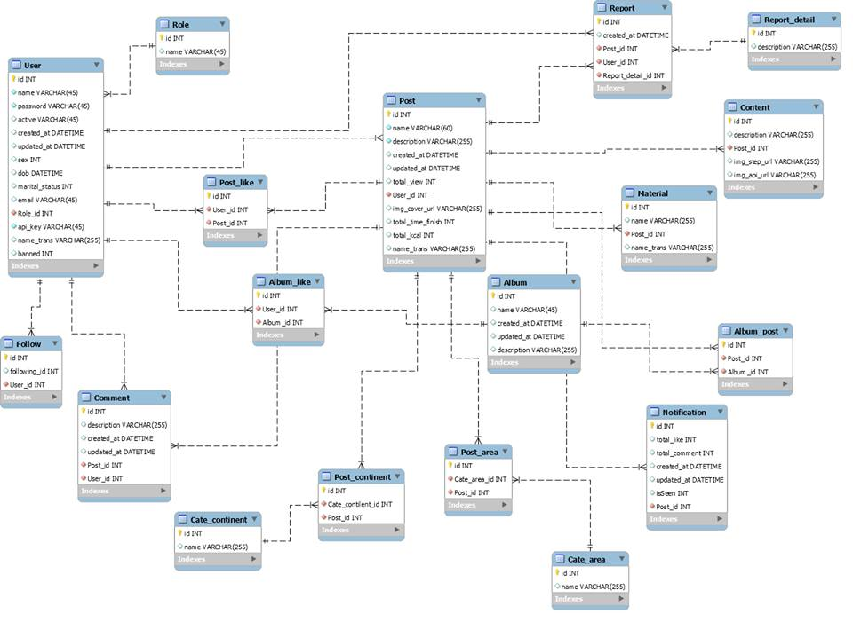

### **3.4.2 Mobile Application ERD**

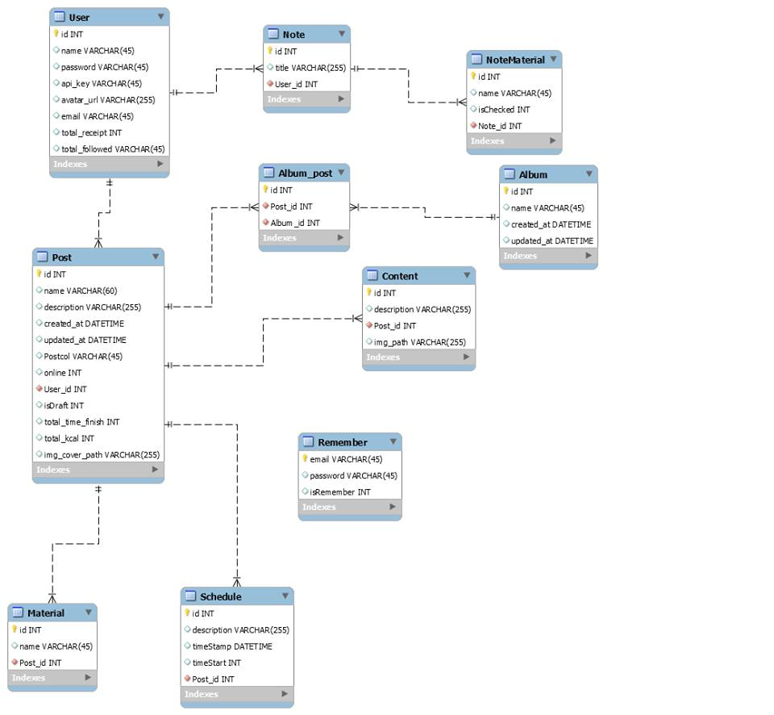

# **Chapter 4: SYSTEM DESIGN DESCRIPTION**

## **4.1 Purpose**

This chapter is to give the developer team a guidance of what the system’s architecture is, and how they should be implemented. This chapter consists of:

* Design overview
* Software architecture design
* Component diagram
* Detailed design
* Detailed description of components
* Database design

## **4.2 Software Architecture Design**

### **4.2.1** **Overall System Architecture**

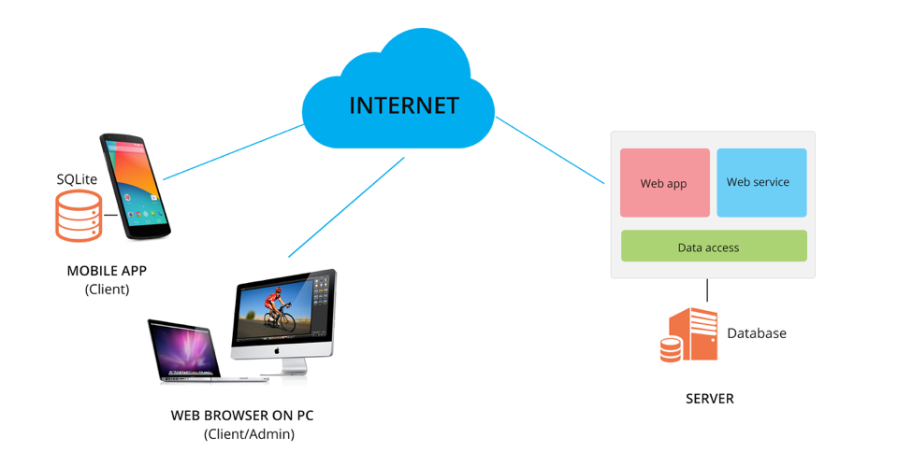

**Figure 4.2**: Overall System Architecture

## **4.3 System Architectural Design**

#### **4.3.1. Web Application & Service**

##### **4.3.1.1 MVC model & Laravel Framework**

* + We choose **Laravel Framework** and **MVC model** for Web Application and Web Service.

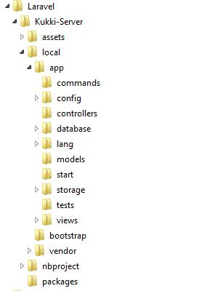

**Figure 4.3.1.1**: Laravel Framework directory structure

The **Model-View-Controller (MVC)** is an architectural pattern that separates an application into three main logical components: the **models**, the **views**, and the **controllers**. Each of these components are built to handle specific development aspects of an application.

In **Laravel Framework**, the standard Laravel application structure has an application directory called **app** with three subdirectories: **models, views** and **controllers**. Which means the Laravel follows the **model-view-controller (MVC)** architectural pattern and suitable for it.

**Model -** The Model component corresponds to all the data related logic that the user works with. This part in applications do all the work such as handling database access, store data, create API….

**View** – Views is the interface of application for user. Controllers handle request and input from view then pass data to each view to renders in some format.

**Controller** – Controllers is responsible to processing input, manipulating models and deciding which view to display based on user’s request, passing data that each view need.



**Figure 4.3.1.2**: MVC structure in Laravel Framework

##### **4.3.1.2 The reason of choosing MVC Model**

* The separation the three components, allows the re-use of the business logic across applications.
* Multiple User Interfaces can be developed without concerning the code base.
* The developers of UI can focus exclusively on the UI screens without bogged down with business logic.
* The developer of Model / business can focus exclusively on the business logic implementations, modifications, updating without concerning the look and feel and it has nothing to with business logic.
* Business logic developers can build the classes, while the UI developers can involve in designing UI screens simultaneously, resulting the interdependency issues and time conservation.
* UI updating can be made without slowing down the business logic process
* Business logic rules changes are very less that needs the revision/ updating of the UI.

#### **4.3.2. Mobile Application**

##### **4.3.2.1 Model View ViewModel (MVVM Model)**

We choose **MVVM Model** for Mobile Application

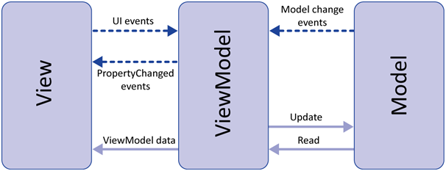

**Figure 4.3.2**: MVVM model structure

**Model-View-ViewModel (MVVM)** is a variant of MVC that takes advantage of particular strengths of the Windows Presentation Foundation (WPF) architecture to separate the Model and the View by introducing an abstract layer between them: a “Model of the View,” or ViewModel. Even though it's the pattern of choice in Microsoft frameworks but it possible to use MVVM in other platforms such as Android.

As mentions above, MVVM is a variant of MVC so the model and view of two patterns are the same but view models and controllers are the differences.

**Model** - the model represents the domain model and core business logic.

**View** - the view represents the interface with which the user interacts.

**View Model -** The view model is a mediator between the model and view. It's responsible for exposing data to the view for it to display, as well as providing commands the view can use to communicate events back down to the view model

##### **4.3.2.2 The reason of choosing**

##### MVVM enables a great developer-designer workflow, providing these benefits:

* During the development process, developers and designers can work more independently and concurrently on their components. The designers can concentrate on the view, and if they are using Expression Blend, they can easily generate sample data to work with, while the developers can work on the view model and model components.
* The developers can create unit tests for the view model and the model without using the view. The unit tests for the view model can exercise exactly the same functionality as used by the view.
* It is easy to redesign the UI of the application without touching the code because the view is implemented entirely in XAML. A new version of the view should work with the existing view model.
* If there is an existing implementation of the model that encapsulates existing business logic, it may be difficult or risky to change. In this scenario, the view model acts as an adapter for the model classes and enables you to avoid making any major changes to the model code.

## **4.4 Web Application**

### **4.4.1 Architectural Design**

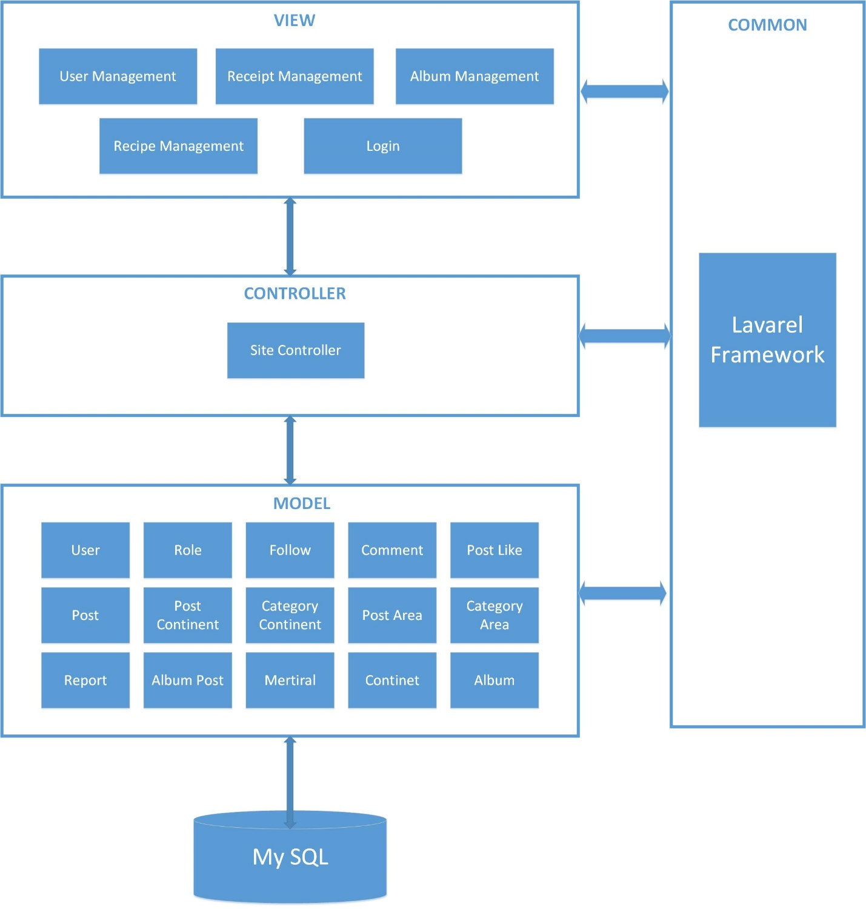

**Figure 4.4**: Web app architectural design

### **4.4.2 Detail Design**

**Class Diagram**

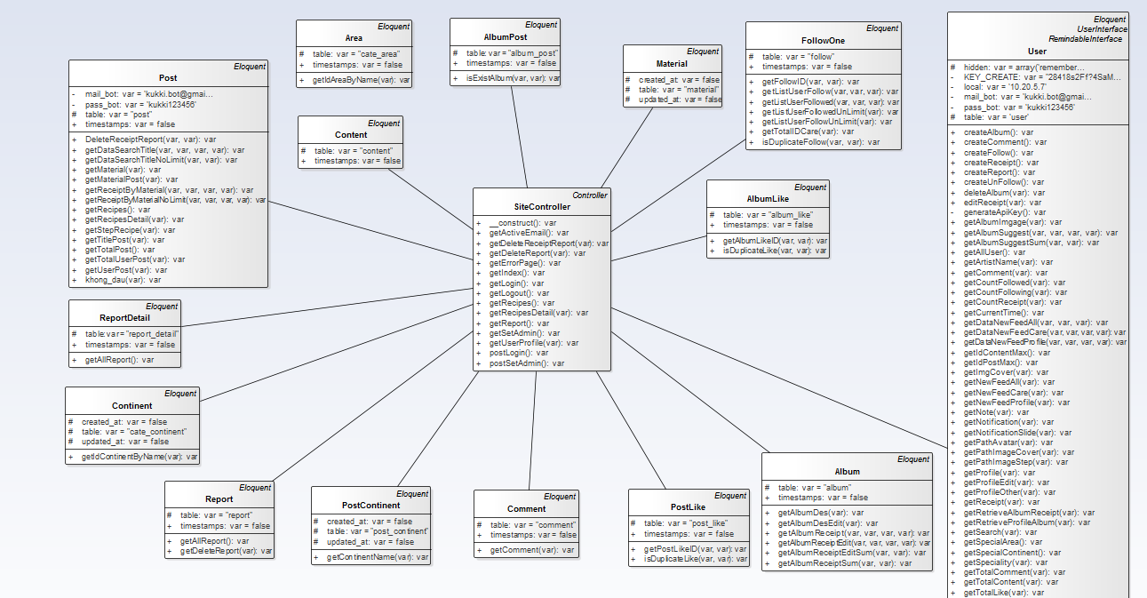

**Class Diagram Explanations**

This class diagram has responsibility for all function on Web Application.

|  |  |
| --- | --- |
| Class Name | Description |
| SiteController | Provides function to interactive with models |
| Continent | Provides function to interactive with Continent table in database |
| Report | Provides function to interactive with Report table in database |
| PostContinent | Provides function to interactive with PostContinent table in database |
| Comment | Provides function to interactive with Comment table in database |
| PostLike | Provides function to interactive with PostLike table in database |
| Album | Provides function to interactive with Album table in database |
| User | Provides function to interactive with User table in database |
| FollowOne | Provides function to interactive with FollowOne table in database |
| AlbumLike | Provides function to interactive with AlbumLike table in database |
| Material | Provides function to interactive with Material table in database |
| AlbumPost | Provides function to interactive with AlbumPost table in database |
| Area | Provides function to interactive with Area table in database |
| Content | Provides function to interactive with Content table in database |
| Post | Provides function to interactive with Post table in database |
| ReportDetail | Provides function to interactive with ReportDetail table in database |

## **4.5 Mobile Application**

### **4.5.1 Architectural design**



**Figure 4.5**: Mobile app architectural design

### **4.4.2 Detail Design**

##### **4.3.2.2 Mobile Application**

###### **4.4.2.2.1. Register**

**Class Diagram**

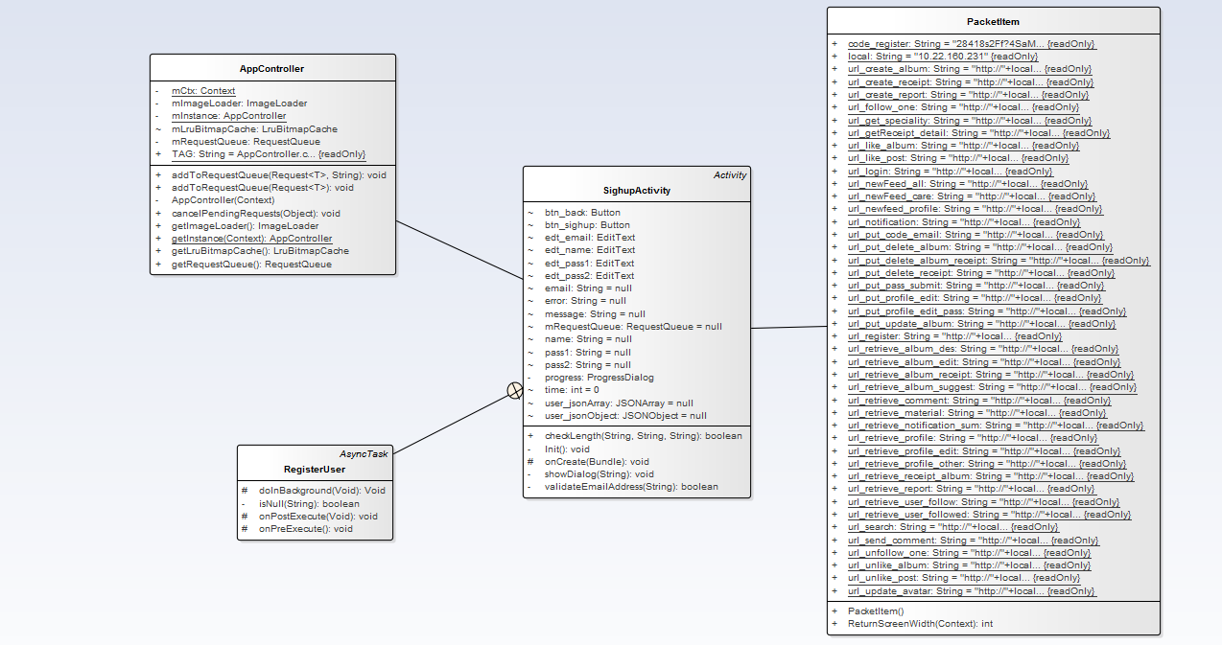

**Class Diagram Explanation**

This class diagram has responsibility for Register function on Mobile Application.

|  |  |
| --- | --- |
| Class Name | Description |
| SignUpActivity | Provides two things: Action and Data |
| RegisterUser | Execute: Create new user |
| PacketItem | Get URL for create user |
| AppController | Push request HTTP to server |

###### **4.4.2.2.2. Authentication**

**4.4.2.2.2.1 Login**

**Class Diagram**

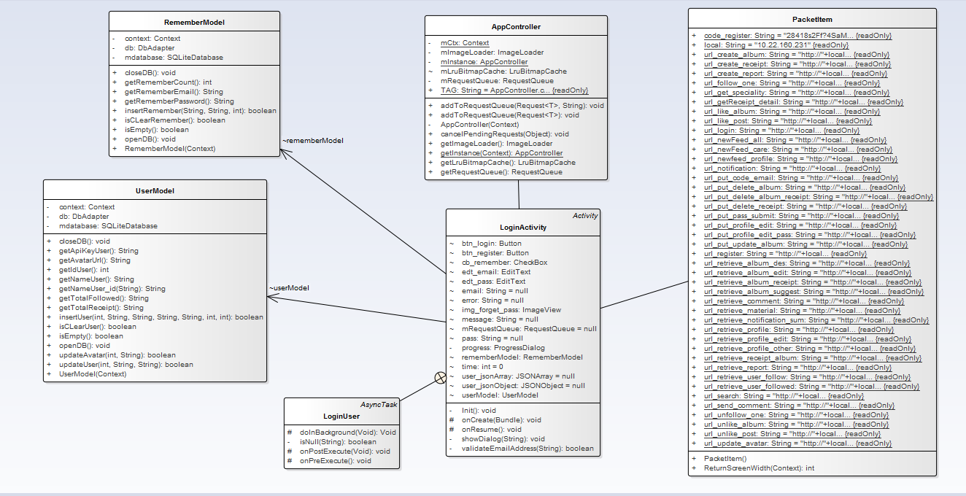

**Class Diagram Explanation**

This class diagram has responsibility for Login function on Mobile Application.

|  |  |
| --- | --- |
| Class Name | Description |
| LoginActivity | Provides two things: Action and Data |
| LoginUser | Execute: Login |
| PacketItem | Get URL for Login |
| AppController | Push request HTTP to server |
| UserModel | Insert user data to SQLite |
| RememberModel | Insert status remember account |

**4.4.2.2.2.3 Forget password**

**Class Diagram**

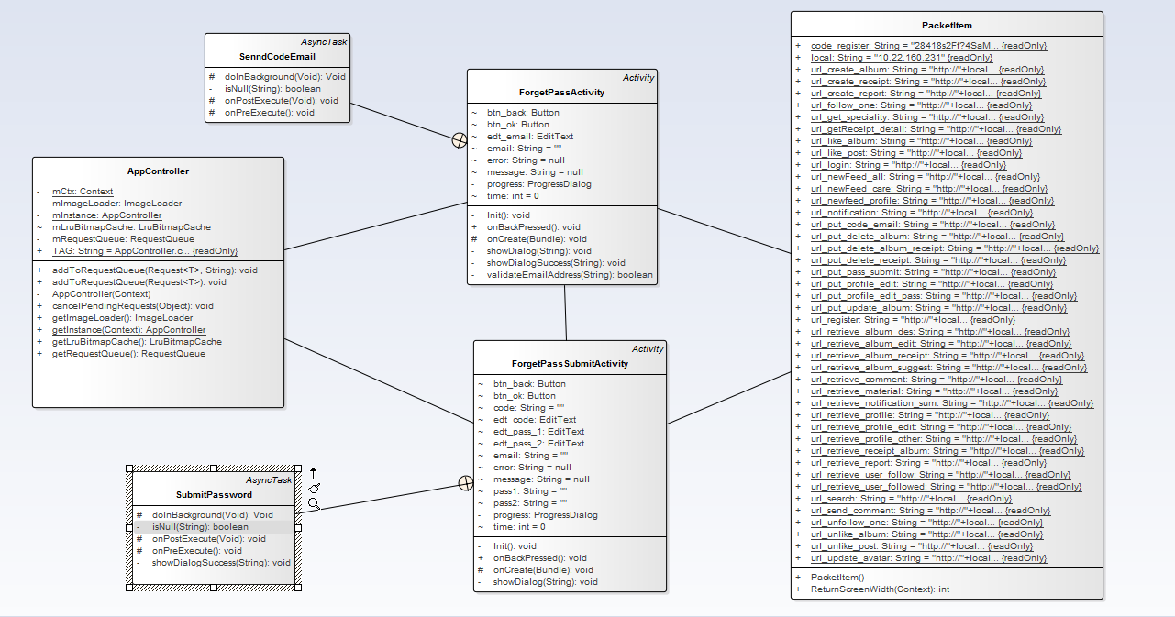

**Class Diagram Explanation**

This class diagram has responsibility for Forget Password function on Mobile Application.

|  |  |
| --- | --- |
| Class Name | Description |
| ForgetPassActivity | Provides two things: Action and Data |
| SendCodeEmail | Execute: Send code to email |
| PacketItem | Get URL for sending code, submit password |
| AppController | Push request HTTP to server |
| ForgetPassSubmitActivity | Provides two things: Action and Data |
| SubmitPassword | Execute: Change password |

###### **4.4.2.2.3 Profile Management**

**4.4.2.2.3.1 Edit profile**

**Class Diagram**

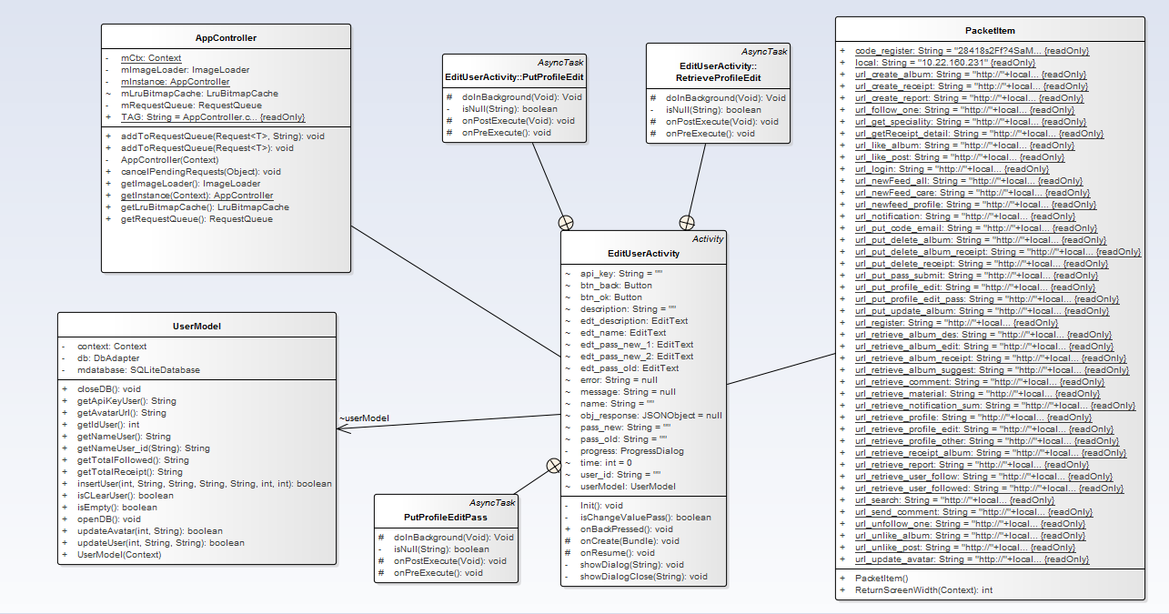

**Class Diagram Explanation**

This class diagram has responsibility for Edit Profile function on Mobile Application.

|  |  |
| --- | --- |
| Class Name | Description |
| EditUserActivity | Provides two things: Action and Data |
| RetrieveprofileEdit | Execute: Fill data user to exist form |
| PacketItem | Get URL for Retrieve profile, Change profile |
| AppController | Push request HTTP to server |
| PutProfileEdit | Execute: Change profile user without changing password |
| PutProfileEditPass | Execute: Change profile user, also change password |
| UserModel | Get id + api_key for security API request |

**4.4.2.2.3.2 View profile**

**Class Diagram**

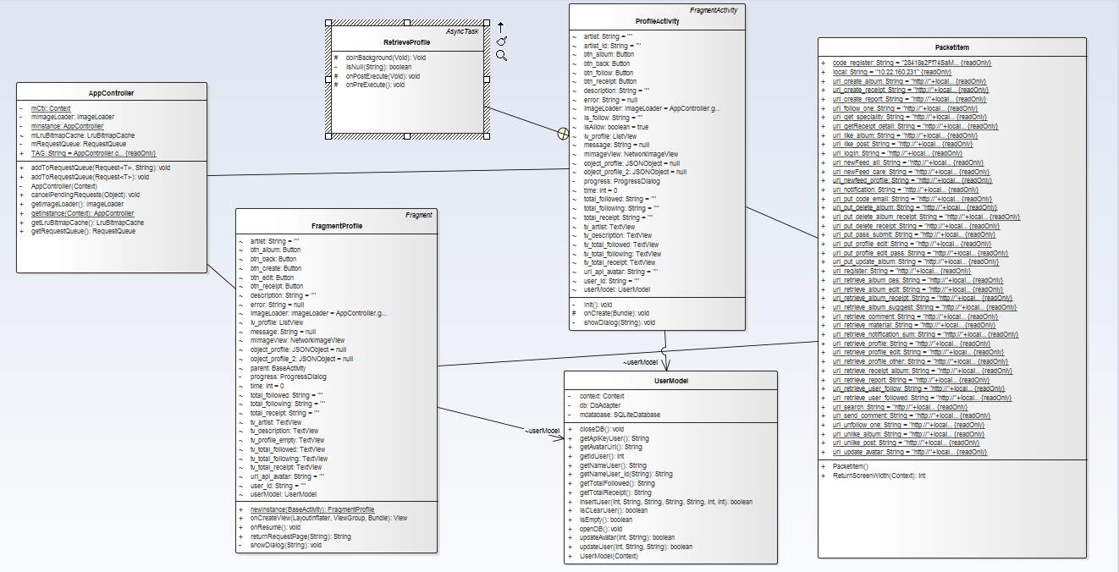

**Class Diagram Explanation**

This class diagram has responsibility for View Profile function on Mobile Application.

|  |  |
| --- | --- |
| Class Name | Description |
| FragmentProfile | Provides two things: Action and Data |
| RetrieveProfile | Execute: Get profile user |
| PacketItem | Get URL for view profile |
| AppController | Push request HTTP to server |
| UserModel | Get id + api_key for security API request |

###### **4.4.2.2.4 Community**

**4.4.2.2.4.1 View list people following**

**Class Diagram**

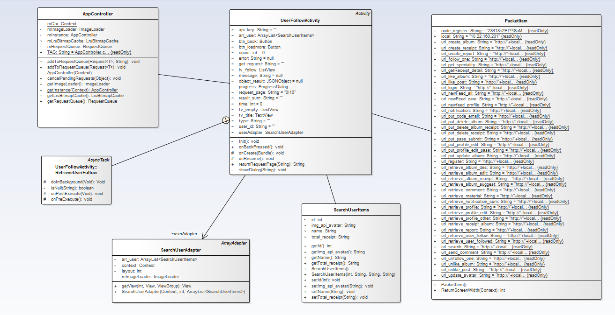

**Class Diagram Explanation**

This class diagram has responsibility for View list people following function on Mobile Application.

|  |  |
| --- | --- |
| Class Name | Description |
| UserFollowActivity | Provides two things: Action and Data |
| RetrievePeopleFollow | Execute: Retrieve and Display People Following |
| PacketItem | Get URL for Retrieve people Following |
| AppController | Push request HTTP to server |
| SearchUserItems | Object contains variable of people |
| SearchUserAdapter | Display custom list view of people |

**4.4.2.2.4.2 View list people were followed**

**Class Diagram**

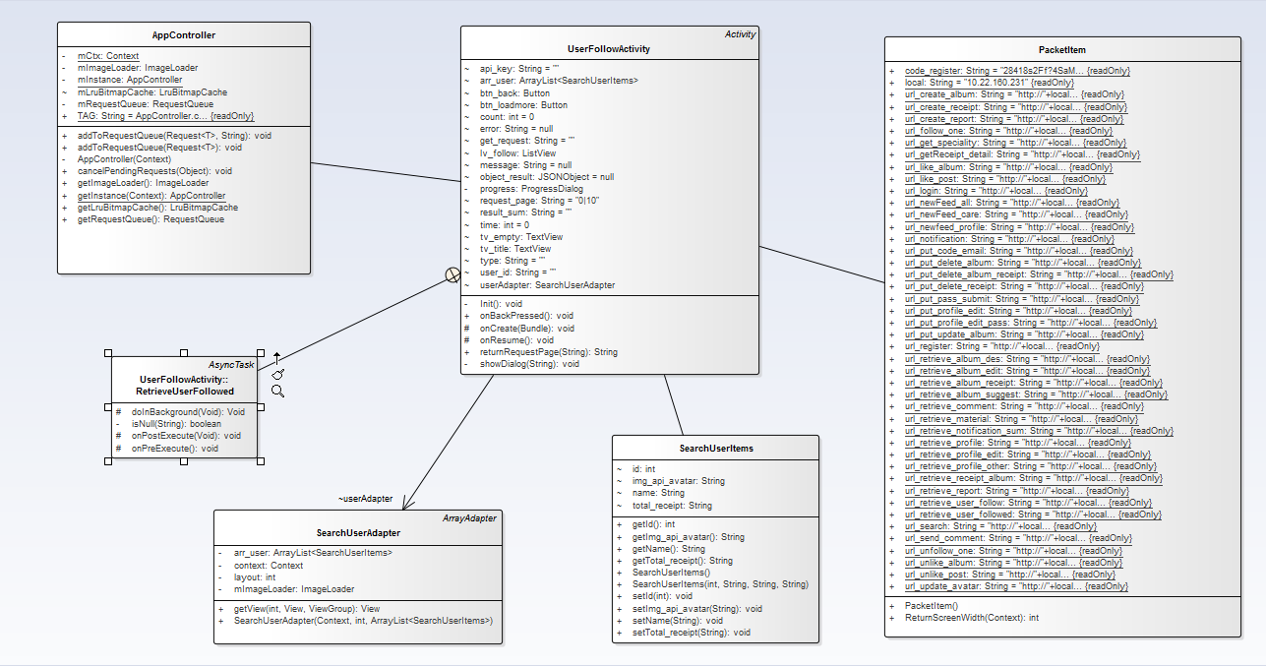

**Class Diagram Explanation**

This class diagram has responsibility for View list people were followed function on Mobile Application.

|  |  |
| --- | --- |
| Class Name | Description |
| UserFollowActivity | Provides two things: Action and Data |
| RetrievePeopleFollowed | Execute: Retrieve People Followed |
| PacketItem | Get URL for Retrieve People Followed |
| AppController | Push request HTTP to server |
| SearchUserItems | Object contains variable of people |
| SearchUserAdapter | Display custom list view of people |

**4.4.2.2.4.3 Search member**

**Class Diagram**

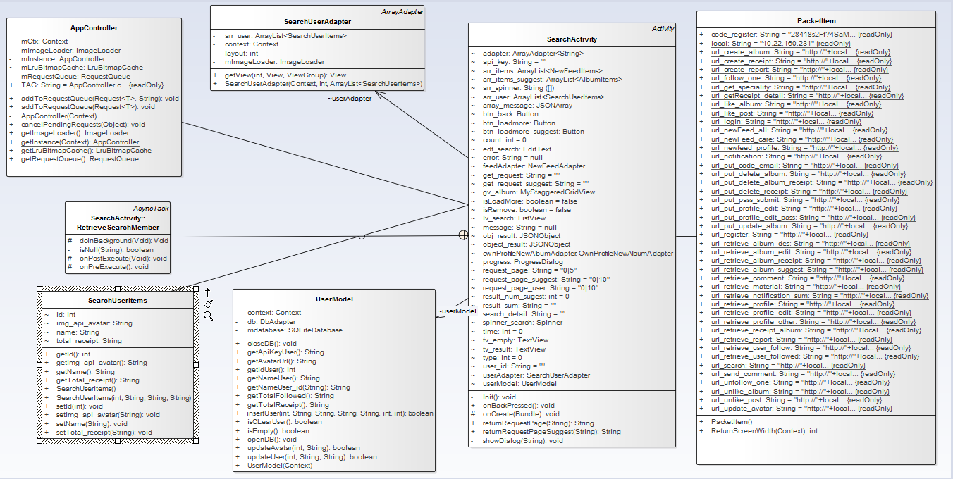

**Class Diagram Explanation**

This class diagram has responsibility for Register function on Mobile Application.

|  |  |
| --- | --- |
| Class Name | Description |
| SearchActivity | Provides two things: Action and Data |
| RetrieveSearchMember | Execute: get member and display |
| PacketItem | Get URL for Retrieve Search Member |
| AppController | Push request HTTP to server |
| SearchUserItems | Object contains variable for user |
| SearchUserAdapter | Display custom list view for user |
| UserModel | Get id + api_key for security API request |

**4.4.2.2.4.4 Unfollow**

**Class Diagram**

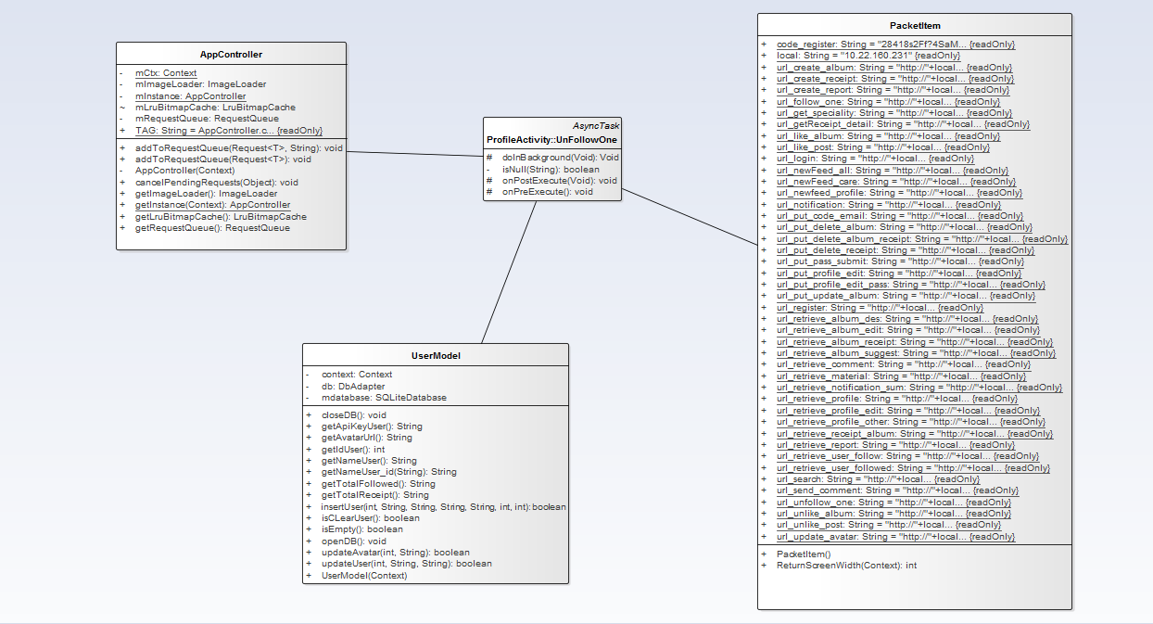

**Class Diagram Explanation**

This class diagram has responsibility for Unfollow function on Mobile Application.

|  |  |
| --- | --- |
| Class Name | Description |
| UnFollowOne | Execute: Unfollow someone |
| UserModel | Get id + api_key for security API request |
| PacketItem | Get URL for Making request unfollow |
| AppController | Push request HTTP to server |

**4.4.2.2.4.5 Follow**

**Class Diagram**

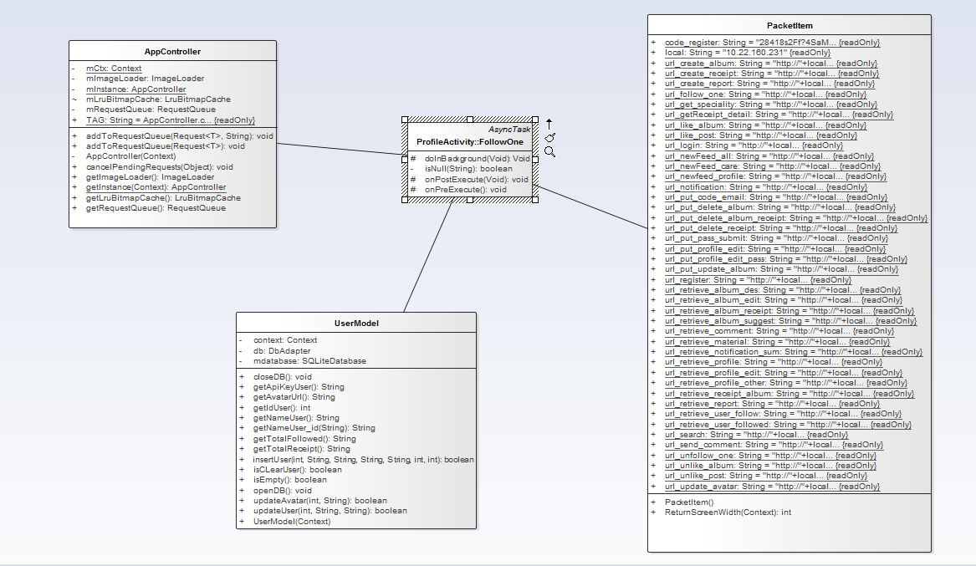

**Class Diagram Explanation**

This class diagram has responsibility for Follow function on Mobile Application.

|  |  |
| --- | --- |
| Class Name | Description |
| FollowOne | Execute: Follow someone |
| UserModel | Get id + api_key for security API request |
| PacketItem | Get URL for making request follow |
| AppController | Push request HTTP to server |

**4.4.2.2.4.6 Unlike recipe**

**Class Diagram**

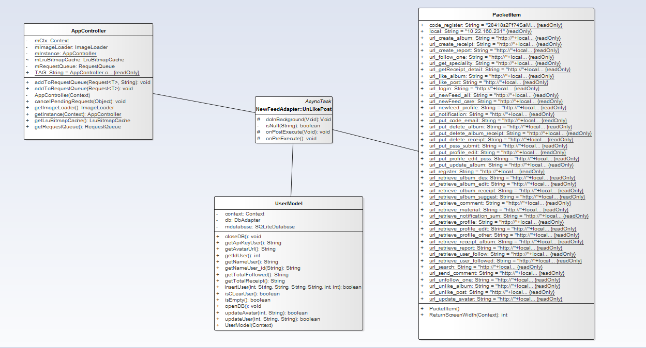

**Class Diagram Explanation**

This class diagram has responsibility for Unlike recipe function on Mobile Application.

|  |  |
| --- | --- |
| Class Name | Description |
| UnlikePost | Execute : Unlike recipe |
| UserModel | get id + api_key for security API request |
| PacketItem | Get URL for Unlike recipe |
| AppController | Push request HTTP to server |

**4.4.2.2.4.7 Like recipe**

**Class Diagram**

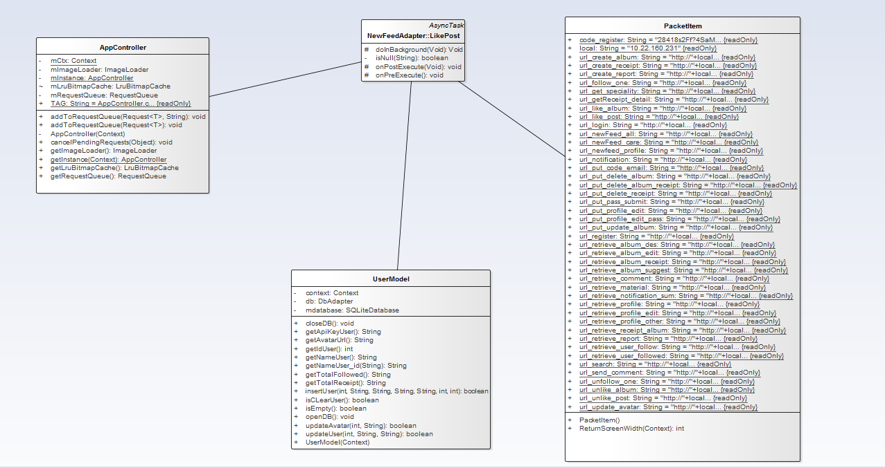

**Class Diagram Explanation**

This class diagram has responsibility for Register function on Mobile Application.

|  |  |
| --- | --- |
| Class Name | Description |
| LikePost | Execute: Like recipe |
| UserModel | Get id + api_key for security API request |
| PacketItem | Get URL for like recipe |
| AppController | Push request HTTP to server |

**4.4.2.2.4.8 Comment**

**Class Diagram**

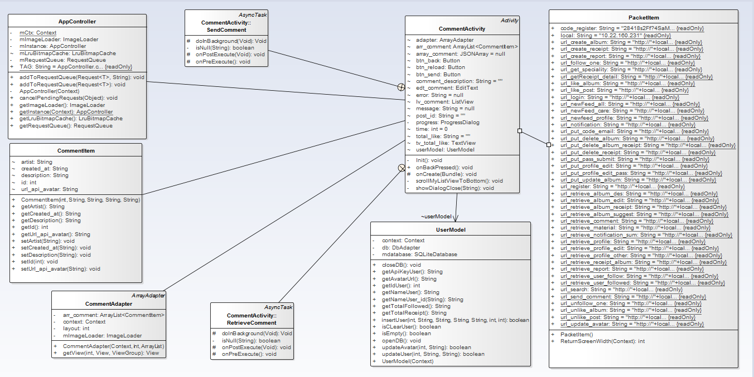

**Class Diagram Explanation**

This class diagram has responsibility for Comment function on Mobile Application.

|  |  |
| --- | --- |
| Class Name | Description |
| CommentActivity | Provides two things: Action and Data |
| RetrieveComment | Execute: Get comment and display |
| SendComment | Execute: Send comment to server |
| PacketItem | Get URL for Send Comment |
| AppController | Push request HTTP to server |
| UserModel | Get id + api_key for security API request |
| CommentItems | Object contains variable for comment |
| CommentAdapter | Display custom list view for comment |

**4.4.2.2.4.9 View notification**

**Class Diagram**

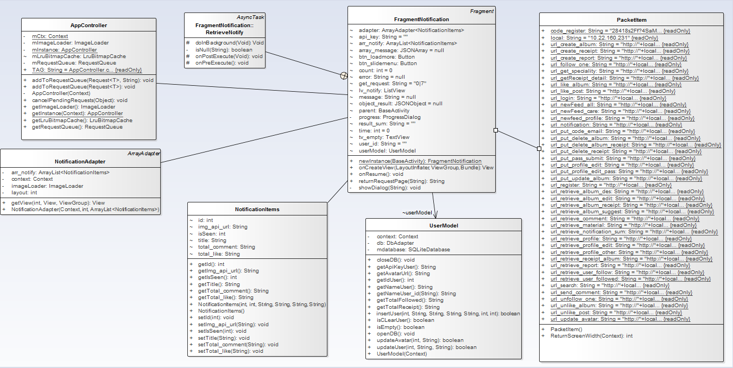

**Class Diagram Explanation**

This class diagram has responsibility for View Notification function on Mobile Application.

|  |  |
| --- | --- |
| Class Name | Description |
| FragmentNotification | Provides two things: Action and Data |
| RetrieveNotify | execute: get notifications and display |
| PacketItem | Get URL for Retrieve Notify |
| AppController | Push request HTTP to server |
| NotificationItems | Object contains variable for each notification |
| NotificationAdapter | Display custom list view for notifications |
| UserModel | Get id + appi_key for security API request |

**4.4.2.2.4.10 Report recipe**

**Class Diagram**

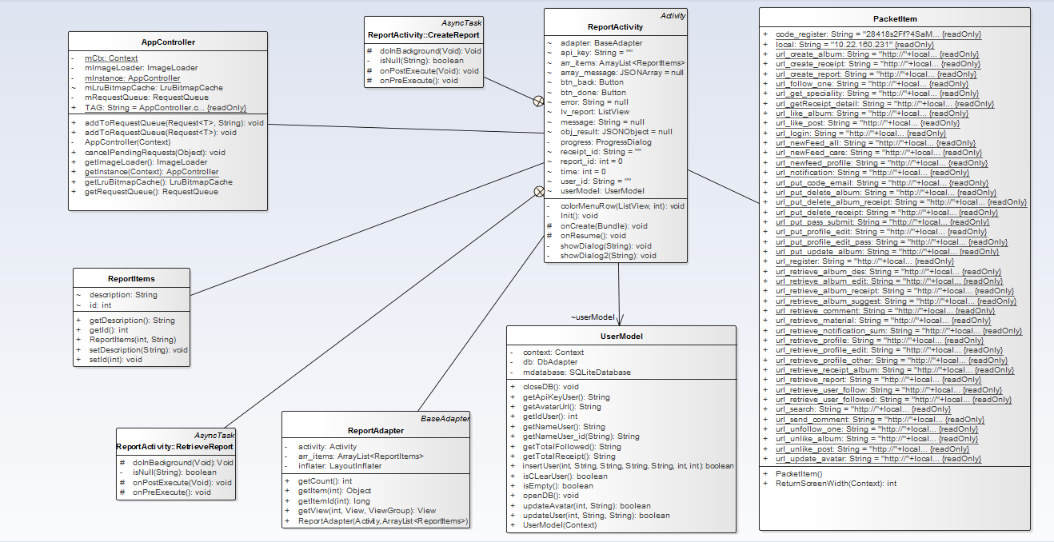

**Class Diagram Explanation**

This class diagram has responsibility for Report recipe function on Mobile Application.

|  |  |
| --- | --- |
| Class Name | Description |
| ReportActivity | Provides two things: Action and Data |
| CreateReport | Execute: send report of recipe to server |
| PacketItem | Get URL for send report of recipe to server |
| AppController | Push request HTTP to server |
| RetrieveReport | Get report detail from server and display on screen for user to choose |
| UserModel | Get id + api_key for security API request |
| ReportItems | Object contains variable of report |
| ReportAdapter | Display custom list view for report |

**4.4.2.2.4.11 Like album**

**Class Diagram**

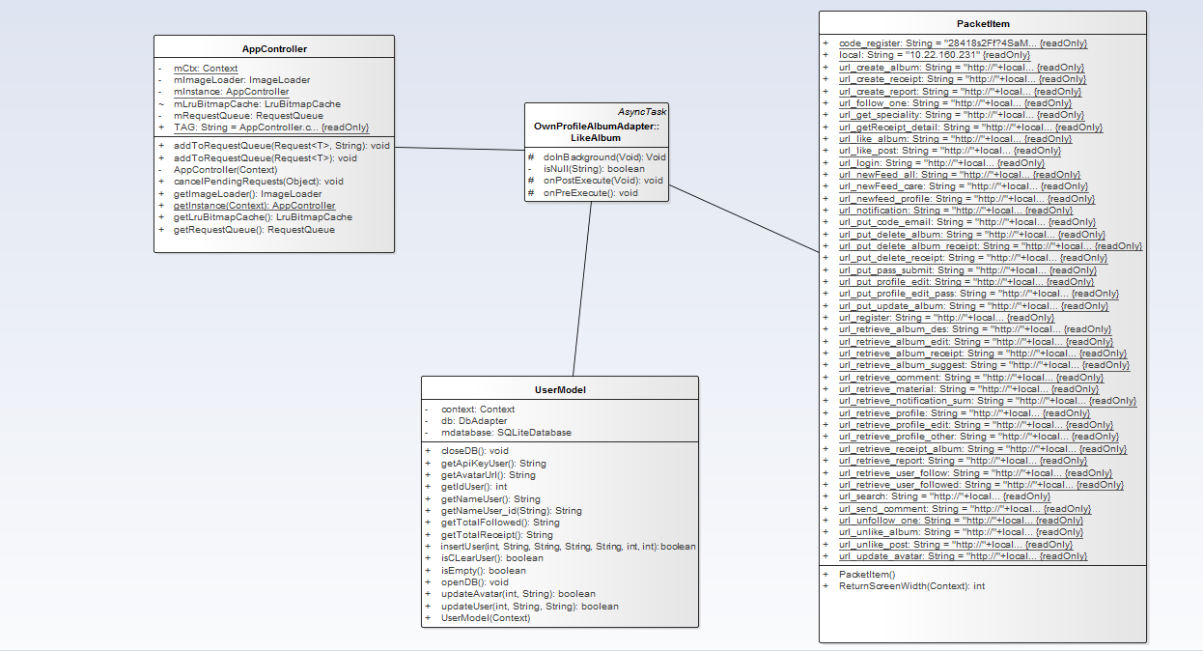

**Class Diagram Explanation**

This class diagram has responsibility for Like album function on Mobile Application.

|  |  |
| --- | --- |
| Class Name | Description |
| LikeAlbum | Execute: like album |
| UserModel | Get id + api_key for security API request |
| PacketItem | Get URL for like album |
| AppController | Push request HTTP to server |

**4.4.2.2.4.12 Unlike album**

**Class Diagram**

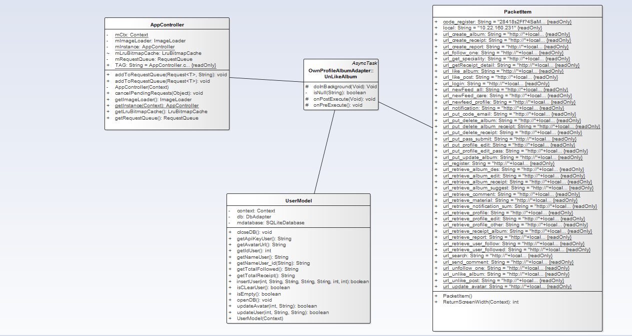

**Class Diagram Explanation**

This class diagram has responsibility for Unlike Album function on Mobile Application.

|  |  |
| --- | --- |
| Class Name | Description |
| UnlikePost | Execute: Unlike album |
| UserModel | Get id + api_key for security API request |
| PacketItem | Get URL for Unlike album |
| AppController | Push request HTTP to server |

###### **4.4.2.2.5 Recipe Management**

**4.4.2.2.5.1 View list all recipe**

**Class Diagram**

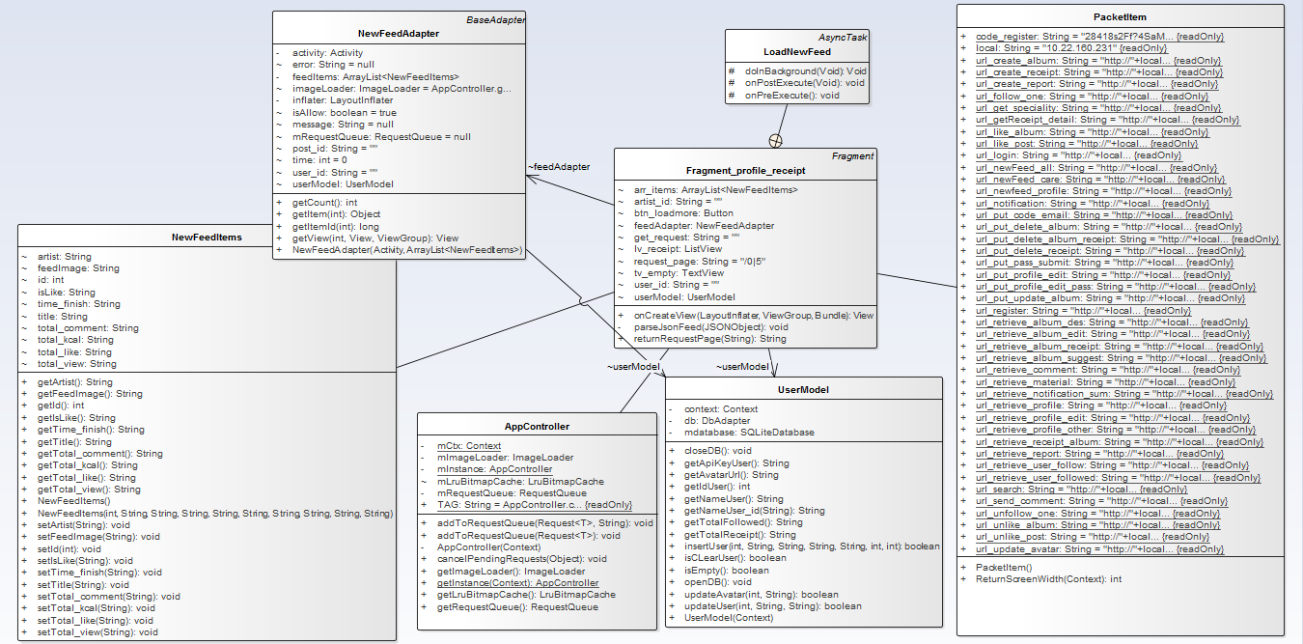

**Class Diagram Explanation**

This class diagram has responsibility for View list all recipe function on Mobile Application.

|  |  |
| --- | --- |
| Class Name | Description |
| Fragment_profile_recipe | Provides two things: Action and Data |
| LoadNewFeed | Load more recipe |
| PacketItem | Get URL for get all recipes |
| AppController | Push request HTTP to server |
| UserModel | Get id + api_key for security API request |
| NewFeedItems | Object contains variable for each recipe |
| newFeedAdapter | Display custom list view of recipe |

**4.4.2.2.5.2 View list all recipe of following people**

**Class Diagram**



**Class Diagram Explanation**

This class diagram has responsibility for View list all recipe of following people function on Mobile Application.

|  |  |
| --- | --- |
| Class Name | Description |
| Fragment_profile_recipe | Provides two things: Action and Data |
| LoadNewFeed | Load more recipe |
| PacketItem | Get URL for get all recipes |
| AppController | Push request HTTP to server |
| UserModel | Get id + api_key for security API request |
| NewFeedItems | Object contains variable for each recipe |
| newFeedAdapter | Display custom list view of recipe |

**4.4.2.2.5.3 Search recipe**

**Class Diagram**

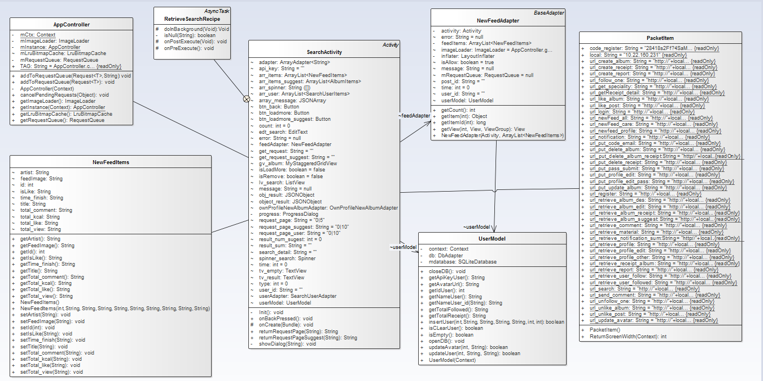

**Class Diagram Explanation**

This class diagram has responsibility for Search recipe function on Mobile Application.

|  |  |
| --- | --- |
| Class Name | Description |
| SearchActivity | Provides two things: Action and Data |
| RetrieveSearchRecipe | Get recipe and display |
| PacketItem | Get url for RetrieveSearchRecipe |
| AppController | Push request to server |
| UserModel | Get id + appi_key for security api request |
| NewFeedAdapter | Object contains variable for each recipe |
| NewFeedItems | Display custom listview for recipes |

**4.4.2.2.5.4 Edit recipe**

**Class Diagram**

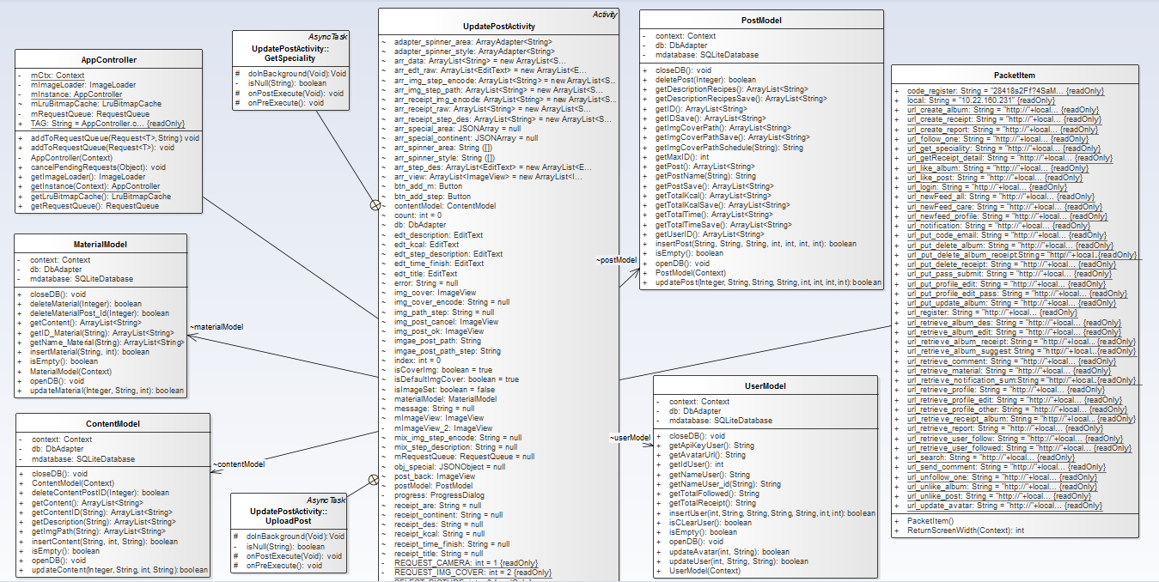

**Class Diagram Explanation**

This class diagram has responsibility for Edit recipe function on Mobile Application.

|  |  |
| --- | --- |
| Class Name | Description |
| UpdatePostActivity | Provides two things: Action and Data |
| GetSpeciality | Execute: execute: get data area and continent and display in form |
| PacketItem | Get URL for GetSpeciality, edit recipe |
| AppController | Push request HTTP to server |
| UploadPost | Execute: edit recipe |
| UserModel | Get id + api_key for security API request |
| PostModel | Insert data to sqlite |
| MaterialModel | Insert data to sqlite |
| ContentModel | Insert data to sqlite |

**4.4.2.2.5.5 View recipe detail**

**Class Diagram**

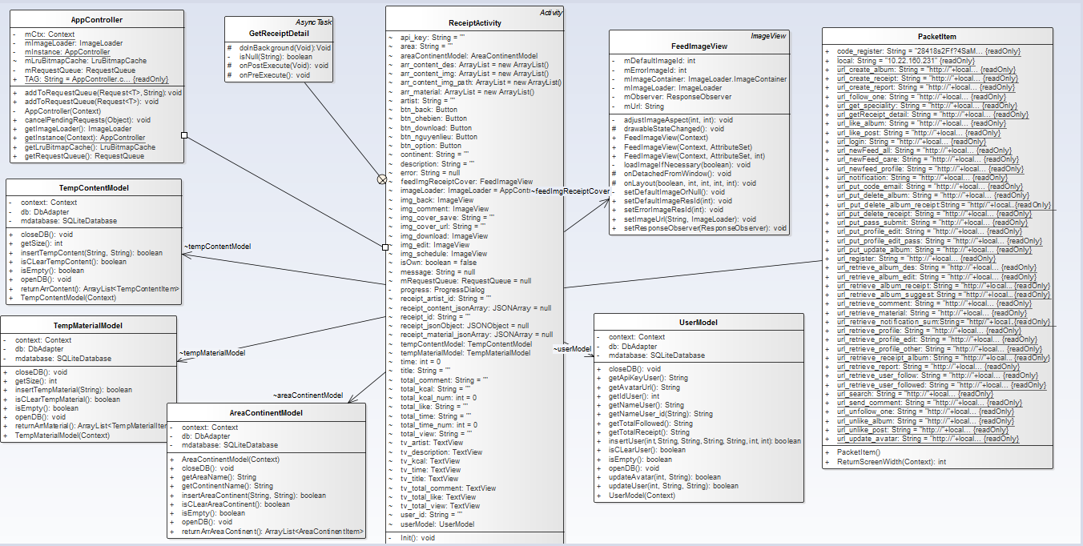

**Class Diagram Explanation**

This class diagram has responsibility for View recipe detail function on Mobile Application.

|  |  |
| --- | --- |
| Class Name | Description |
| RecipeActivity | Provides two things: Action and Data |
| GetRecipeDetail | Execute: get recipe data and display |
| PacketItem | Get URL for GetRecipeDetail |
| AppController | Push request HTTP to server |
| FeedImageView | support display custom image |
| UserModel | Get id + api_key for security api request |
| TempMaterialModel | Save ingredients to sqlite |
| TempContentModel | Save content ro sqlite |
| AreaContinentModel | Save area and continent to sqlite |

**4.4.2.2.5.7 Create recipe**

**Class Diagram**

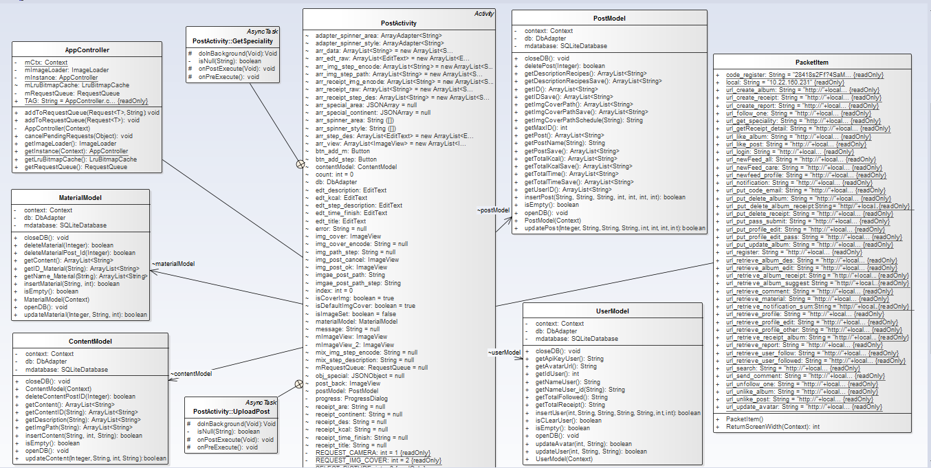

**Class Diagram Explanation**

This class diagram has responsibility for Create recipe function on Mobile Application.

|  |  |
| --- | --- |
| Class Name | Description |
| PostActivity | Provides two things: Action and Data |
| GetSpeciality | Execute: execute: get data area and continent and display in form |
| PacketItem | Get URL for GetSpeciality, create new recipe |
| AppController | Push request HTTP to server |
| UploadPost | Execute: create new recipe |
| UserModel | Get id + api_key for security API request |
| PostModel | Insert data to SQLite |
| MaterialModel | Insert data to SQLite |
| ContentModel | Insert data to SQLite |

**4.4.2.2.5.9 Delete recipe**

**Class Diagram**

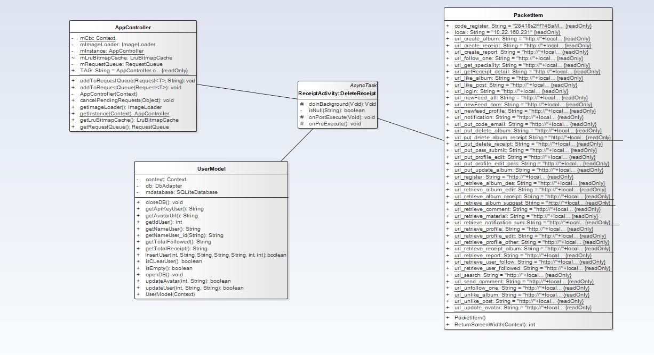

**Class Diagram Explanation**

This class diagram has responsibility for Delete recipe function on Mobile Application.

|  |  |
| --- | --- |
| Class Name | Description |
| DeleteRecipe | Execute: delete recipe |
| UserModel | Get id + api_key for security API request |
| PacketItem | Get URL for Delete recipe |
| AppController | Push request HTTP to server |

###### **4.4.2.2.2.6 Album Management**

**4.4.2.2.6.1 View album**

**Class Diagram**

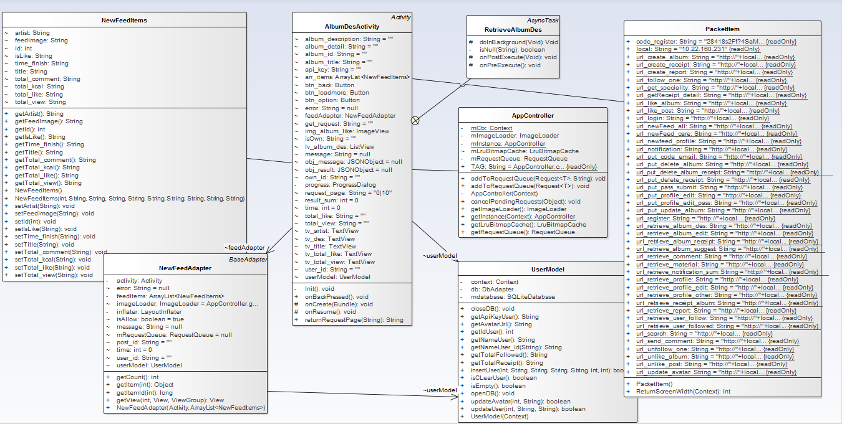

**Class Diagram Explanation**

This class diagram has responsibility for View album function on Mobile Application.

|  |  |
| --- | --- |
| Class Name | Description |
| AlbumDesActivity | Provides two things: Action and Data |
| RetrieveAlbumDes | Execute: get recipe and display for each album |
| PacketItem | Get URL for RetrieveAlbumDes |
| AppController | Push request HTTP to server |
| NewFeedItems | Object contains variable for each recipe |
| NewFeedAdapter | Display custom listview for recipe |
| UserModel | Get id + api_key for security api request |

**4.4.2.2.6.2 Edit album**

**Class Diagram**

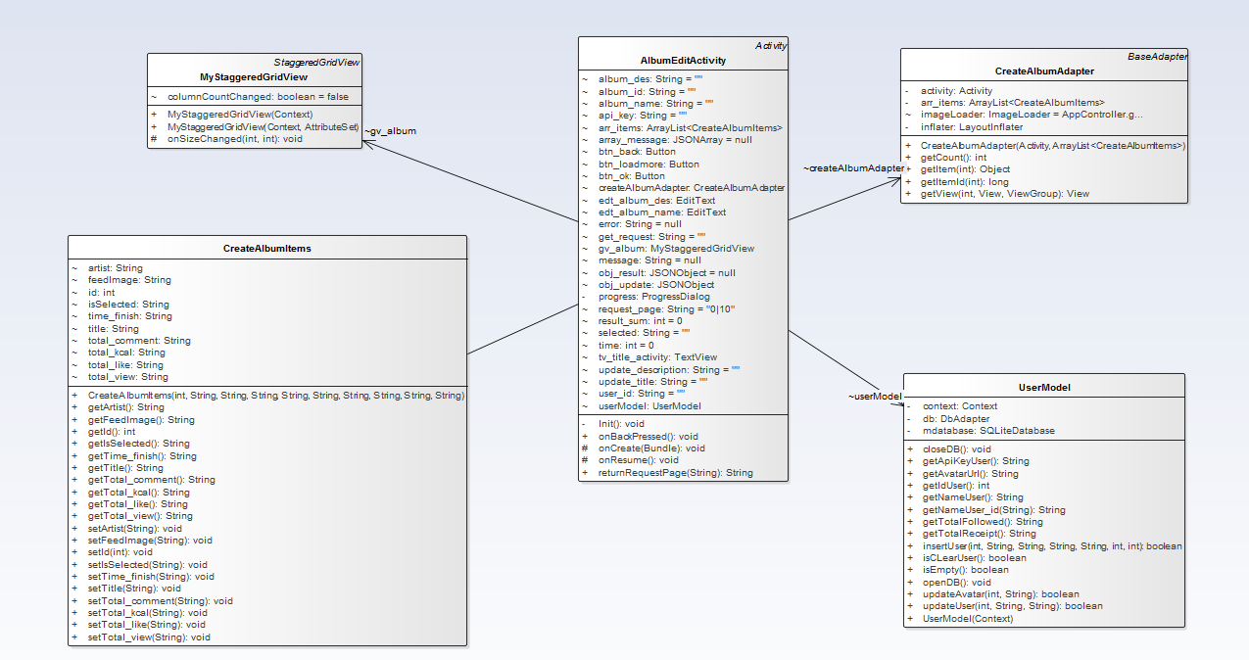

**Class Diagram Explanation**

This class diagram has responsibility for Edit album function on Mobile Application.

|  |  |
| --- | --- |
| Class Name | Description |
| AlbumEditActivity | Provides two things: Action and Data |
| MyStaggeredGridView | Display custom gridview |
| UserModel | Get id + api_key for security api request |
| CreateAlbumItems | Object contains variable for each album |
| CreateAlbumAdapter | Display custom gridview album |

**4.4.2.2.6.3 Delete album**

**Class Diagram**

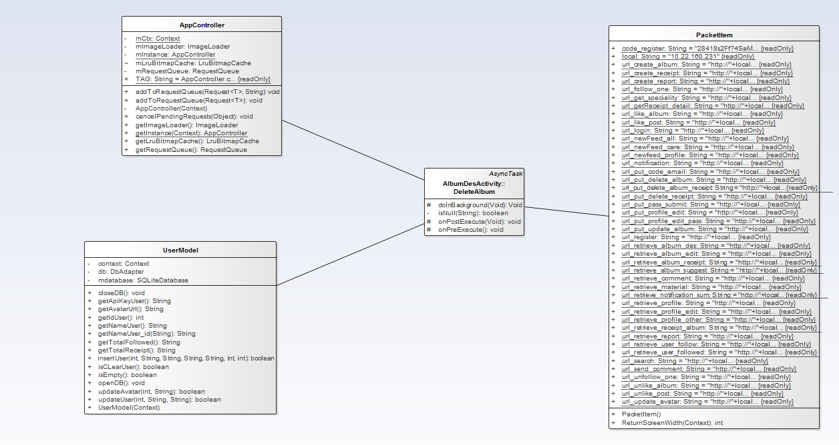

**Class Diagram Explanation**

This class diagram has responsibility for Delete album function on Mobile Application.

|  |  |
| --- | --- |
| Class Name | Description |
| DeleteAlbum | Provides two things: Action and Data |
| UserModel | Get id + api_key for security API request |
| PacketItem | Get URL for Delete album |
| AppController | Push request HTTP to server |

**4.4.2.2.6.4 Search album**

**Class Diagram**

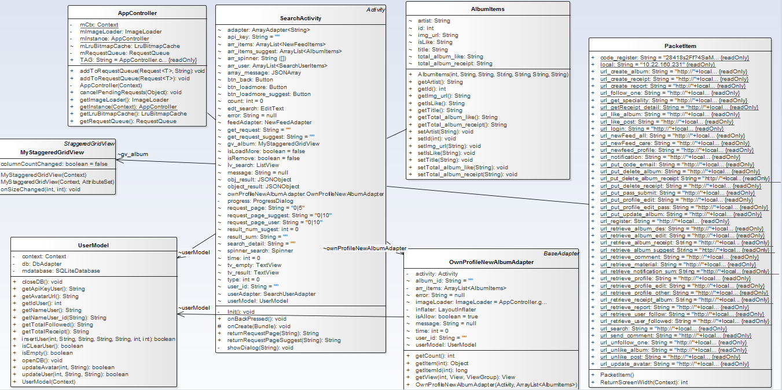

**Class Diagram Explanation**

This class diagram has responsibility for Search Album function on Mobile Application.

|  |  |
| --- | --- |
| Class Name | Description |
| SearchActivity | Provides two things: Action and Data |
| RetrieveSearchAlbum | execute get album and display |
| PacketItem | Get URL for RetrieveSearchAlbum |
| AppController | Push request HTTP to server |
| OwnProfileNewAlbumAdapter | display custom gridview for album |
| AlbumItems | object contains variable for each album |
| MyStaggeredGridView | display custom gridview |
| UserModel | get id + appi_key for security api request |

**4.4.2.2.6.5 Create album**

**Class Diagram**

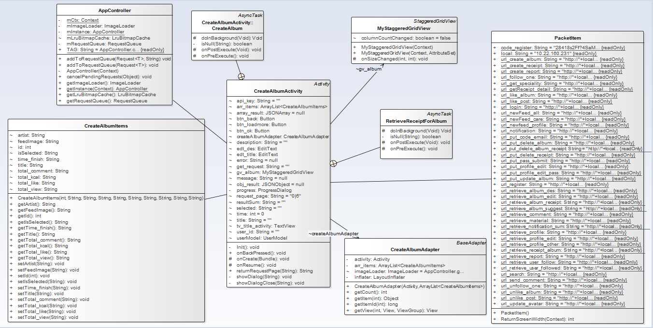

**Class Diagram Explanation**

This class diagram has responsibility for Create album function on Mobile Application.

|  |  |
| --- | --- |
| Class Name | Description |
| CreateAlbumActivity | Provides two things: Action and Data |
| RetrieveRecipeForAlbum | Execute: get recipe for creating new album |
| PacketItem | Get URL for RetrieveRecipeForAlbum |
| AppController | Push request HTTP to server |
| CreateAlbum | Execute: create new album |
| MyStaggeredGridView | Display custom gridview |
| CreateAlbumItems | Object contains variable for each album |
| CreateAlbumAdapter | Display custom gridview for album |

###### **4.4.2.2.2.7 Shopping List Management**

**4.4.2.2.7.2 Add ingredient to shopping list**

**Class Diagram**

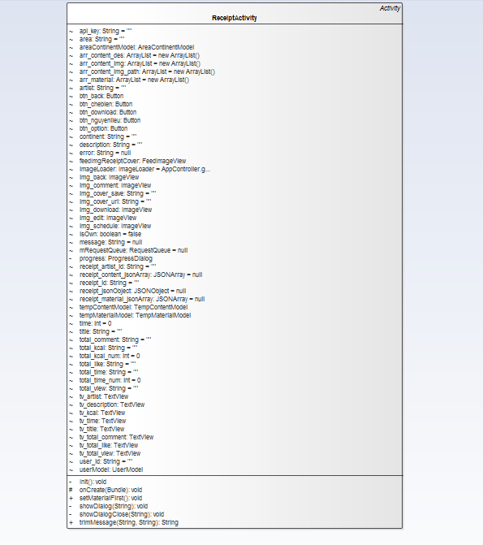

**Class Diagram Explanation**

This class diagram has responsibility for Add ingredient to shopping list function on Mobile Application.

|  |  |
| --- | --- |
| Class Name | Description |
| RecipeActivity | Provide a method do this case |

**4.4.2.2.7.3 View shopping list**

**Class Diagram**

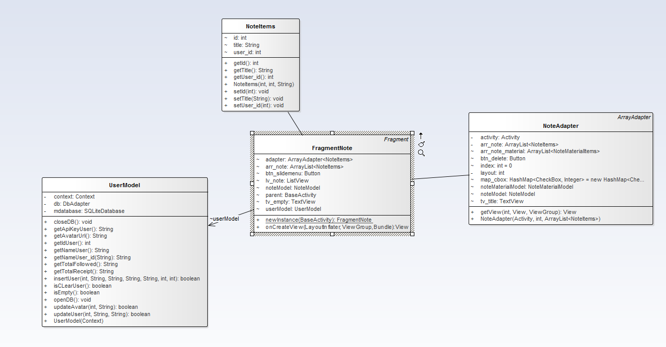

**Class Diagram Explanation**

This class diagram has responsibility for View shopping list function on Mobile Application.

|  |  |
| --- | --- |
| Class Name | Description |
| FragmentNote | Provides two things: Action and Data |
| Usermodel | Get id + api_key for security API request |
| NoteItems | Object contains variable for each note |
| NoteAdapter | Display custom list view for note |

## **4.6 Web service**

### **4.6.1 Architecture design**

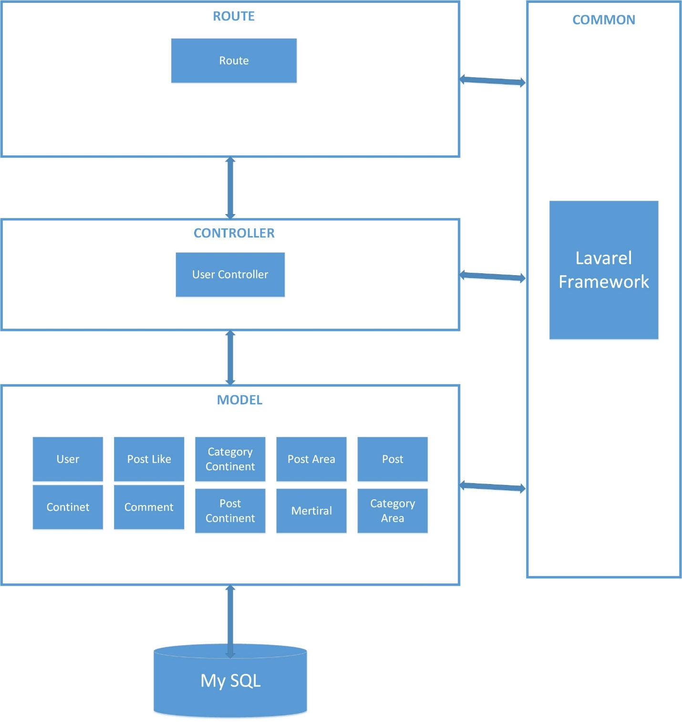

### **4.6.2 Detail Design**

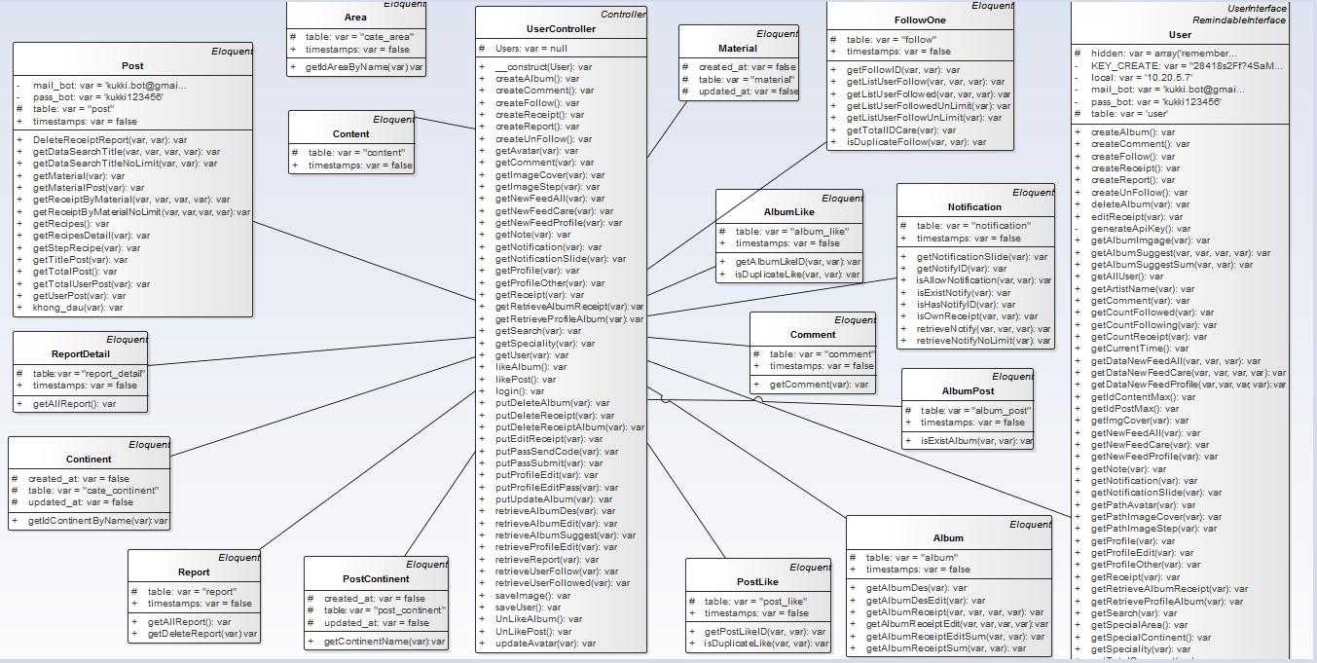

**Class Diagram Explanations**

This class diagram has responsibility for all function on Web Application.

|  |  |
| --- | --- |
| Class Name | Description |
| UserController | Provides function to help client (mobile app) interactive with models on server |
| Continent | Provides function to interactive with Continent table in database |
| Report | Provides function to interactive with Report table in database |
| PostContinent | Provides function to interactive with PostContinent table in database |
| Comment | Provides function to interactive with Comment table in database |
| PostLike | Provides function to interactive with PostLike table in database |
| Album | Provides function to interactive with Album table in database |
| User | Provides function to interactive with User table in database |
| FollowOne | Provides function to interactive with FollowOne table in database |
| AlbumLike | Provides function to interactive with AlbumLike table in database |
| Material | Provides function to interactive with Material table in database |
| AlbumPost | Provides function to interactive with AlbumPost table in database |
| Area | Provides function to interactive with Area table in database |
| Content | Provides function to interactive with Content table in database |
| Post | Provides function to interactive with Post table in database |
| ReportDetail | Provides function to interactive with ReportDetail table in database |
| Notification | Provides function to interactive with Notification table in database |

## **4.7 Sequence Diagram**

### **4.7.1 Web Application**

##### **4.7.1.1 Login**

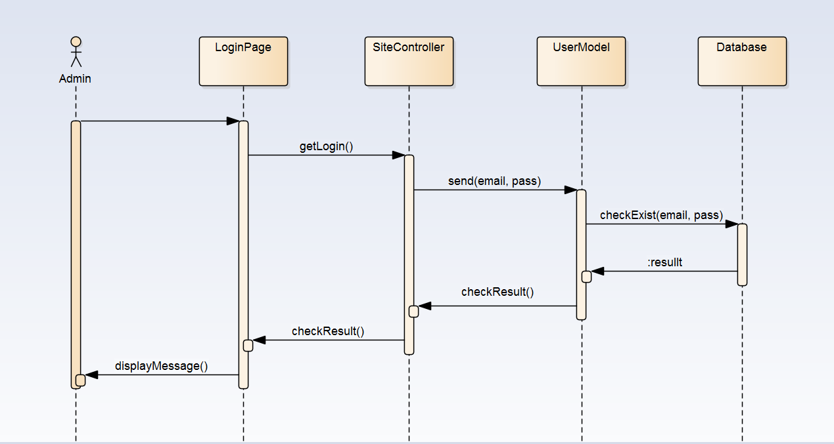

##### **4.7.1.2 Set member as Admin**

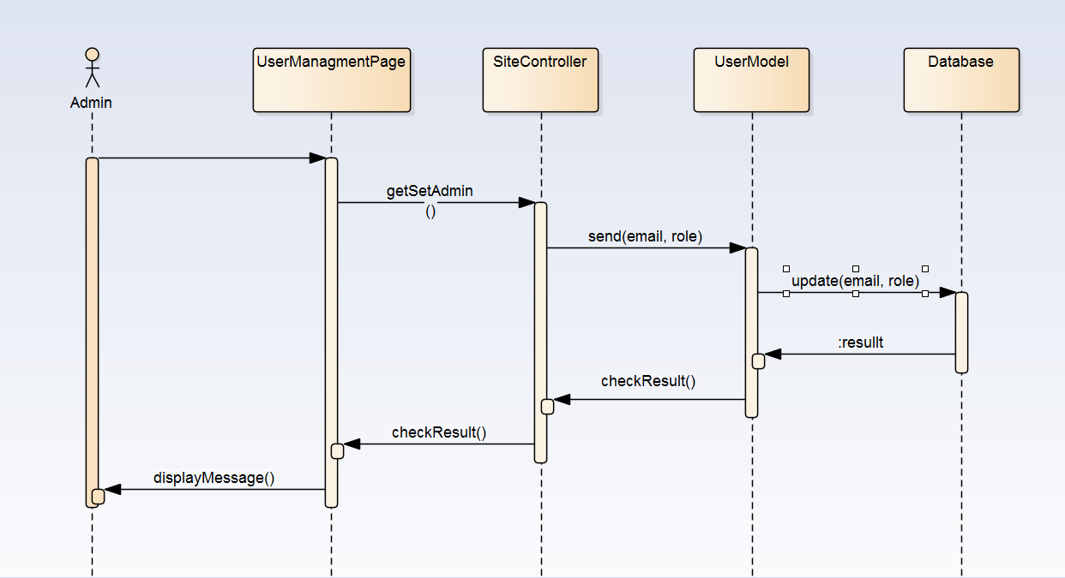

##### **4.7.1.1 View report list**

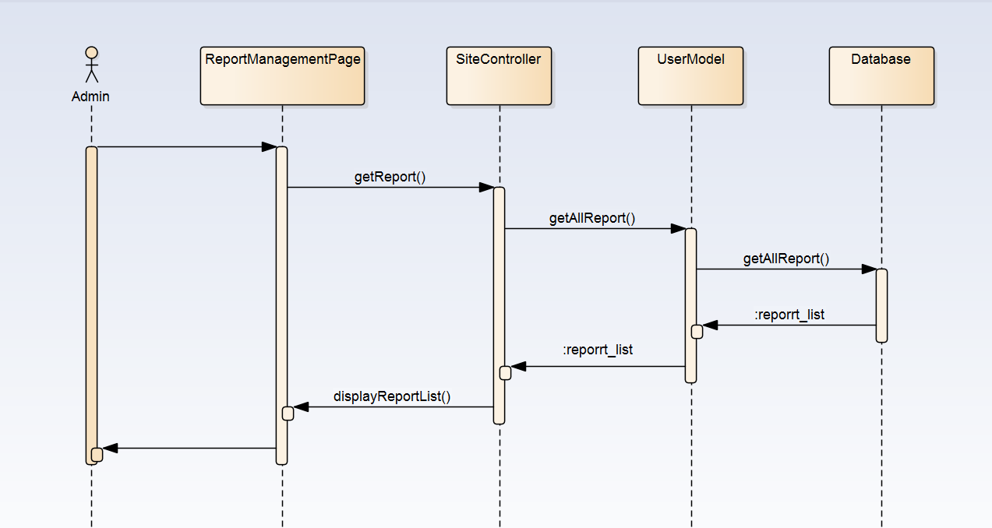

### **4.7.2 Mobile Application**

##### **4.7.2.1 Login**

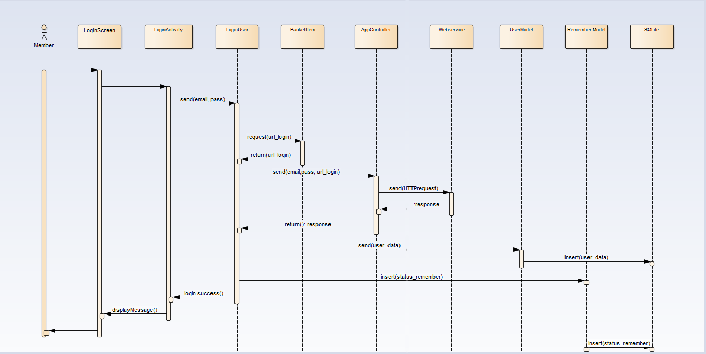

##### **4.7.2.1 Comment**

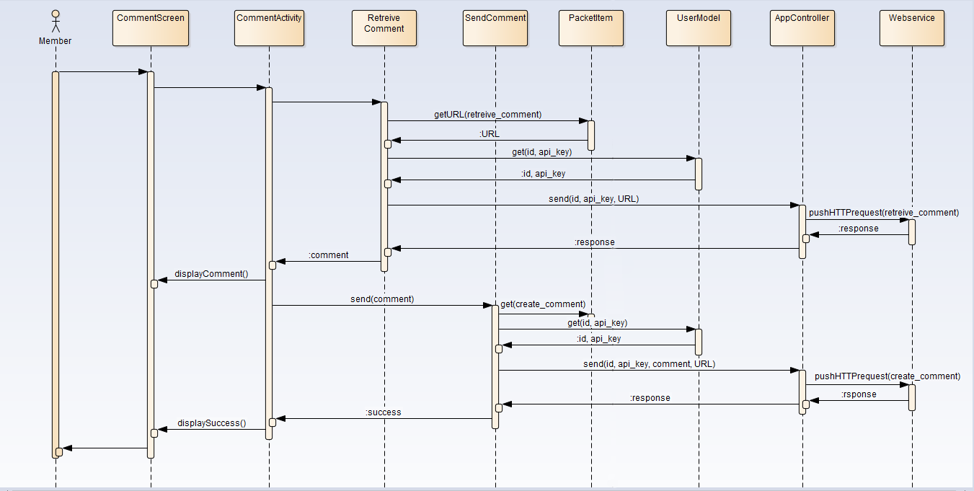

##### **4.7.2.1 Report Recipe**

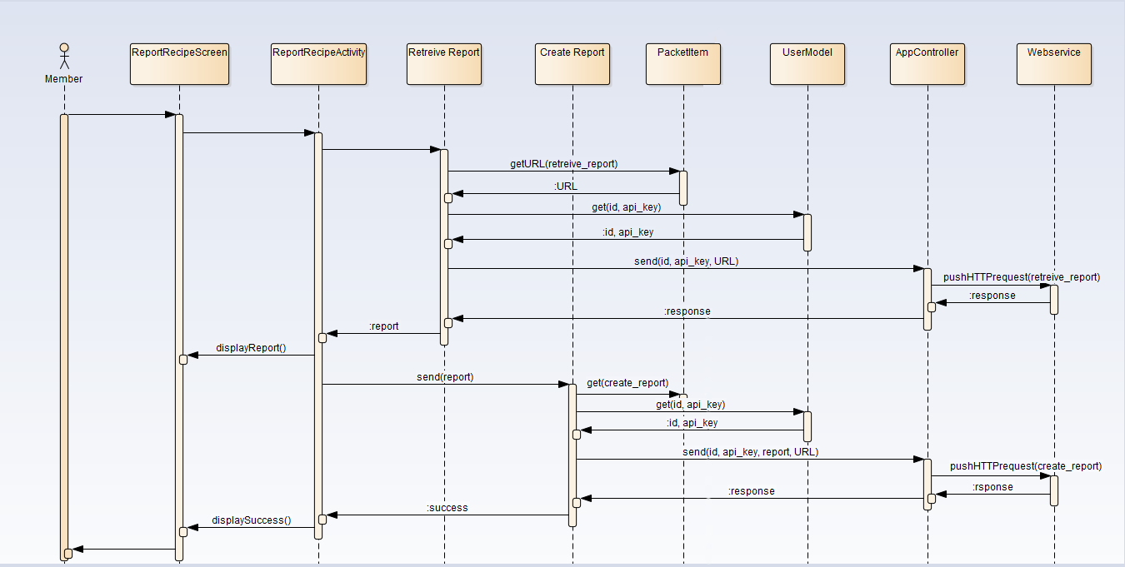

## **4.8 User Interface Design**

### **4.8.1 Web Application**

#### **Login Page**

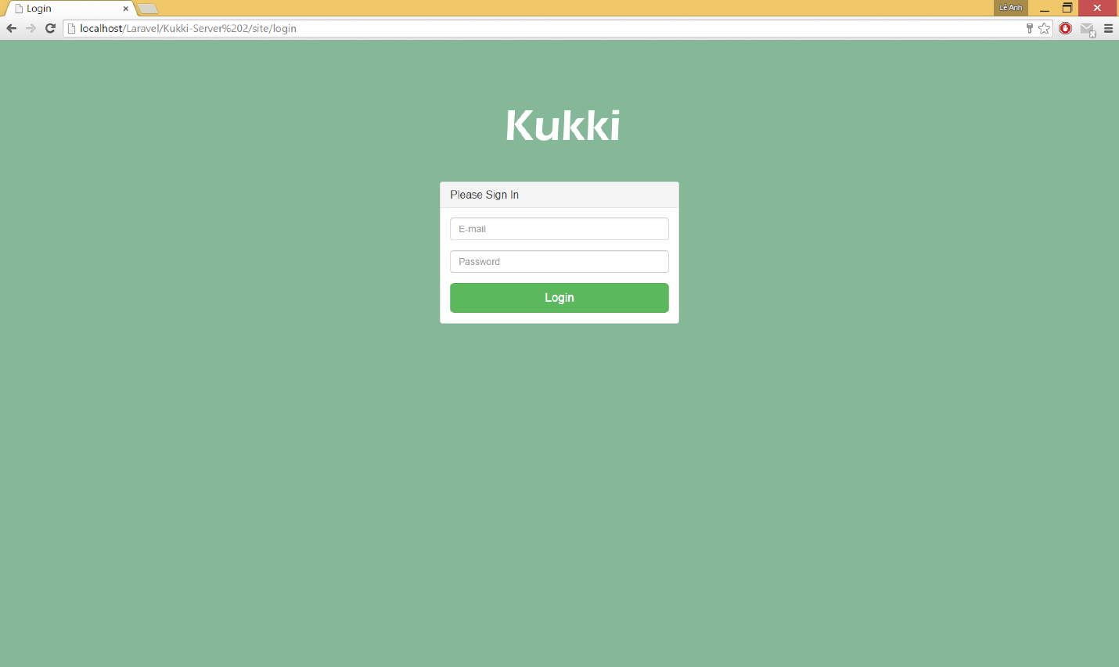

**Figure 4.8.1**: Login Page

|  |  |  |
| --- | --- | --- |
| **Element** | **Type** | **Description** |
| “Email” input | Text | Enter user email |
| “Password” input | Text | Enter user password |
| Login button | Button | Button for logging in system |

#### **Home Page or Member Management Page**

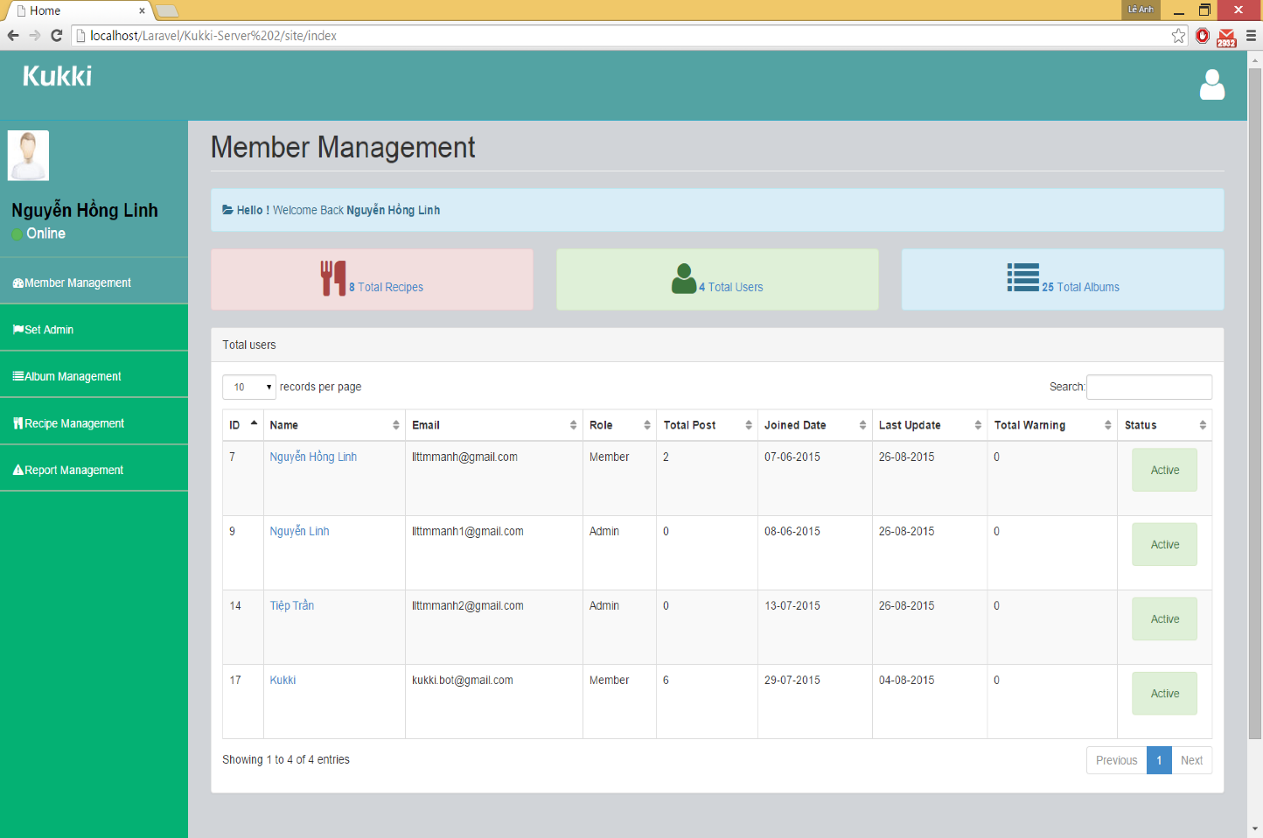

**Figure 4.8.2**: Member Management Page

|  |  |  |
| --- | --- | --- |
| **Element** | **Type** | **Description** |
| Member Management Text | Text | Show name of page |
| Message Text | Text | Show greeting message |
| Total Recipes Text | Text | Show total recipes in Kukki System |
| Total Users Text | Text | Show total users in Kukki System |
| Total Albums Text | Text | Show total album in Kukki System |
| Total Users table | Table | Show list of member in Kukki System |
| ID Text | Text | Show ID of member |
| Name of member link | Hyperlink | Direct to User Profile Page |
| Role Text | Text | Show role of member |
| Joined Date Text | Text | Show the first time user register |
| Last Update Text | Text | Show the last time user update |
| Total Warning Text | Text | The number of email warning user received from admin |
| “Active/Deactive” button | Button | Button to ban user |
| “Set Admin” Link | Hyperlink | Direct to Set Admin Page |
| “Album Management” Link | Hyperlink | Direct to Album Management Page |
| “Recipe Management” Link | Hyperlink | Direct to Recipe Management Page |
| “Report Management” Link | Hyperlink | Direct to Report Management Page |

#### **User Profile Page (with list of recipe)**

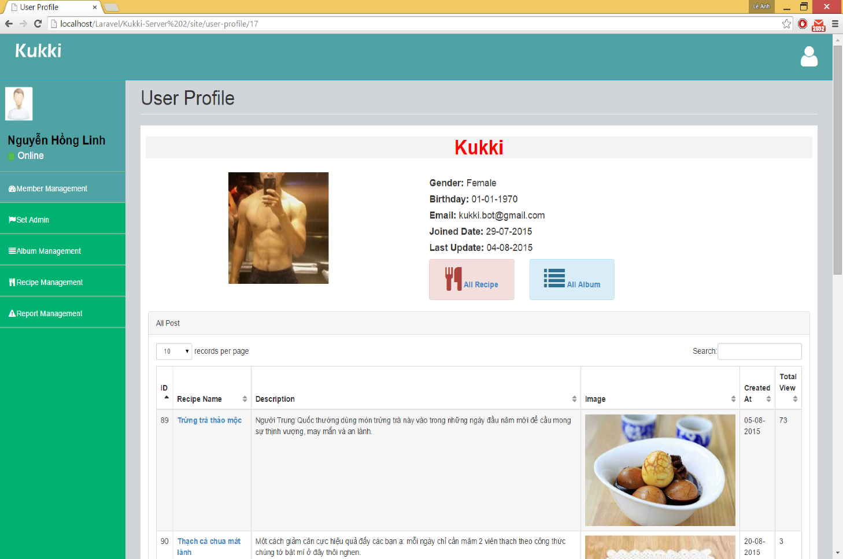

**Figure 4.8.3**: User Profile Page with list of recipes

|  |  |  |
| --- | --- | --- |
| **Element** | **Type** | **Description** |
| User Profile Text | Text | Show name of page |
| User name Text | Text | Show name of user |
| User avatar Image | Image | Show Image of user |
| Gender Text | Text | Show gender of user |
| Birthday Text | Text | Show birthday of user |
| Email Text | Text | Show email of user |
| Join Date Text | Text | Show the first time user register |
| Last Update Text | Text | Show the last time user update |
| ID Text | Text | Show ID of recipe |
| Name of Recipe Link | Hyperlink | Direct to Recipe Detail Page |
| Description Text | Text | Show description of recipe |
| Cover Image | Text | Show cover image of recipe |
| Created At Text | Text | Show the time recipe created |
| Total View | Text | Show total view of recipe |
| “All Recipes” Button | Button | Direct to User Profile Page with list of recipes |
| “All Albums” Button | Button | Direct to User Profile Page with list of albums |
| “Member Management” Link | Hyperlink | Direct to Member Management Page |
| “Set Admin” Link | Hyperlink | Direct to Set Admin Page |
| “Album Management” Link | Hyperlink | Direct to Album Management Page |
| “Recipe Management” Link | Hyperlink | Direct to Recipe Management Page |
| “Report Management” Link | Hyperlink | Direct to Report Management Page |

#### **User Profile Page (with list of albums)**

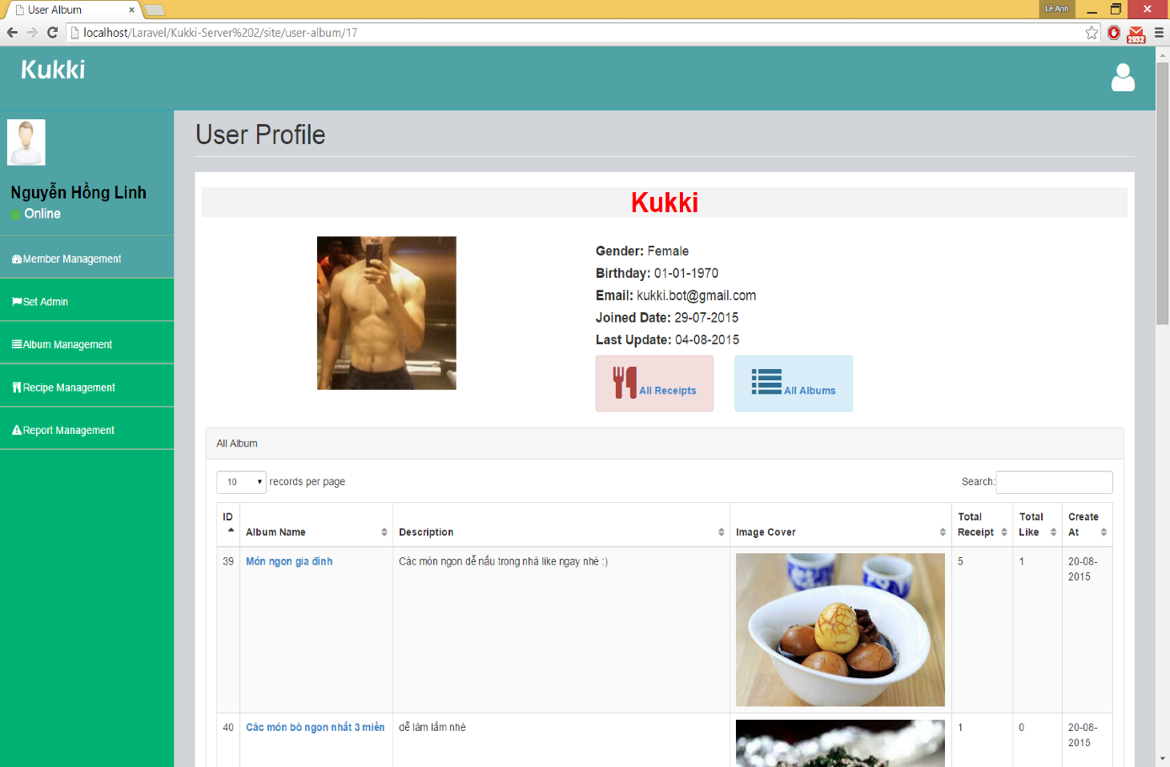

**Figure 4.8.4**: User Profile Page with list of albums

|  |  |  |
| --- | --- | --- |
| **Element** | **Type** | **Description** |
| User Profile Text | Text | Show name of page |
| User name Text | Text | Show name of user |
| User avatar Image | Image | Show Image of user |
| Gender Text | Text | Show gender of user |
| Birthday Text | Text | Show birthday of user |
| Email Text | Text | Show email of user |
| Join Date Text | Text | Show the first time user register |
| Last Update Text | Text | Show the last time user update |
| ID Text | Text | Show ID of recipe |
| Name of Album Link | Hyperlink | Direct to Album Page |
| Description Text | Text | Show description of recipe |
| Cover Image | Text | Show cover image of recipe |
| Created At Text | Text | Show the time recipe created |
| Total View | Text | Show total view of recipe |
| “All Recipes” Button | Button | Direct to User Profile Page with list of recipes |
| “All Albums” Button | Button | Direct to User Profile Page with list of albums |
| “Member Management” Link | Hyperlink | Direct to Member Management Page |
| “Set Admin” Link | Hyperlink | Direct to Set Admin Page |
| “Album Management” Link | Hyperlink | Direct to Album Management Page |
| “Recipe Management” Link | Hyperlink | Direct to Recipe Management Page |
| “Report Management” Link | Hyperlink | Direct to Report Management Page |

#### **Set Admin**

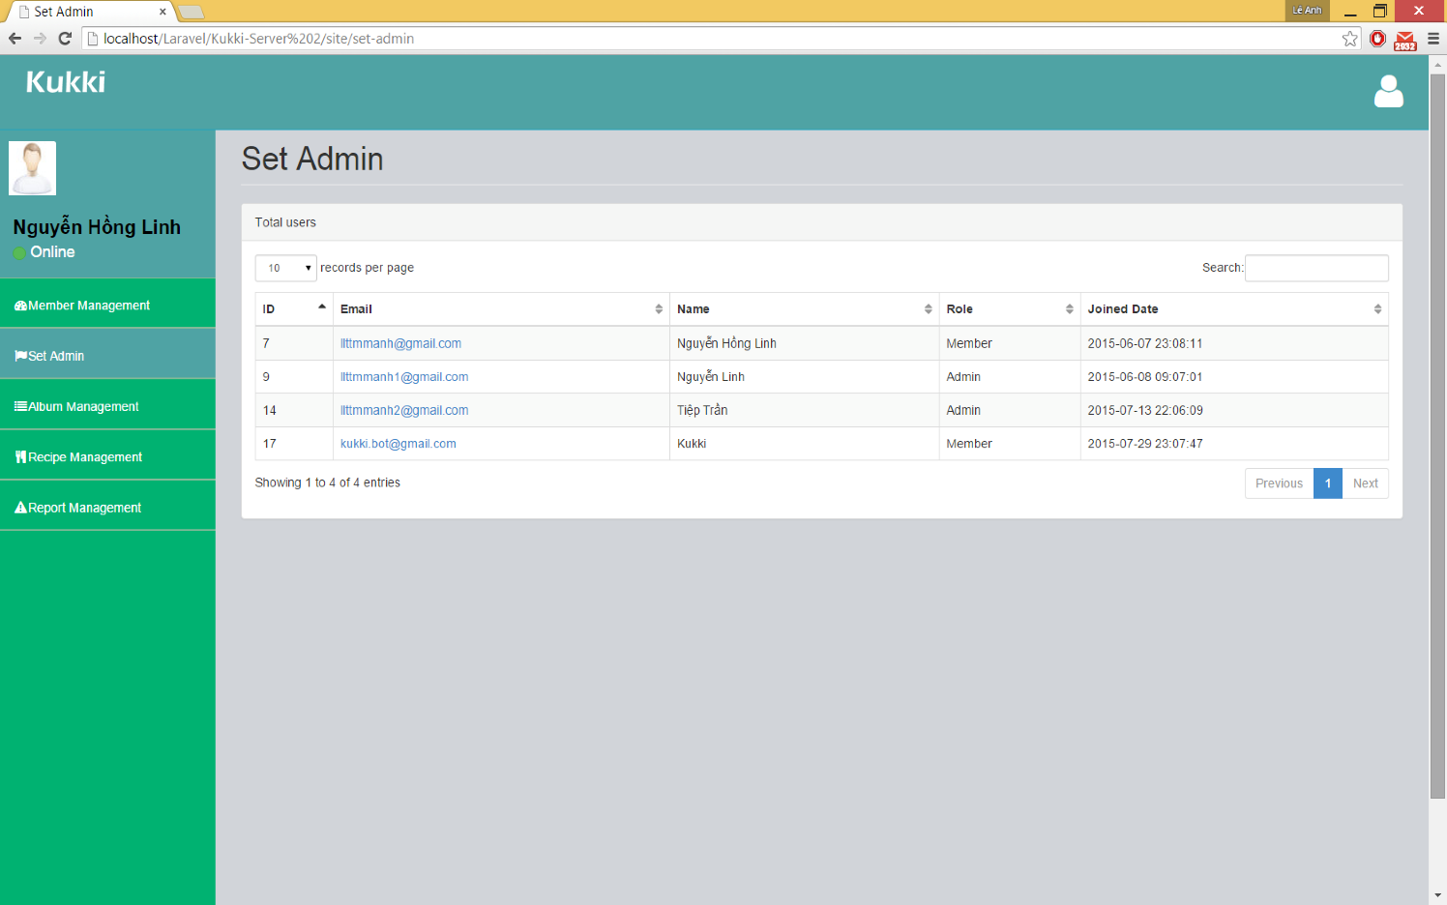

**Figure 4.8.5**: Set Admin

|  |  |  |
| --- | --- | --- |
| **Element** | **Type** | **Description** |
| Set Admin Text | Text | Show name of page |
| Total User Table | Table | Show list of user in Kukki System |
| ID Text | Text | Show ID of user |
| Email of user Link | Hyperlink | Link to set user |
| Name Text | Text | Show name of user |
| Role Text | Text | Show Role of user |
| Joined Date Text | Text | Show the date user registered |
| “All Recipes” Button | Button | Direct to User Profile Page with list of recipes |
| “All Albums” Button | Button | Direct to User Profile Page with list of albums |
| “Member Management” Link | Hyperlink | Direct to Member Management Page |
| “Set Admin” Link | Hyperlink | Direct to Set Admin Page |
| “Album Management” Link | Hyperlink | Direct to Album Management Page |
| “Recipe Management” Link | Hyperlink | Direct to Recipe Management Page |
| “Report Management” Link | Hyperlink | Direct to Report Management Page |

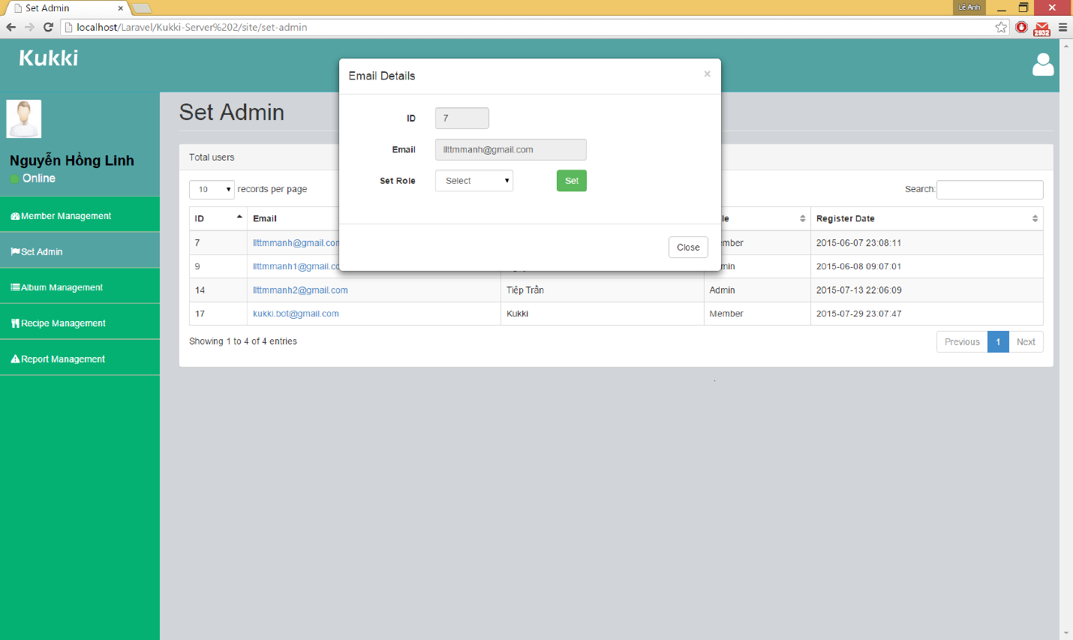

**Figure 4.8.6**: Set Admin Popup

|  |  |  |
| --- | --- | --- |
| **Element** | **Type** | **Description** |
| Email Detail Text | Text | Show name of popup |
| ID Text | Text | Show ID label |
| ID Input | Text | Show ID of user. (Lock) |
| Email Text | Text | Show Email label |
| Email Input | Text | Show email of user (Lock) |
| Set Role Text | Text | Show Set Role label |
| Set Role Drop Down List | Drop Down List | Show 2 kind of role can be set. “Admin” or “Member”. |
| Set Button | Button | To set role for member |
| Close Button | Button | Close Popup |

#### **Recipe Management**

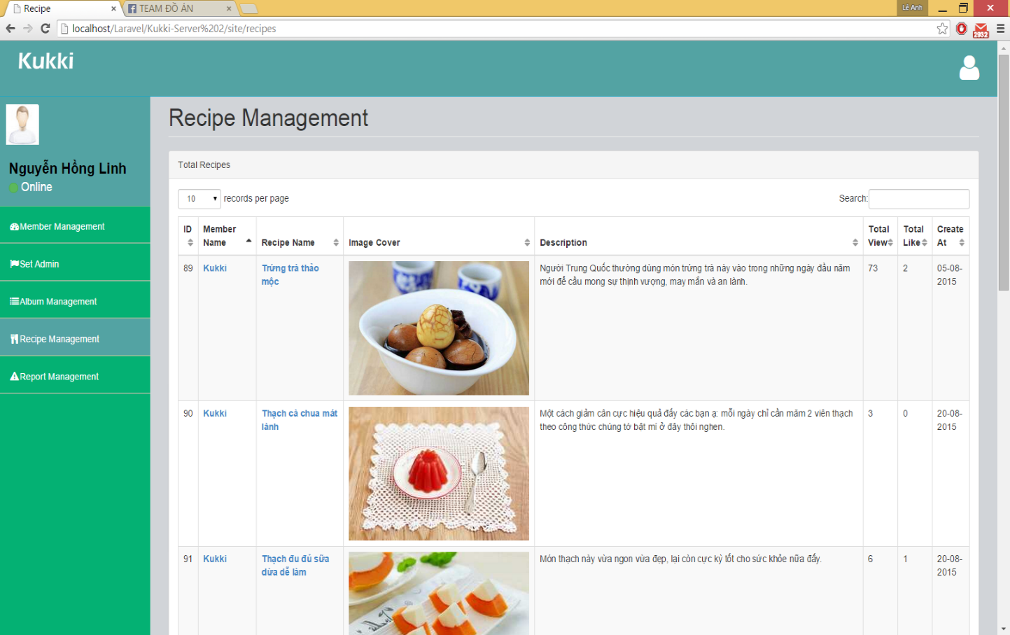

|  |  |  |
| --- | --- | --- |
| **Element** | **Type** | **Description** |
| Recipe Management | Text | Show name of page |
| Total Recipes Table | Table | Show list of recipes in Kukki System |
| ID Text | Text | Show ID of member |
| Member Name Link | Hyperlink | Direct to User Profile Page |
| Recipe Name Link | Hyperlink | Direct to Recipe Detail Page |
| Cover Image | Image | Show Image cover of recipe |
| Description Text | Text | Show description of recipe |
| Total Views Text | Text | Show total views of recipe |
| Total Likes Text | Text | Show total likes of recipe |
| Create At Text | Text | Show the date recipe created |
| “All Recipes” Button | Button | Direct to User Profile Page with list of recipes |
| “All Albums” Button | Button | Direct to User Profile Page with list of albums |
| “Member Management” Link | Hyperlink | Direct to Member Management Page |
| “Set Admin” Link | Hyperlink | Direct to Set Admin Page |
| “Album Management” Link | Hyperlink | Direct to Album Management Page |
| “Recipe Management” Link | Hyperlink | Direct to Recipe Management Page |
| “Report Management” Link | Hyperlink | Direct to Report Management Page |

#### **Recipe Detail**

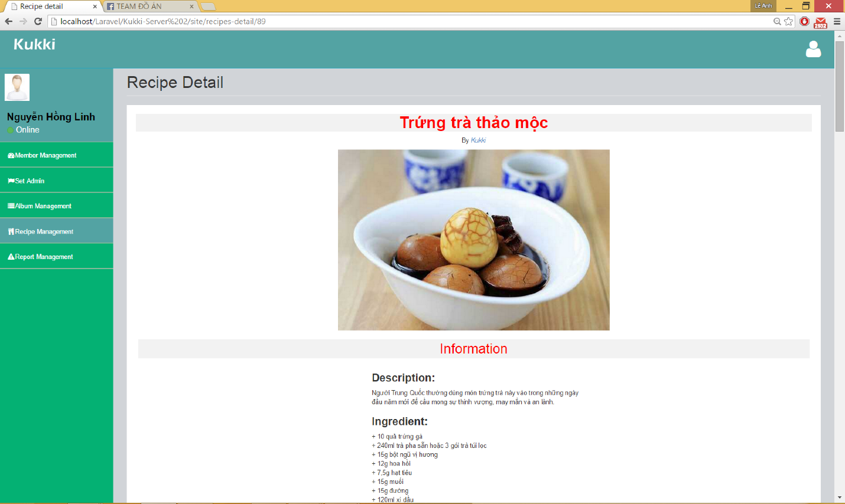

**Figure 4.8.8**: Recipe Detail

|  |  |  |
| --- | --- | --- |
| **Element** | **Type** | **Description** |
| Recipe Detail Text | Text | Show name of page |
| Name of Recipe Text | Table | Show name of recipe |
| Member name Link | Hyperlink | Direct to User Profile Page |
| “All Recipes” Button | Button | Direct to User Profile Page with list of recipes |
| “All Albums” Button | Button | Direct to User Profile Page with list of albums |
| “Member Management” Link | Hyperlink | Direct to Member Management Page |
| “Set Admin” Link | Hyperlink | Direct to Set Admin Page |
| “Album Management” Link | Hyperlink | Direct to Album Management Page |
| “Recipe Management” Link | Hyperlink | Direct to Recipe Management Page |
| “Report Management” Link | Hyperlink | Direct to Report Management Page |

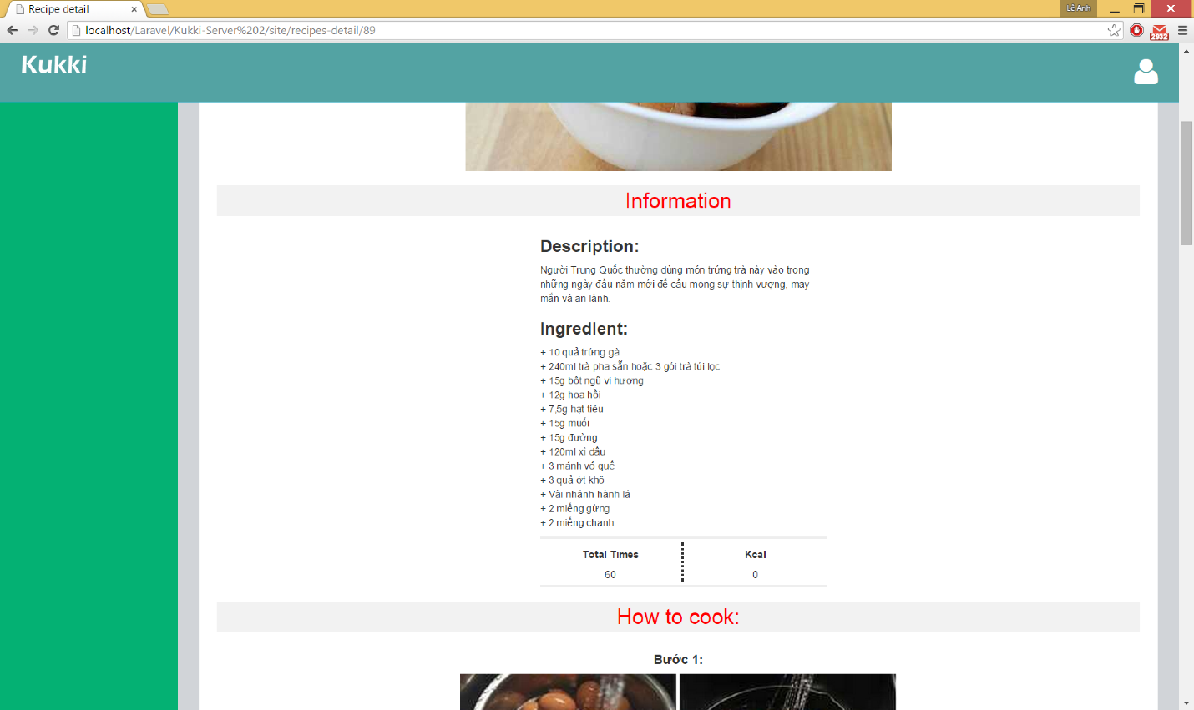

**Figure 4.8.9**: Recipe Detail

|  |  |  |
| --- | --- | --- |
| **Element** | **Type** | **Description** |
| Information Text | Text | Show information part |
| Description Text | Text | Show description of recipe |
| Ingredient Text | Text | Show Ingredient of recipe |
| Total Time Text | Text | Show total time to cook |
| Kcal | Text | Show the Kilo Calories of the food |

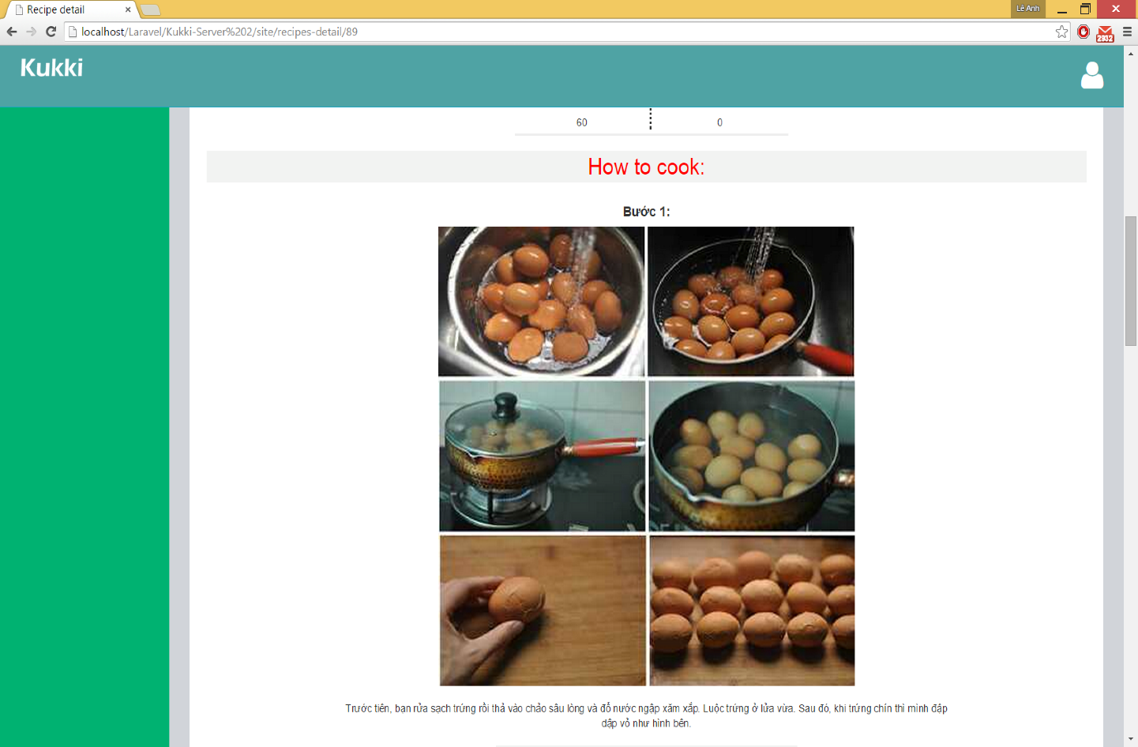

**Figure 4.8.10**: Recipe Detail

|  |  |  |
| --- | --- | --- |
| **Element** | **Type** | **Description** |
| How to cook Text | Text | Show the how to cook part |
| Step Text | Text | Show the number of step in recipe |
| Step Cover Image | Text | Show the image of each step |
| Description Text | Text | Show the guild to help people cook |

#### **Album Management**

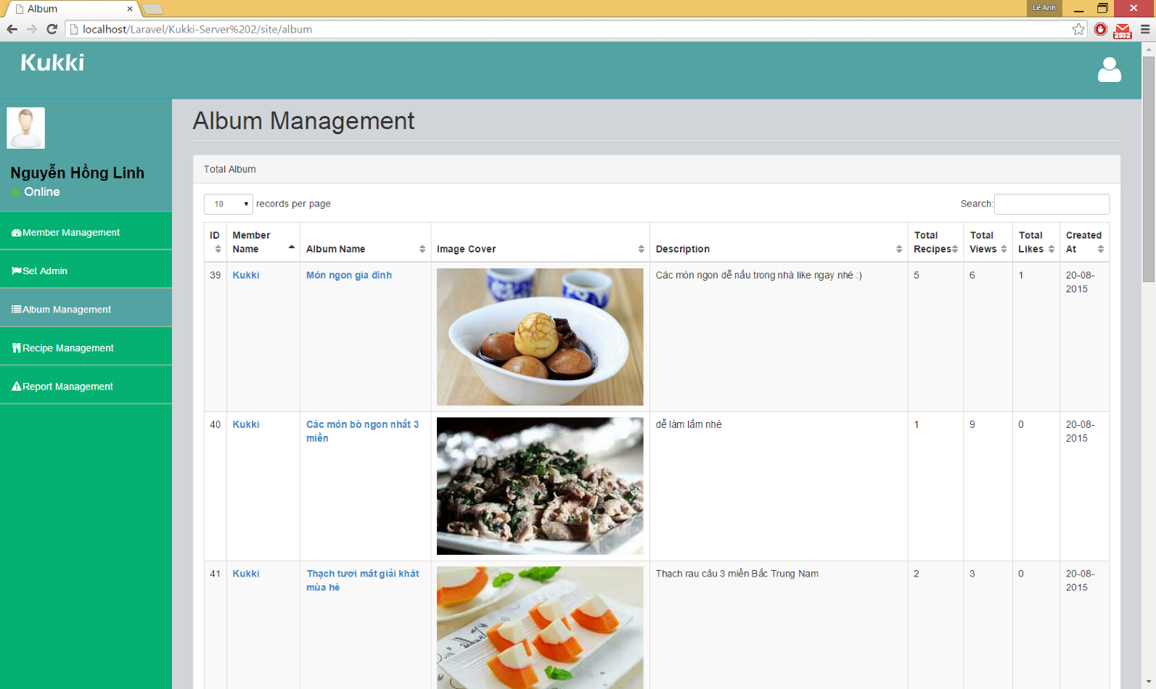

**Figure 4.8.11**: Album Management

|  |  |  |
| --- | --- | --- |
| **Element** | **Type** | **Description** |
| Album Management | Text | Show name of page |
| Total Album Table | Table | Show list of albums in Kukki System |
| ID Text | Text | Show ID of member |
| Member Name Link | Hyperlink | Direct to User Profile Page |
| Album Name Link | Hyperlink | Direct to Album Detail Page |
| Cover Image | Image | Show Image cover of album |
| Description Text | Text | Show description of album |
| Total Recipes | Text | Show total recipes in album |
| Total Views Text | Text | Show total views of album |
| Total Likes Text | Text | Show total likes of album |
| Create At Text | Text | Show the date recipe created |
| “All Recipes” Button | Button | Direct to User Profile Page with list of recipes |
| “All Albums” Button | Button | Direct to User Profile Page with list of albums |
| “Member Management” Link | Hyperlink | Direct to Member Management Page |
| “Set Admin” Link | Hyperlink | Direct to Set Admin Page |
| “Album Management” Link | Hyperlink | Direct to Album Management Page |
| “Recipe Management” Link | Hyperlink | Direct to Recipe Management Page |
| “Report Management” Link | Hyperlink | Direct to Report Management Page |
|  |  |  |

#### **Album Detail**

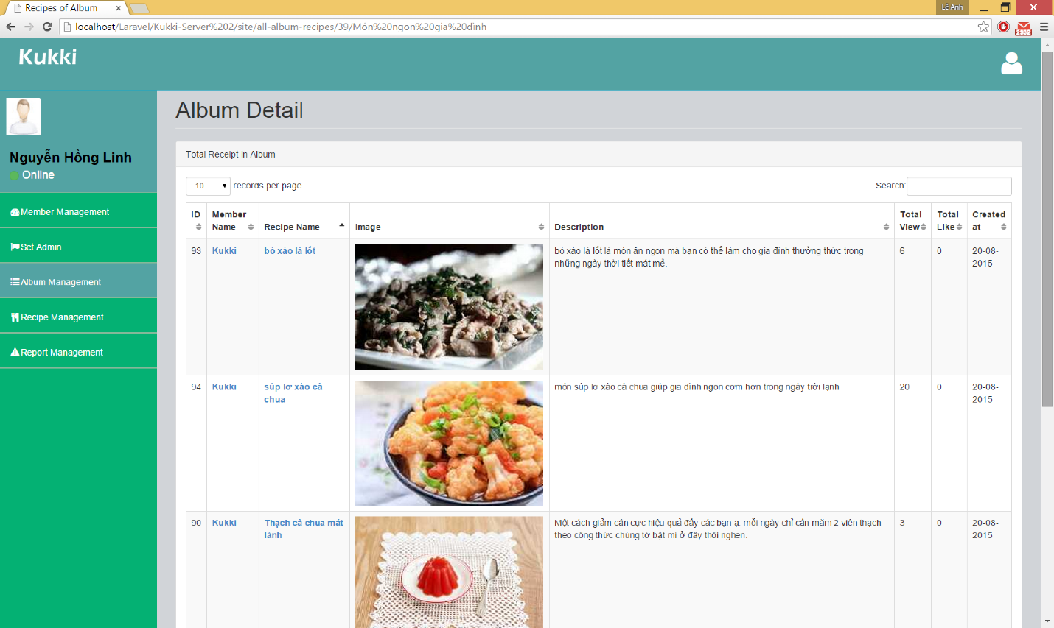

**Figure 4.8.12**: Album Detail

|  |  |  |
| --- | --- | --- |
| **Element** | **Type** | **Description** |
| Album Detail | Text | Show name of page |
| Total Recipes in album Table | Table | Show list of recipes in album |
| ID Text | Text | Show ID of member |
| Member Name Link | Hyperlink | Direct to User Profile Page |
| Recipe Name Link | Hyperlink | Direct to Recipe Detail Page |
| Cover Image | Image | Show Image cover of recipe |
| Description Text | Text | Show description of recipe |
| Total Views Text | Text | Show total views of recipe |
| Total Likes Text | Text | Show total likes of recipe |
| Create At Text | Text | Show the date recipe created |
| “All Recipes” Button | Button | Direct to User Profile Page with list of recipes |
| “All Albums” Button | Button | Direct to User Profile Page with list of albums |
| “Member Management” Link | Hyperlink | Direct to Member Management Page |
| “Set Admin” Link | Hyperlink | Direct to Set Admin Page |
| “Album Management” Link | Hyperlink | Direct to Album Management Page |
| “Recipe Management” Link | Hyperlink | Direct to Recipe Management Page |
| “Report Management” Link | Hyperlink | Direct to Report Management Page |

#### **Report Management**

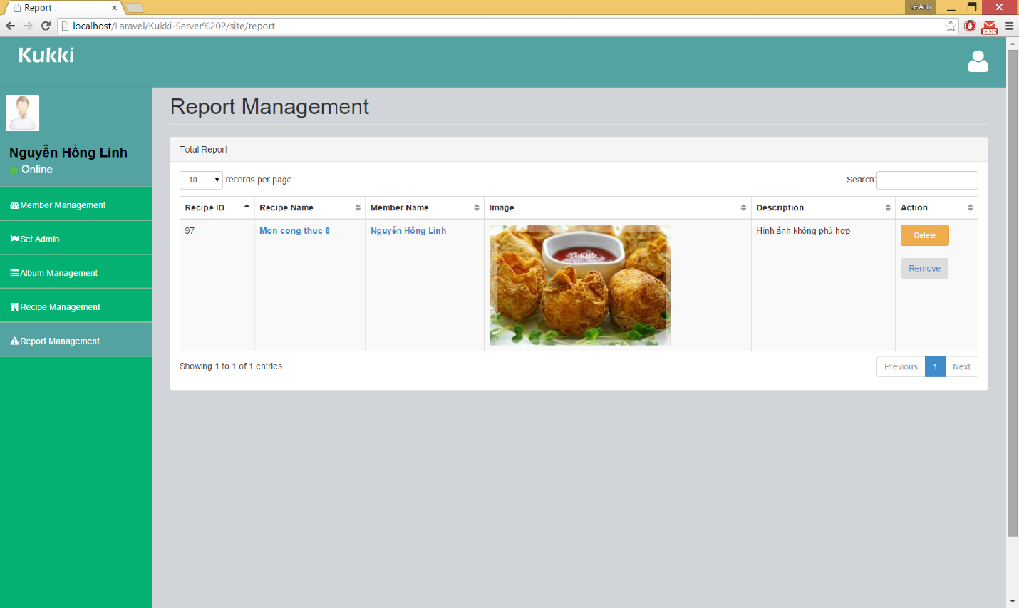

**Figure 4.8.13**: Report Management

|  |  |  |
| --- | --- | --- |
| **Element** | **Type** | **Description** |
| Report Management | Text | Show name of page |
| Total report Table | Table | Show list of report |
| ID Text | Text | Show ID of recipe |
| Recipe Name Link | Hyperlink | Direct to Recipe Detail Page |
| Member Name Link | Hyperlink | Direct to User Profile Page |
| Cover Image | Image | Show Image cover of recipe |
| Description Text | Text | Show description of report for this recipe |
| Delete Button | Button | Delete Recipe, Report and Send warning email to member. |
| Remove Button | Button | Delete Report in the table |
| “All Recipes” Button | Button | Direct to User Profile Page with list of recipes |
| “All Albums” Button | Button | Direct to User Profile Page with list of albums |
| “Member Management” Link | Hyperlink | Direct to Member Management Page |
| “Set Admin” Link | Hyperlink | Direct to Set Admin Page |
| “Album Management” Link | Hyperlink | Direct to Album Management Page |
| “Recipe Management” Link | Hyperlink | Direct to Recipe Management Page |
| “Report Management” Link | Hyperlink | Direct to Report Management Page |

### **4.8.2 Mobile Application**

#### **Home screen**

|  |  |
| --- | --- |
| ../Google%20Drive/Dropbox/Kukki%20Document/Graphics/PSDs/Home.jpg | ../Google%20Drive/Dropbox/Kukki%20Document/Graphics/PSDs/Home.jpg |

|  |  |  |
| --- | --- | --- |
| **Element** | **Type** | **Description** |
| Menu icon | Button | Button to show menu side bar |
| Kukki logo | Image view | Logo image |
| Add icon | Button | Button to show create new recipe screen |
| Tất cả | Button | Button for showing list of all recipes |
| Quan tâm | Button | Button for showing list of recipes posted by people member followed |
| Sinh tố chanh dưa hấu | Label | Clickable to show detail of recipe |
| Minh Tri Do | Label | Username |
| Time icon | Image view | Show time of finish this recipe |
| 20 phút | Label | Show time of finish this recipe |
| Image sinh tố chanh dưa hấu | Image view | Clickable image view to show detail of recipe |
| Like icon | Button | Clickable button to like/unlike |
| Comment icon | Button | Clickable button for showing comment screen |
| View icon | Image view | Show times members view this recipe |
| Kcal icon | Image view | Show amount of kcal in a recipe |
| Search icon | Button | Clickable button for showing searching screen |
| User profile picture | Image view | Clickable image to change profile picture |
| Trang chủ icon | Button | Clickable button for showing home screen |
| Cá nhân icon | Button | Clickable button for showing profile screen |
| Thông báo icon | Button | Clickable button for showing notification screen |
| Ghi chú nguyên liệu icon | Button | Clickable button for showing shopping list screen |
| Lịch đảm đang icon | Button | Clickable button for showing minder screen |
| Công thức đã tải về icon | Button | Clickable button for showing list of saved recipes |
| Nháp icon | Button | Clickable button for showing draft screen |
| Đăng xuất icon | Button | Clickable button for logging out |

#### **Detail screen**

|  |  |
| --- | --- |
| ../Google%20Drive/Dropbox/Kukki%20Document/Graphics/PSDs/Home.jpg | ../Google%20Drive/Dropbox/Kukki%20Document/Graphics/PSDs/Home.jpg |

|  |  |  |
| --- | --- | --- |
| **Element** | **Type** | **Description** |
| Back icon | Button | Button to show home screen |
| Save icon | Button | Button to save recipe |
| More option icon | Button | Button to show more options |
| Tất cả | Button | Button for showing list of all recipes |
| Minh Tri Do | Label | Clickable textview to show profile page |
| Nguyên liệu button | Button | Clickable button to show ingredients of recipe |
| Chế biến button | Button | Clickable button to show process of recipe |
| Time icon | Image view | Show time of finish this recipe |
| Like icon | Button | Clickable button to like/unlike |
| Comment icon | Button | Clickable button for showing comment screen |
| View icon | Image view | Show times members view this recipe |
| Kcal icon | Image view | Show amount of kcal in a recipe |
| + Tất cả vào ghi chú | Button | Clickable button to add ingredients to shopping list |

#### **Search screen**

|  |  |
| --- | --- |
| ../Google%20Drive/Dropbox/Kukki%20Document/Graphics/PSDs/Home.jpg | ../Google%20Drive/Dropbox/Kukki%20Document/Graphics/PSDs/Home.jpg |

|  |  |  |
| --- | --- | --- |
| **Element** | **Type** | **Description** |
| Back icon | Button | Button to show home screen |
| Món ăn | Dropdown list | Dropdown list to show “Món ăn, người dung, bộ sưu tập” |
| Chạm để bắt đầu tìm kiếm | Textfield | Textfield to enter keyword to search |
| Tìm thấy 35 món ăn | Label | Textview to show number of results |
| Các món ít béo label | Label | Clickable textview to show collection of recipe |
| Like icon | Button | Clickable button to like/unlike |

#### **Profile screen**

|  |  |
| --- | --- |
| ../Google%20Drive/Dropbox/Kukki%20Document/Graphics/PSDs/Home.jpg | ../Google%20Drive/Dropbox/Kukki%20Document/Graphics/PSDs/Home.jpg |

|  |  |  |
| --- | --- | --- |
| **Element** | **Type** | **Description** |
| Back icon | Button | Button to show home screen |
| Chỉnh sửa button | Button | Button to show edit profile screen |
| Quan tâm label | Label | Clickable textview to show list of people followed by member |
| Quan tâm bạn label | Label | Textview to show number of people follow member |
| Công thức button | Button | Clickable button to show list of recipes |
| Bộ sưu tập button | Button | Clickable button to show collections of recipes |
| Like icon | Button | Clickable button to like/unlike |
| Comment icon | Button | Clickable button for showing comment screen |
| View icon | Image view | Show times members view this recipe |
| Kcal icon | Image view | Show amount of kcal in a recipe |
| Add icon | Button | Button to show create new recipe screen |
| Tên hiển thị textfield | Edit text | Edit username |
| Miêu tả textfield | Edit text | Edit desciption |
| Mật khẩu cũ textfield | Edit text | Enter old password |
| Mật khẩu mới textfield | Edit text | Enter new password |
| Nhập lại mật khẩu mới textfield | Edit text | Enter confirm new password |
| Done button | Button | Button to save new information |

#### **Notification screen**

|  |  |
| --- | --- |
|  |  |

|  |  |  |
| --- | --- | --- |
| **Element** | **Type** | **Description** |
| Kritijan label | Textview | Clickable textview to show user’s profile |
| Image of recipe | Image view | Cliackable image view to show detail of recipe |

#### **Shopping list screen**

|  |  |
| --- | --- |
|  |  |

|  |  |  |
| --- | --- | --- |
| **Element** | **Type** | **Description** |
| 300g thịt lợn | Button | Button to check/uncheck |
| Delete icon | Button | Button to delete list |

#### **Reminder screen**

|  |  |
| --- | --- |
|  |  |

|  |  |  |
| --- | --- | --- |
| **Element** | **Type** | **Description** |
| Option icon | Button | Delete reminder |
| Recipe image | Image view | Image of recipe |
| Cơm rang thập cẩm | Label | Name of recipe |
| 29/06 – 18:00 label | Label | Time to reminder |
| Cả nhà ăn cùng nhau label | Label | Note for reminer |

#### **Saved screen**

|  |  |  |  |  |
| --- | --- | --- | --- | --- |
|  | | | |  |
| **Element** | **Type** | **Description** | |
| Menu icon | Button | Button to show menu side bar | |
| Search icon | Button | Clickable button for showing searching screen | |
| Minh Tri Do | Label | Username | |
| Time icon | Image view | Show time of finish this recipe | |
| 20 phút | Label | Show time of finish this recipe | |
| Image sinh tố chanh dưa hấu | Image view | Clickable image view to show detail of recipe | |
| Like icon | Button | Clickable button to like/unlike | |
| Comment icon | Button | Clickable button for showing comment screen | |
| View icon | Image view | Show times members view this recipe | |
| Kcal icon | Image view | Show amount of kcal in a recipe | |

#### **Draft screen**

|  |  |
| --- | --- |
|  |  |

Figure 4-5: Draft Screen

|  |  |  |
| --- | --- | --- |
| **Element** | **Type** | **Description** |
| Menu icon | Button | Button to show menu side bar |
| Search icon | Button | Clickable button for showing searching screen |
| Minh Tri Do | Label | Username |
| Time icon | Image view | Show time of finish this recipe |
| 20 phút | Label | Show time of finish this recipe |
| Image sinh tố chanh dưa hấu | Image view | Clickable image view to show detail of recipe |
| Like icon | Button | Clickable button to like/unlike |
| Comment icon | Button | Clickable button for showing comment screen |
| View icon | Image view | Show times members view this recipe |
| Kcal icon | Image view | Show amount of kcal in a recipe |

#### **Create new recipe screen**

|  |  |
| --- | --- |
|  |  |

|  |  |  |
| --- | --- | --- |
| **Element** | **Type** | **Description** |
| Back icon | Button | Button to show home screen |
| Done icon | Button | Button to post new recipe |
| Cancel icon | Button | Clickable button for showing cancel upload |
| Tên công thức edit text | Edit text | Edit name of recipe |
| Miêu tả | Edit text | Edit description of recipe |
| Nguyên liệu | Edit text | Add ingredient detail |
| Add button | Button | Add ingredient and step of process |
| Camera icon | Image view | Open camera app to take picture |
| Image icon | Image view | Open gallery to choose a picture |
| Phong cách ẩm thực list | Dropdown list | Dropdown list to show style of making recipe |
| Đặc sản vùng miền list | Dropdown list | Dropdown list to show region recipe belongs |

#### **Collection of recipes screen**

|  |  |
| --- | --- |
|  |  |

Figure 4-5: Collection of recipes Screen

|  |  |  |
| --- | --- | --- |
| **Element** | **Type** | **Description** |
| Back icon | Button | Button to show home screen |
| Add icon | Button | Button to show create new recipe screen |
| Search icon | Button | Clickable button for showing searching screen |
| Minh Tri Do | Label | Username |
| Like icon | Button | Clickable button to like/unlike |
| Sinh tố dễ làm label | Label | Clickable label for showing album |
| Thêm bộ sưu tập button | Button | Clickable to add more collection of recipes |

#### **Detail of collection of recipe screen**

|  |  |
| --- | --- |
|  |  |

|  |  |  |
| --- | --- | --- |
| **Element** | **Type** | **Description** |
| Back icon | Button | Button to show home screen |
| Minh Tri Do | Label | Username |
| Time icon | Image view | Show time of finish this recipe |
| 20 phút | Label | Show time of finish this recipe |
| Image sinh tố chanh dưa hấu | Image view | Clickable image view to show detail of recipe |
| Like icon | Button | Clickable button to like/unlike |
| Comment icon | Button | Clickable button for showing comment screen |
| View icon | Image view | Show times members view this recipe |
| Kcal icon | Image view | Show amount of kcal in a recipe |

#### **Login screen**

|  |  |
| --- | --- |
|  |  |

|  |  |  |
| --- | --- | --- |
| **Element** | **Type** | **Description** |
| Tên đăng nhập text field | Edit text | Edit text: enter email registered |
| Mật khẩu text field | Edit text | Edit text: enter password |
| Ghi nhớ check box | Check box | Check to remember email and password |
| Đăng kí button | Button | Clickable button for showing register screen |
| Đăng nhập button | Button | Clickable button for logging in system |
| Quên mật khẩu label | Label | Clickable label for showing forget password screen |
| Xem công thức đã tải về label | Label | Clickable label for showing saved recipe screen |

#### **Register screen**

|  |  |
| --- | --- |
|  |  |

|  |  |  |
| --- | --- | --- |
| **Element** | **Type** | **Description** |
| Back icon | Button | Button to show home screen |
| Done button | Button | Button to submit |
| Mật khẩu text field | Edit text | Edit text: enter password |
| Nhập lại mật khẩu text field | Edit text | Edit text: enter confirm password |
| Email text field | Edit text | Edit text: enter email |
| Username text field | Edit text | Edit text: enter username |

#### **Forget screen**

|  |  |
| --- | --- |
|  |  |

|  |  |  |
| --- | --- | --- |
| **Element** | **Type** | **Description** |
| Back icon | Button | Button to show home screen |
| Done button | Button | Button to submit |
| Email text field | Edit text | Edit text: enter email |

#### **Forget screen 2**

|  |  |
| --- | --- |
|  |  |

|  |  |  |
| --- | --- | --- |
| **Element** | **Type** | **Description** |
| Back icon | Button | Button to show home screen |
| Done button | Button | Button to submit |
| Mã xác nhận text field | Edit text | Edit text: confirm code from email |
| Mật khẩu text field | Edit text | Edit text: enter new password |
| Nhập lại mật khẩu text field | Edit text | Edit text: enter confirm new password |

## **4.9 Algorithms**

### **4.9.1 Upload image to Server**

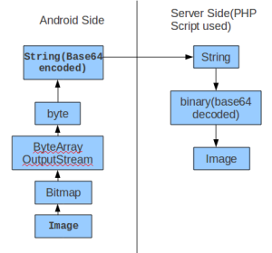

**Base64** encoding **Image** on client side and then decoding on the server side.

Base64 is a group of similar encoding schemes that represent binary data in an ASCII string format by translating it into a radix-64 representation. The Base64 term originates from a specific MIME content transfer encoding.  
 Base64 encoding schemes are commonly used when there is a need to encode binary data that needs be stored and transferred over media that are designed to deal with textual data. This is to ensure that the data remains intact without modification during transport. Base64 is commonly used in a number of applications including email via MIME, and storing complex data in XML.

### **4.9.2 Search recipe by typing ingredient**

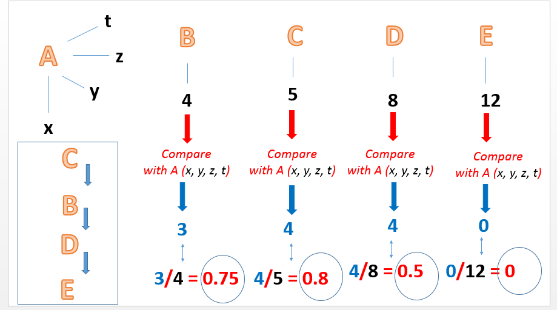

Assuming that import materials to identify dishes A.

4 users import raw materials respectively x , y , z , t. Assuming on systems with 4 dishes with the ingredients turn of each dish are: 4 , 5 , 8 , 12 Raw materials of each dish on the system will be compared with x , y , z , t

Results compare obtained:

+ With dishes B: 3 material polymerization

+ With dishes C: 4 material polymerization

+ With dishes D: 4 material polymerization

+ With dishes E: 0 material polymerization

So the order of priority shown to be arranged like?

We make a calculation: for each recipe, take the material polymerization divided by the total number of materials that form the dish.

Finally, the food will be given priority showing off respectively: C, B, D and E

# **Chapter 5: SYSTEM IMPLEMENTATION & TEST**

## **5.1 Introduction**

### **5.1.1 Purpose**

The primary purpose of this report is to detect software errors and fix them to ensure that our project is thoroughly tested and ready to release.

### **5.1.2 System Overview**

This chapter describes in details test approach, test plan, test case, defect log, Test Milestones, Checklist, etc. It does not describe implementation details of test cases or technical details of how the product features should work. The goal is to provide a framework that can be used by managers and testers to plan and execute the necessary tests in a timely and cost-effective manner.

### **5.1.3 Test Approach**

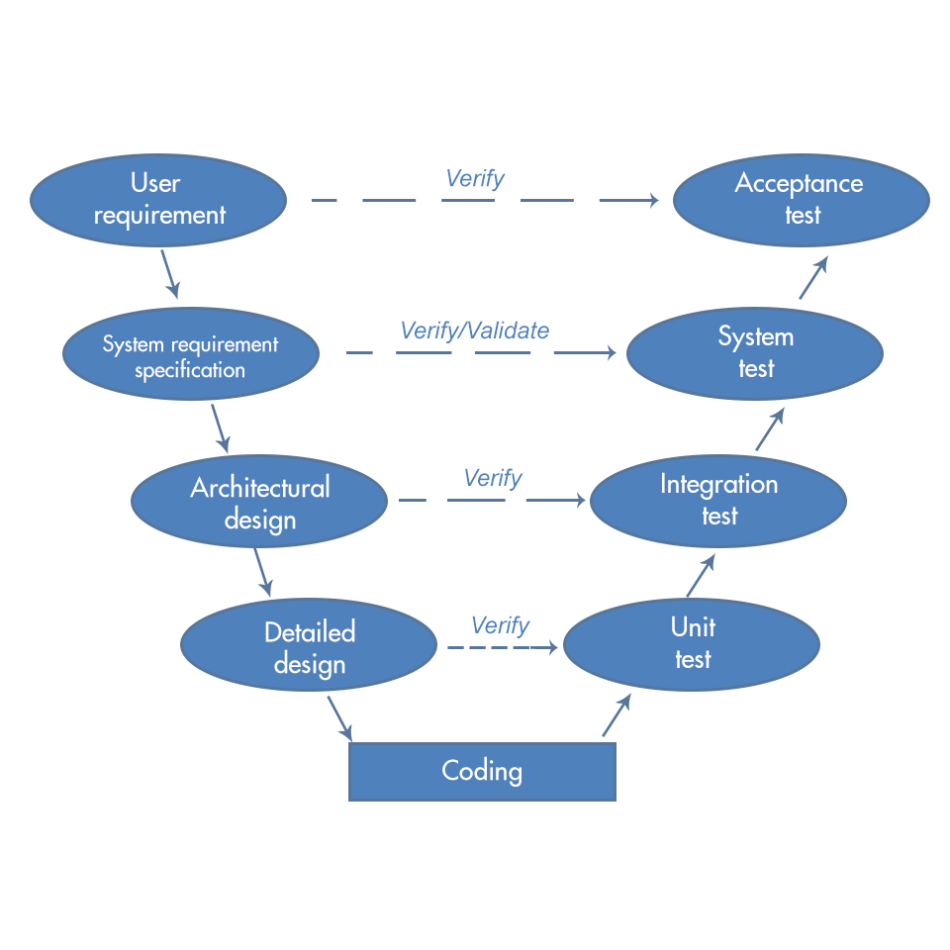

We use Iterative model for our project so V-Model is very appropriate. Under V- Model the corresponding testing phase of the development phase is planned in parallel. Therefore, we can save a lot of time in testing activities like planning, test designing happens well before coding.

Testing progress is divided to 4 phases include: Unit test, Integration test, System test and Acceptance test.

**Unit Test:**

Validating the internal logic code by testing every functions.

Unit test will be done by the developers and will be approved by the leader of implementing team to ensure that the specific function is working as expected. A function might have multiple tests to catch errors carefully.

**Integration testing:**

All modules will be tested together to expose faults in the interfaces and in the interaction between integrated components.

Integration testing will be done by tester.

**System testing:**

Compare the system specifications to the actual system.

System testing checks if the integrated product meets the specified requirements.

**Acceptance testing:**

Acceptance testing will be performed by the test manager and development team leader.

The acceptance test will be done for a period of 1 week after completion of the System/Integration test process.

Programs will enter into Acceptance test after all critical and major defects have been corrected.

Prior to final completion of acceptance testing all open critical and major defects must be corrected.

## **5.2 Test Plan**

### **5.2.1 Features to be tested**

|  |  |  |  |
| --- | --- | --- | --- |
|  | **Feature Name** | | **Feature to be tested** |
| Web | Admin | Login | Login | |
| Logout | Logout | |
| View Member List | View Member List | |
| View Member Profile | View Member Profile | |
| Search Member | Search Member | |
| Ban/Unban Member | Ban/Unban Member | |
| Set Member as Admin | Set Member as Admin | |
| View Recipe List | View Recipe List | |
| View Recipe detail | View Recipe detail | |
| Search Recipe | Search Recipe | |
| Delete Recipe | Delete Recipe | |
| Search Album | Search Album | |
| View Album List | View Album List | |
| View Album Detail | View Album Detail | |
| View Report List | View Report List | |
| Search Report | Search Report | |
| Delete Report | Delete Report | |
| Mobile | Guest | Register | Register | |
| Member | Login | Login | |
| Logout | Logout | |
| Forget password | Forget password | |
| Edit profile | Edit profile | |
| View profile | View profile | |
| View list people following | View list people following | |
| View list people were followed | View list people were followed | |
| Search member | Search member | |
| Unfollow | Unfollow | |
| Follow | Follow | |
| Unlike recipe | Unlike recipe | |
| Like recipe | Like recipe | |
| Comment | Comment | |
| View notification | View notification | |
| Report recipe | Report recipe | |
| Like album | Like album | |
| Unlike album | Unlike album | |
| View list all recipe | View list all recipe | |
| View list all recipe of following people | View list all recipe of following people | |
| Search recipe | Search recipe | |
| Edit recipe | Edit recipe | |
| View recipe detail | View recipe detail | |
| Download recipe | Download recipe | |
| Create recipe | Create recipe | |
| Draft | Draft | |
| Delete recipe | Delete recipe | |
| Add recipes to reminders | Add recipes to reminders | |
| View recipe album | View recipe album | |
| Edit album | Edit album | |
| Delete album | Delete album | |
| Search album | Search album | |
| Create recipe album | Create recipe album | |
| Check/uncheck item were bought or not | Check/uncheck item were bought or not | |
| Add ingredient to shopping list | Add ingredient to shopping list | |
| View shopping list | View shopping list | |

### **5.2.2 Features not to be tested**

- Security

### **5.2.3 Testing Tools & Environment**

|  |  |  |
| --- | --- | --- |
| Category | Software name | Version |
| Operating System | Microsoft Windows 7 | Professional |
| Microsoft Windows 8 | Professional |
| Development framework |  |  |
| Development tools | Android Studio |  |
|  |  |
| Database tools |  |  |
| Data managing tools |  |  |
| Support tools | Microsoft Office | 2013 |
| Assign task and tracking bug |  |  |
| Testing tools |  |  |

### **5.2.4 Test Milestone**

|  |  |  |  |
| --- | --- | --- | --- |
| Milestone Task | Resource | Start Date | Finish date |
| Test plan | Test leader | 2015/07/09 | 2015/07/12 |
| Create Unit Test cases | Developer | 2015/07/13 | 2015/07/15 |
| Create Integration Test cases | Tester | 2015/07/16 | 2015/07/18 |
| Create System Test cases | Tester | 2015/07/18 | 2015/07/19 |
| Review Unit Test cases | Project Team | 2015/07/16 | 2015/07/16 |
| Review Integration Test cases | Project Team | 2015/07/18 | 2015/07/18 |
| Review System Test cases | Project Team | 2015/07/19 | 2015/07/19 |
| Update Test cases | Tester | 2015/07/17 | 2015/08/1 |
| Create data test | Tester | 2015/07/17 | 2015/07/18 |
| Execute Unit Test | Developer | 2015/07/18 | 2015/08/13 |
| Execute Integration Test | Tester | 2015/07/18 | 2015/08/13 |
| Execute System Test | Tester | 2015/07/18 | 2015/08/13 |

## **5.3 Test Case**

### **5.3.1 Unit Test**

Web Application

|  |  |  |  |  |
| --- | --- | --- | --- | --- |
| **ID** | **Class** | **Method** | **Result** | **Test Date** |
| [UTW-1] | Area | getIdAreaByName | Pass | 12/07/2015 |
| [UTW-2] | Comment | getComment | Pass | 12/07/2015 |
| [UTW-3] | Continent | getIdContinentByName | Pass | 12/07/2015 |
| [UTW-4] | FollowOne | isDuplicateFollow | Pass | 12/07/2015 |
| [UTW-5] | FollowOne | getFollowID | Pass | 12/07/2015 |
| [UTW-6] | FollowOne | getTotalIDCare | Pass | 12/07/2015 |
| [UTW-7] | FollowOne | getListUserFollow | Pass | 12/07/2015 |
| [UTW-8] | FollowOne | getListUserFollowUnLimit | Pass | 12/07/2015 |
| [UTW-9] | FollowOne | getListUserFollowed | Pass | 12/07/2015 |
| [UTW-10] | FollowOne | getListUserFollowedUnLimit | Pass | 12/07/2015 |
| [UTW-11] | Notification | isExistNotify | Pass | 12/07/2015 |
| [UTW-12] | Notification | isAllowNotification | Pass | 12/07/2015 |
| [UTW-13] | Notification | retrieveNotify | Pass | 12/07/2015 |
| [UTW-14] | Notification | retrieveNotifyNoLimit | Pass | 12/07/2015 |
| [UTW-15] | Notification | getNotifyID | Pass | 12/07/2015 |
| [UTW-16] | Notification | isHasNotifyID | Pass | 12/07/2015 |
| [UTW-17] | Notification | isOwnReceipt | Pass | 12/07/2015 |
| [UTW-18] | Notification | getNotificationSlide | Pass | 12/07/2015 |
| [UTW-19] | Post | getTitlePost | Pass | 12/07/2015 |
| [UTW-20] | Post | getMaterialPost | Pass | 12/07/2015 |
| [UTW-21] | Post | getDataSearchTitle | Pass | 12/07/2015 |
| [UTW-22] | Post | getDataSearchTitleNoLimit | Pass | 12/07/2015 |
| [UTW-23] | Post | getReceiptByMaterial | Pass | 12/07/2015 |
| [UTW-24] | Post | getReceiptByMaterialNoLimit | Pass | 12/07/2015 |
| [UTW-25] | Post | khong_dau | Pass | 12/07/2015 |
| [UTW-26] | Post | getRecipes | Pass | 12/07/2015 |
| [UTW-27] | Post | getRecipesDetail | Pass | 12/07/2015 |
| [UTW-28] | Post | getStepRecipe | Pass | 12/07/2015 |
| [UTW-29] | Post | getMaterial | Pass | 12/07/2015 |
| [UTW-30] | Post | getTotalPost | Pass | 12/07/2015 |
| [UTW-31] | Post | getUserPost | Pass | 12/07/2015 |
| [UTW-32] | PostArea | getAreaName | Pass | 12/07/2015 |
| [UTW-33] | PostContinent | getContinentName | Pass | 12/07/2015 |
| [UTW-34] | PostLike | getPostLikeID | Pass | 12/07/2015 |
| [UTW-35] | PostLike | isDuplicateLike | Pass | 12/07/2015 |
| [UTW-36] | ReportDetail | getAllReport | Pass | 12/07/2015 |
| [UTW-37] | User | saveUser | Pass | 12/07/2015 |
| [UTW-38] | User | login | Pass | 12/07/2015 |
| [UTW-39] | User | createComment | Pass | 12/07/2015 |
| [UTW-40] | User | retrieveProfileEdit | Pass | 12/07/2015 |
| [UTW-41] | User | putProfileEdit | Pass | 12/07/2015 |
| [UTW-42] | User | getComment | Pass | 12/07/2015 |
| [UTW-43] | User | getNotification | Pass | 12/07/2015 |
| [UTW-44] | User | getNotificationSlide | Pass | 12/07/2015 |
| [UTW-45] | User | getProfile | Pass | 12/07/2015 |
| [UTW-46] | User | getProfileOther | Pass | 12/07/2015 |
| [UTW-47] | User | saveImage | Pass | 12/07/2015 |
| [UTW-48] | User | getNewFeedAll | Pass | 12/07/2015 |
| [UTW-49] | User | getNewFeedCare | Pass | 12/07/2015 |
| [UTW-50] | User | getNewFeedProfile | Pass | 12/07/2015 |
| [UTW-51] | User | putDeleteReceipt | Pass | 12/07/2015 |
| [UTW-52] | User | getNote | Pass | 12/07/2015 |
| [UTW-53] | User | createFollow | Pass | 12/07/2015 |
| [UTW-54] | User | createUnFollow | Pass | 12/07/2015 |
| [UTW-55] | User | retrieveReport | Pass | 12/07/2015 |
| [UTW-56] | User | createReport | Pass | 12/07/2015 |
| [UTW-57] | User | likePost | Pass | 12/07/2015 |
| [UTW-58] | User | putPassSubmit | Pass | 12/07/2015 |
| [UTW-59] | User | putPassSendCode | Pass | 12/07/2015 |
| [UTW-60] | User | retrieveUserFollowed | Pass | 12/07/2015 |
| [UTW-61] | User | getSearch | Pass | 12/07/2015 |
| [UTW-62] | User | UnLikePost | Pass | 12/07/2015 |
| [UTW-63] | User | retrieveUserFollow | Pass | 12/07/2015 |
| [UTW-64] | User | getReceipt | Pass | 12/07/2015 |
| [UTW-65] | User | putProfileEditPass | Pass | 12/07/2015 |
| [UTW-66] | User | getSpeciality | Pass | 12/07/2015 |
| [UTW-67] | User | getPathAvatar | Pass | 12/07/2015 |
| [UTW-68] | User | getPathImageCover | Pass | 12/07/2015 |
| [UTW-69] | User | createReceipt | Pass | 12/07/2015 |
| [UTW-70] | User | updateAvatar | Pass | 12/07/2015 |
| [UTW-71] | User | getAllUser | Pass | 12/07/2015 |
| [UTW-72] | User | getTotalUser | Pass | 12/07/2015 |
| [UTW-73] | User | getUserProfile | Pass | 12/07/2015 |
| [UTW-74] | User | getIdPostMax | Pass | 12/07/2015 |
| [UTW-75] | User | getIdContentMax | Pass | 12/07/2015 |
| [UTW-76] | User | getSpecialContinent | Pass | 12/07/2015 |
| [UTW-77] | User | getSpecialArea | Pass | 12/07/2015 |
| [UTW-78] | User | isDuplicateEmail | Pass | 12/07/2015 |
| [UTW-79] | User | getCurrentTime | Pass | 12/07/2015 |
| [UTW-80] | User | generateApiKey | Pass | 12/07/2015 |
| [UTW-81] | User | getDataNewFeedAll | Pass | 12/07/2015 |
| [UTW-82] | User | getDataNewFeedCare | Pass | 12/07/2015 |
| [UTW-83] | User | getDataNewFeedProfile | Pass | 12/07/2015 |
| [UTW-84] | User | getCountReceipt | Pass | 12/07/2015 |
| [UTW-85] | User | getCountFollowed | Pass | 12/07/2015 |
| [UTW-86] | User | getCountFollowing | Pass | 12/07/2015 |
| [UTW-87] | User | getArtistName | Pass | 12/07/2015 |
| [UTW-88] | User | getTotalComment | Pass | 12/07/2015 |
| [UTW-89] | User | getTotalLike | Pass | 12/07/2015 |
| [UTW-90] | User | getTotalMaterial | Pass | 12/07/2015 |
| [UTW-91] | User | getTotalContent | Pass | 12/07/2015 |
| [UTW-92] | User | getImgCover | Pass | 12/07/2015 |
| [UTW-93] | User | isFollowingUser | Pass | 12/07/2015 |
| [UTW-94] | User | returnSearchUser | Pass | 12/07/2015 |
| [UTW-95] | User | getProfileEdit | Pass | 12/07/2015 |
| [UTW-96] | User | isValidPassOld | Pass | 12/07/2015 |
| [UTW-97] | User | isExistEmail | Pass | 12/07/2015 |
| [UTW-98] | SiteController | __construct | Pass | 21/07/2015 |
| [UTW-99] | SiteController | getIndex | Pass | 21/07/2015 |
| [UTW-100] | SiteController | getUserProfile | Pass | 21/07/2015 |
| [UTW-101] | SiteController | getRecipes | Pass | 21/07/2015 |
| [UTW-102] | SiteController | getRecipesDetail | Pass | 21/07/2015 |
| [UTW-103] | SiteController | getLogin | Pass | 21/07/2015 |
| [UTW-104] | SiteController | getLogout | Pass | 21/07/2015 |
| [UTW-105] | SiteController | getErrorPage | Pass | 21/07/2015 |
| [UTW-106] | SiteController | postLogin | Pass | 21/07/2015 |
| [UTW-107] | SiteController | getSetAdmin | Pass | 21/07/2015 |
| [UTW-108] | SiteController | postSetAdmin | Pass | 21/07/2015 |
| [UTW-109] | SiteController | getActiveEmail | Pass | 21/07/2015 |
| [UTW-110] | UserController | __construct | Pass | 21/07/2015 |
| [UTW-111] | UserController | getUser | Pass | 21/07/2015 |
| [UTW-112] | UserController | saveUser | Pass | 21/07/2015 |
| [UTW-113] | UserController | putProfileEditPass | Pass | 21/07/2015 |
| [UTW-114] | UserController | getReceipt | Pass | 21/07/2015 |
| [UTW-115] | UserController | retrieveUserFollow | Pass | 21/07/2015 |
| [UTW-116] | UserController | createComment | Pass | 21/07/2015 |
| [UTW-117] | UserController | retrieveProfileEdit | Pass | 21/07/2015 |
| [UTW-118] | UserController | putProfileEdit | Pass | 21/07/2015 |
| [UTW-119] | UserController | getNotification | Pass | 21/07/2015 |
| [UTW-120] | UserController | getNotificationSlide | Pass | 21/07/2015 |
| [UTW-121] | UserController | createFollow | Pass | 21/07/2015 |
| [UTW-122] | UserController | createUnFollow | Pass | 21/07/2015 |
| [UTW-123] | UserController | getProfile | Pass | 21/07/2015 |
| [UTW-124] | UserController | getProfileOther | Pass | 21/07/2015 |
| [UTW-125] | UserController | getComment | Pass | 21/07/2015 |
| [UTW-126] | UserController | getSpeciality | Pass | 21/07/2015 |
| [UTW-127] | UserController | getNewFeedAll | Pass | 21/07/2015 |
| [UTW-128] | UserController | getNewFeedCare | Pass | 21/07/2015 |
| [UTW-129] | UserController | getNote | Pass | 21/07/2015 |
| [UTW-130] | UserController | getNewFeedProfile | Pass | 21/07/2015 |
| [UTW-131] | UserController | getSearch | Pass | 21/07/2015 |
| [UTW-132] | UserController | retrieveUserFollowed | Pass | 21/07/2015 |
| [UTW-133] | UserController | putPassSendCode | Pass | 21/07/2015 |
| [UTW-134] | UserController | putPassSubmit | Pass | 21/07/2015 |
| [UTW-135] | UserController | retrieveReport | Pass | 21/07/2015 |
| [UTW-136] | UserController | createReport | Pass | 21/07/2015 |
| [UTW-137] | UserController | likePost | Pass | 21/07/2015 |
| [UTW-138] | UserController | UnLikePost | Pass | 21/07/2015 |
| [UTW-139] | UserController | getAvatar | Pass | 21/07/2015 |
| [UTW-140] | UserController | getImageCover | Pass | 21/07/2015 |
| [UTW-141] | UserController | getImageStep | Pass | 21/07/2015 |
| [UTW-142] | UserController | updateAvatar | Pass | 21/07/2015 |
| [UTW-143] | UserController | createReceipt | Pass | 21/07/2015 |
| [UTW-144] | UserController | login | Pass | 21/07/2015 |
| [UTW-145] | UserController | saveImage | Pass | 21/07/2015 |

**Mobile Application**

|  |  |  |  |  |
| --- | --- | --- | --- | --- |
| **ID** | **Class** | **Method** | **Result** | **Test Date** |
| [UTM-1] | PacketItem | ReturnScreenWidth | Pass | 25/06/2015 |
| [UTM-2] | DbAdapter | onCreate | Pass | 25/06/2015 |
| [UTM-3] | DbAdapter | onUpgrade | Pass | 25/06/2015 |
| [UTM-4] | SlidemenuAdapter | SlidemenuAdapter | Pass | 25/06/2015 |
| [UTM-5] | SlidemenuAdapter | getView | Pass | 25/06/2015 |
| [UTM-6] | NewFeedAdapter | NewFeedAdapter | Pass | 25/06/2015 |
| [UTM-7] | NewFeedAdapter | getView | Pass | 25/06/2015 |
| [UTM-8] | CommentAdapter | getView | Pass | 25/06/2015 |
| [UTM-9] | NoteAdapter | NoteAdapter | Pass | 25/06/2015 |
| [UTM-10] | NoteAdapter | getView | Pass | 25/06/2015 |
| [UTM-11] | DraftAdapter | DraftAdapter | Pass | 25/06/2015 |
| [UTM-12] | DraftAdapter | getView | Pass | 25/06/2015 |
| [UTM-13] | SearchUserAdapter | SearchUserAdapter | Pass | 25/06/2015 |
| [UTM-14] | SearchUserAdapter | getView | Pass | 25/06/2015 |
| [UTM-15] | NotificationAdapter | NotificationAdapter | Pass | 25/06/2015 |
| [UTM-16] | NotificationAdapter | getView | Pass | 25/06/2015 |
| [UTM-17] | ScheduleAdapter | ScheduleAdapter | Pass | 25/06/2015 |
| [UTM-18] | ScheduleAdapter | getView | Pass | 25/06/2015 |
| [UTM-19] | DownloadAdapter | DownloadAdapter | Pass | 25/06/2015 |
| [UTM-20] | DownloadAdapter | getView | Pass | 25/06/2015 |
| [UTM-21] | CropOptionAdapter | CropOptionAdapter | Pass | 25/06/2015 |
| [UTM-22] | CropOptionAdapter | getView | Pass | 25/06/2015 |
| [UTM-23] | AreaContinentItem | AreaContinentItem | Pass | 06/07/2015 |
| [UTM-24] | AreaContinentItem | getArea | Pass | 06/07/2015 |
| [UTM-25] | AreaContinentItem | setArea | Pass | 06/07/2015 |
| [UTM-26] | AreaContinentItem | getContinent | Pass | 06/07/2015 |
| [UTM-27] | AreaContinentItem | setContinent | Pass | 06/07/2015 |
| [UTM-28] | CommentItem | CommentItem | Pass | 06/07/2015 |
| [UTM-29] | CommentItem | getId | Pass | 06/07/2015 |
| [UTM-30] | CommentItem | setId | Pass | 06/07/2015 |
| [UTM-31] | CommentItem | getArtist | Pass | 06/07/2015 |
| [UTM-32] | CommentItem | setArtist | Pass | 06/07/2015 |
| [UTM-33] | CommentItem | getDescription | Pass | 06/07/2015 |
| [UTM-34] | CommentItem | setDescription | Pass | 06/07/2015 |
| [UTM-35] | CommentItem | getCreated_at | Pass | 06/07/2015 |
| [UTM-36] | CommentItem | setCreated_at | Pass | 06/07/2015 |
| [UTM-37] | CommentItem | getUrl_api_avatar | Pass | 06/07/2015 |
| [UTM-38] | CommentItem | setUrl_api_avatar | Pass | 06/07/2015 |
| [UTM-39] | DraftItem | DraftItem | Pass | 06/07/2015 |
| [UTM-40] | DraftItem | getName_recipes | Pass | 06/07/2015 |
| [UTM-41] | DraftItem | setName_recipes | Pass | 06/07/2015 |
| [UTM-42] | DraftItem | getName_user | Pass | 06/07/2015 |
| [UTM-43] | DraftItem | setName_user | Pass | 06/07/2015 |
| [UTM-44] | DraftItem | getImage_cover | Pass | 06/07/2015 |
| [UTM-45] | DraftItem | setImage_cover | Pass | 06/07/2015 |
| [UTM-46] | DraftItem | getTime | Pass | 06/07/2015 |
| [UTM-47] | DraftItem | setTime | Pass | 06/07/2015 |
| [UTM-48] | DraftItem | setKcal | Pass | 06/07/2015 |
| [UTM-49] | DraftItem | getKcal | Pass | 06/07/2015 |
| [UTM-50] | NewFeedItems | NewFeedItems | Pass | 06/07/2015 |
| [UTM-51] | NewFeedItems | getId | Pass | 06/07/2015 |
| [UTM-52] | NewFeedItems | setId | Pass | 06/07/2015 |
| [UTM-53] | NewFeedItems | getTitle | Pass | 06/07/2015 |
| [UTM-54] | NewFeedItems | setTitle | Pass | 06/07/2015 |
| [UTM-55] | NewFeedItems | getArtist | Pass | 06/07/2015 |
| [UTM-56] | NewFeedItems | setArtist | Pass | 06/07/2015 |
| [UTM-57] | NewFeedItems | getTime_finish | Pass | 06/07/2015 |
| [UTM-58] | NewFeedItems | setTime_finish | Pass | 06/07/2015 |
| [UTM-59] | NewFeedItems | getTotal_like | Pass | 06/07/2015 |
| [UTM-60] | NewFeedItems | setTotal_like | Pass | 06/07/2015 |
| [UTM-61] | NewFeedItems | getTotal_comment | Pass | 06/07/2015 |
| [UTM-62] | NewFeedItems | setTotal_comment | Pass | 06/07/2015 |
| [UTM-63] | NewFeedItems | getTotal_view | Pass | 06/07/2015 |
| [UTM-64] | NewFeedItems | setTotal_view | Pass | 06/07/2015 |
| [UTM-65] | NewFeedItems | getTotal_kcal | Pass | 06/07/2015 |
| [UTM-66] | NewFeedItems | setTotal_kcal | Pass | 06/07/2015 |
| [UTM-67] | NewFeedItems | getFeedImage | Pass | 06/07/2015 |
| [UTM-68] | NewFeedItems | setFeedImage | Pass | 06/07/2015 |
| [UTM-69] | NewFeedItems | getIsLike | Pass | 06/07/2015 |
| [UTM-70] | NewFeedItems | setIsLike | Pass | 06/07/2015 |
| [UTM-71] | NoteItems | NoteItems | Pass | 06/07/2015 |
| [UTM-72] | NoteItems | getId | Pass | 06/07/2015 |
| [UTM-73] | NoteItems | setId | Pass | 06/07/2015 |
| [UTM-74] | NoteItems | getUser_id | Pass | 06/07/2015 |
| [UTM-75] | NoteItems | setUser_id | Pass | 06/07/2015 |
| [UTM-76] | NoteItems | getTitle | Pass | 06/07/2015 |
| [UTM-77] | NoteItems | setTitle | Pass | 06/07/2015 |
| [UTM-78] | NoteMaterialItems | NoteMaterialItems | Pass | 06/07/2015 |
| [UTM-79] | NoteMaterialItems | getId | Pass | 06/07/2015 |
| [UTM-80] | NoteMaterialItems | setId | Pass | 06/07/2015 |
| [UTM-81] | NoteMaterialItems | getIsChecked | Pass | 06/07/2015 |
| [UTM-82] | NoteMaterialItems | setIsChecked | Pass | 06/07/2015 |
| [UTM-83] | NoteMaterialItems | getNote_id | Pass | 06/07/2015 |
| [UTM-84] | NoteMaterialItems | setNote_id | Pass | 06/07/2015 |
| [UTM-85] | NoteMaterialItems | getName | Pass | 06/07/2015 |
| [UTM-86] | NoteMaterialItems | setName | Pass | 06/07/2015 |
| [UTM-87] | NotificationItems | NotificationItems | Pass | 06/07/2015 |
| [UTM-88] | NotificationItems | getId | Pass | 06/07/2015 |
| [UTM-89] | NotificationItems | setId | Pass | 06/07/2015 |
| [UTM-90] | NotificationItems | getIsSeen | Pass | 06/07/2015 |
| [UTM-91] | NotificationItems | setIsSeen | Pass | 06/07/2015 |
| [UTM-92] | NotificationItems | getTotal_like | Pass | 06/07/2015 |
| [UTM-93] | NotificationItems | setTotal_like | Pass | 06/07/2015 |
| [UTM-94] | NotificationItems | getTotal_comment | Pass | 06/07/2015 |
| [UTM-95] | NotificationItems | setTotal_comment | Pass | 06/07/2015 |
| [UTM-96] | NotificationItems | getTitle | Pass | 06/07/2015 |
| [UTM-97] | NotificationItems | setTitle | Pass | 06/07/2015 |
| [UTM-98] | NotificationItems | getImg_api_url | Pass | 06/07/2015 |
| [UTM-99] | NotificationItems | setImg_api_url | Pass | 06/07/2015 |
| [UTM-100] | RememberItems | RememberItems | Pass | 06/07/2015 |
| [UTM-101] | RememberItems | getEmai | Pass | 06/07/2015 |
| [UTM-102] | RememberItems | setEmai | Pass | 06/07/2015 |
| [UTM-103] | RememberItems | getPassword | Pass | 06/07/2015 |
| [UTM-104] | RememberItems | setPassword | Pass | 06/07/2015 |
| [UTM-105] | RememberItems | getIsRember | Pass | 06/07/2015 |
| [UTM-106] | ReportItems | ReportItems | Pass | 06/07/2015 |
| [UTM-107] | ReportItems | getId | Pass | 06/07/2015 |
| [UTM-108] | ReportItems | setId | Pass | 06/07/2015 |
| [UTM-109] | ReportItems | getDescription | Pass | 06/07/2015 |
| [UTM-110] | ReportItems | setDescription | Pass | 06/07/2015 |
| [UTM-111] | SchduleItem | SchduleItem | Pass | 06/07/2015 |
| [UTM-112] | SchduleItem | getName_recipes | Pass | 06/07/2015 |
| [UTM-113] | SchduleItem | setName_recipes | Pass | 06/07/2015 |
| [UTM-114] | SchduleItem | getDescription | Pass | 06/07/2015 |
| [UTM-115] | SchduleItem | setDescription | Pass | 06/07/2015 |
| [UTM-116] | SchduleItem | getTimeStamp | Pass | 06/07/2015 |
| [UTM-117] | SchduleItem | setTimeStamp | Pass | 06/07/2015 |
| [UTM-118] | SchduleItem | getTimeStart | Pass | 06/07/2015 |
| [UTM-119] | SchduleItem | setTimeStart | Pass | 06/07/2015 |
| [UTM-120] | SearchUserItems | SearchUserItems | Pass | 06/07/2015 |
| [UTM-121] | SearchUserItems | getId | Pass | 06/07/2015 |
| [UTM-122] | SearchUserItems | setId | Pass | 06/07/2015 |
| [UTM-123] | SearchUserItems | getName | Pass | 06/07/2015 |
| [UTM-124] | SearchUserItems | setName | Pass | 06/07/2015 |
| [UTM-125] | SearchUserItems | getTotal_receipt | Pass | 06/07/2015 |
| [UTM-126] | SearchUserItems | setTotal_receipt | Pass | 06/07/2015 |
| [UTM-127] | SearchUserItems | getImg_api_avatar | Pass | 06/07/2015 |
| [UTM-128] | SearchUserItems | setImg_api_avatar | Pass | 06/07/2015 |
| [UTM-129] | SlidemenuItems | SlidemenuItems | Pass | 06/07/2015 |
| [UTM-130] | SlidemenuItems | getIcon | Pass | 06/07/2015 |
| [UTM-131] | SlidemenuItems | setIcon | Pass | 06/07/2015 |
| [UTM-132] | SlidemenuItems | getName | Pass | 06/07/2015 |
| [UTM-133] | SlidemenuItems | setName | Pass | 06/07/2015 |
| [UTM-134] | TempContentItem | getId | Pass | 06/07/2015 |
| [UTM-135] | TempContentItem | setId | Pass | 06/07/2015 |
| [UTM-136] | TempContentItem | getImg_api_url | Pass | 06/07/2015 |
| [UTM-137] | TempContentItem | setImg_api_url | Pass | 06/07/2015 |
| [UTM-138] | TempContentItem | getDescription | Pass | 06/07/2015 |
| [UTM-139] | TempContentItem | setDescription | Pass | 06/07/2015 |
| [UTM-140] | TempMaterialItem | TempMaterialItem | Pass | 06/07/2015 |
| [UTM-141] | TempMaterialItem | getId | Pass | 06/07/2015 |
| [UTM-142] | TempMaterialItem | setId | Pass | 06/07/2015 |
| [UTM-143] | TempMaterialItem | getName | Pass | 06/07/2015 |
| [UTM-144] | TempMaterialItem | setName | Pass | 06/07/2015 |
| [UTM-145] | UserItems | UserItems | Pass | 06/07/2015 |
| [UTM-146] | UserItems | getId | Pass | 06/07/2015 |
| [UTM-147] | UserItems | setId | Pass | 06/07/2015 |
| [UTM-148] | UserItems | getName | Pass | 06/07/2015 |
| [UTM-149] | UserItems | setName | Pass | 06/07/2015 |
| [UTM-150] | UserItems | getEmail | Pass | 06/07/2015 |
| [UTM-151] | UserItems | setEmail | Pass | 06/07/2015 |
| [UTM-152] | UserItems | getPassword | Pass | 06/07/2015 |
| [UTM-153] | UserItems | setPassword | Pass | 06/07/2015 |
| [UTM-154] | UserItems | getApi_key | Pass | 06/07/2015 |
| [UTM-155] | UserItems | setApi_key | Pass | 06/07/2015 |
| [UTM-156] | UserItems | getTotal_receipt | Pass | 06/07/2015 |
| [UTM-157] | UserItems | setTotal_receipt | Pass | 06/07/2015 |
| [UTM-158] | UserItems | getTotal_followed | Pass | 06/07/2015 |
| [UTM-159] | UserItems | setTotal_followed | Pass | 06/07/2015 |
| [UTM-160] | AppController | AppController | Pass | 15/07/2015 |
| [UTM-161] | AppController | getInstance | Pass | 15/07/2015 |
| [UTM-162] | AppController | getRequestQueue | Pass | 15/07/2015 |
| [UTM-163] | AppController | getImageLoader | Pass | 15/07/2015 |
| [UTM-164] | AppController | getLruBitmapCache | Pass | 15/07/2015 |
| [UTM-165] | AppController | addToRequestQueue | Pass | 15/07/2015 |
| [UTM-166] | AppController | cancelPendingRequests | Pass | 15/07/2015 |
| [UTM-167] | CustomVolleyRequestQueue | CustomVolleyRequestQueue | Pass | 15/07/2015 |
| [UTM-168] | CustomVolleyRequestQueue | getInstance | Pass | 15/07/2015 |
| [UTM-169] | CustomVolleyRequestQueue | getRequestQueue | Pass | 15/07/2015 |
| [UTM-170] | CustomVolleyRequestQueue | getImageLoader | Pass | 15/07/2015 |
| [UTM-171] | FeedImageView | ResponseObserver | Pass | 15/07/2015 |
| [UTM-172] | FeedImageView | setResponseObserver | Pass | 15/07/2015 |
| [UTM-173] | FeedImageView | FeedImageView | Pass | 15/07/2015 |
| [UTM-174] | FeedImageView | FeedImageView | Pass | 15/07/2015 |
| [UTM-175] | FeedImageView | FeedImageView | Pass | 15/07/2015 |
| [UTM-176] | FeedImageView | setImageUrl | Pass | 15/07/2015 |
| [UTM-177] | FeedImageView | setDefaultImageResId | Pass | 15/07/2015 |
| [UTM-178] | FeedImageView | setErrorImageResId | Pass | 15/07/2015 |
| [UTM-179] | FeedImageView | loadImageIfNecessary | Pass | 15/07/2015 |
| [UTM-180] | FeedImageView | setDefaultImageOrNull | Pass | 15/07/2015 |
| [UTM-181] | FeedImageView | onLayout | Pass | 15/07/2015 |
| [UTM-182] | FeedImageView | onDetachedFromWindow | Pass | 15/07/2015 |
| [UTM-183] | FeedImageView | drawableStateChanged | Pass | 15/07/2015 |
| [UTM-184] | FeedImageView | adjustImageAspect | Pass | 15/07/2015 |
| [UTM-185] | LruBitmapCache | LruBitmapCache | Pass | 15/07/2015 |
| [UTM-186] | LruBitmapCache | sizeOf | Pass | 15/07/2015 |
| [UTM-187] | LruBitmapCache | getBitmap | Pass | 15/07/2015 |
| [UTM-188] | LruBitmapCache | putBitmap | Pass | 15/07/2015 |
| [UTM-189] | AreaContinentModel | AreaContinentModel | Pass | 15/07/2015 |
| [UTM-190] | AreaContinentModel | openDB | Pass | 15/07/2015 |
| [UTM-191] | AreaContinentModel | closeDB | Pass | 15/07/2015 |
| [UTM-192] | AreaContinentModel | isEmpty | Pass | 15/07/2015 |
| [UTM-193] | AreaContinentModel | isCLearAreaContinent | Pass | 15/07/2015 |
| [UTM-194] | AreaContinentModel | insertAreaContinent | Pass | 15/07/2015 |
| [UTM-195] | AreaContinentModel | getAreaName | Pass | 15/07/2015 |
| [UTM-196] | AreaContinentModel | getContinentName | Pass | 15/07/2015 |
| [UTM-197] | AreaContinentModel | returnArrAreaContinent | Pass | 15/07/2015 |
| [UTM-198] | ContentModel | openDB | Pass | 15/07/2015 |
| [UTM-199] | ContentModel | closeDB | Pass | 15/07/2015 |
| [UTM-200] | ContentModel | isEmpty | Pass | 15/07/2015 |
| [UTM-201] | ContentModel | insertContent | Pass | 15/07/2015 |
| [UTM-202] | ContentModel | updateContent | Pass | 15/07/2015 |
| [UTM-203] | ContentModel | getContent | Pass | 15/07/2015 |
| [UTM-204] | ContentModel | getDescription | Pass | 15/07/2015 |
| [UTM-205] | ContentModel | getImgPath | Pass | 15/07/2015 |
| [UTM-206] | ContentModel | getContentID | Pass | 15/07/2015 |
| [UTM-207] | MaterialModel | MaterialModel | Pass | 15/07/2015 |
| [UTM-208] | MaterialModel | openDB | Pass | 15/07/2015 |
| [UTM-209] | MaterialModel | closeDB | Pass | 15/07/2015 |
| [UTM-210] | MaterialModel | isEmpty | Pass | 15/07/2015 |
| [UTM-211] | MaterialModel | insertMaterial | Pass | 15/07/2015 |
| [UTM-212] | MaterialModel | updateMaterial | Pass | 15/07/2015 |
| [UTM-213] | MaterialModel | deleteMaterial | Pass | 15/07/2015 |
| [UTM-214] | MaterialModel | getContent | Pass | 15/07/2015 |
| [UTM-215] | MaterialModel | getName_Material | Pass | 15/07/2015 |
| [UTM-216] | MaterialModel | getID_Material | Pass | 15/07/2015 |
| [UTM-217] | NoteMaterialModel | NoteMaterialModel | Pass | 15/07/2015 |
| [UTM-218] | NoteMaterialModel | openDB | Pass | 15/07/2015 |
| [UTM-219] | NoteMaterialModel | closeDB | Pass | 15/07/2015 |
| [UTM-220] | NoteMaterialModel | insertNote | Pass | 15/07/2015 |
| [UTM-221] | NoteMaterialModel | returnArrNoteMaterial | Pass | 15/07/2015 |
| [UTM-222] | NoteMaterialModel | updateNoteMaterial | Pass | 15/07/2015 |
| [UTM-223] | NoteMaterialModel | isCLearNoteMaterial | Pass | 15/07/2015 |
| [UTM-224] | NoteMaterialModel | deleteNoteMaterial | Pass | 15/07/2015 |
| [UTM-225] | NoteModel | NoteModel | Pass | 15/07/2015 |
| [UTM-226] | NoteModel | openDB | Pass | 15/07/2015 |
| [UTM-227] | NoteModel | closeDB | Pass | 15/07/2015 |
| [UTM-228] | NoteModel | insertNote | Pass | 15/07/2015 |
| [UTM-229] | NoteModel | deleteNote | Pass | 15/07/2015 |
| [UTM-230] | NoteModel | returnArrNote | Pass | 15/07/2015 |
| [UTM-231] | NoteModel | getIdNoteMax | Pass | 15/07/2015 |
| [UTM-232] | NoteModel | isCLearNote | Pass | 15/07/2015 |
| [UTM-233] | PostModel | PostModel | Pass | 15/07/2015 |
| [UTM-234] | PostModel | openDB | Pass | 15/07/2015 |
| [UTM-235] | PostModel | closeDB | Pass | 15/07/2015 |
| [UTM-236] | PostModel | isEmpty | Pass | 15/07/2015 |
| [UTM-237] | PostModel | insertPost | Pass | 15/07/2015 |
| [UTM-238] | PostModel | updatePost | Pass | 15/07/2015 |
| [UTM-239] | PostModel | getImgCoverPath | Pass | 15/07/2015 |
| [UTM-240] | PostModel | getImgCoverPathSave | Pass | 15/07/2015 |
| [UTM-241] | PostModel | getPost | Pass | 15/07/2015 |
| [UTM-242] | PostModel | getPostSave | Pass | 15/07/2015 |
| [UTM-243] | PostModel | getID | Pass | 15/07/2015 |
| [UTM-244] | PostModel | getIDSave | Pass | 15/07/2015 |
| [UTM-245] | PostModel | getDescriptionRecipes | Pass | 15/07/2015 |
| [UTM-246] | PostModel | getDescriptionRecipesSave | Pass | 15/07/2015 |
| [UTM-247] | PostModel | getUserID | Pass | 15/07/2015 |
| [UTM-248] | PostModel | getTotalKcalSave | Pass | 15/07/2015 |
| [UTM-249] | PostModel | getTotalKcal | Pass | 15/07/2015 |
| [UTM-250] | PostModel | getTotalTime | Pass | 15/07/2015 |
| [UTM-251] | PostModel | getTotalTimeSave | Pass | 15/07/2015 |
| [UTM-252] | PostModel | getPostName | Pass | 15/07/2015 |
| [UTM-253] | PostModel | getMaxID | Pass | 15/07/2015 |
| [UTM-254] | ScheduleModel | ScheduleModel | Pass | 15/07/2015 |
| [UTM-255] | ScheduleModel | openDB | Pass | 15/07/2015 |
| [UTM-256] | ScheduleModel | closeDB | Pass | 15/07/2015 |
| [UTM-257] | ScheduleModel | isEmpty | Pass | 15/07/2015 |
| [UTM-258] | ScheduleModel | insertSchedule | Pass | 15/07/2015 |
| [UTM-259] | ScheduleModel | getDescription | Pass | 15/07/2015 |
| [UTM-260] | ScheduleModel | getPost_id | Pass | 15/07/2015 |
| [UTM-261] | ScheduleModel | getTimeStamp | Pass | 15/07/2015 |
| [UTM-262] | ScheduleModel | getTimeStart | Pass | 15/07/2015 |
| [UTM-263] | TempContentModel | TempContentModel | Pass | 15/07/2015 |
| [UTM-264] | TempContentModel | openDB | Pass | 15/07/2015 |
| [UTM-265] | TempContentModel | closeDB | Pass | 15/07/2015 |
| [UTM-266] | TempContentModel | isEmpty | Pass | 15/07/2015 |
| [UTM-267] | TempContentModel | isCLearTempContent | Pass | 15/07/2015 |
| [UTM-268] | TempContentModel | insertTempContent | Pass | 15/07/2015 |
| [UTM-269] | TempContentModel | getSize | Pass | 15/07/2015 |
| [UTM-270] | TempContentModel | returnArrContent | Pass | 15/07/2015 |
| [UTM-271] | UserModel | UserModel | Pass | 15/07/2015 |
| [UTM-272] | UserModel | openDB | Pass | 15/07/2015 |
| [UTM-273] | UserModel | closeDB | Pass | 15/07/2015 |
| [UTM-274] | UserModel | isEmpty | Pass | 15/07/2015 |
| [UTM-275] | UserModel | insertUser | Pass | 15/07/2015 |
| [UTM-276] | UserModel | updateUser | Pass | 15/07/2015 |
| [UTM-277] | UserModel | updateAvatar | Pass | 15/07/2015 |
| [UTM-278] | UserModel | isCLearUser | Pass | 15/07/2015 |
| [UTM-279] | UserModel | getAvatarUrl | Pass | 15/07/2015 |
| [UTM-280] | UserModel | getApiKeyUser | Pass | 15/07/2015 |
| [UTM-281] | UserModel | getNameUser | Pass | 15/07/2015 |
| [UTM-282] | UserModel | getNameUser_id | Pass | 15/07/2015 |
| [UTM-283] | UserModel | getTotalReceipt | Pass | 15/07/2015 |
| [UTM-284] | UserModel | getTotalFollowed | Pass | 15/07/2015 |
| [UTM-285] | UserModel | getIdUser | Pass | 15/07/2015 |
| [UTM-286] | AlarmReceiver | onReceive | Pass | 22/07/2015 |
| [UTM-287] | BaseActivity | BaseActivity | Pass | 22/07/2015 |
| [UTM-288] | BaseActivity | onCreate | Pass | 22/07/2015 |
| [UTM-289] | BaseActivity | onOptionsItemSelected | Pass | 22/07/2015 |
| [UTM-290] | CommentActivity | onCreate | Pass | 22/07/2015 |
| [UTM-291] | CommentActivity | Init | Pass | 22/07/2015 |
| [UTM-292] | CommentActivity | onPostExecute | Pass | 22/07/2015 |
| [UTM-293] | CommentActivity | showDialogClose | Pass | 22/07/2015 |
| [UTM-294] | CommentActivity | scrollMyListViewToBottom | Pass | 22/07/2015 |
| [UTM-295] | CommentActivity | onBackPressed | Pass | 22/07/2015 |
| [UTM-296] | DownloadFragment | newInstance | Pass | 22/07/2015 |
| [UTM-297] | DownloadFragment | onCreateView | Pass | 22/07/2015 |
| [UTM-298] | DownloadRecipesDetail | onCreate | Pass | 22/07/2015 |
| [UTM-299] | DownloadRecipesDetail | Init | Pass | 22/07/2015 |
| [UTM-300] | DownloadRecipesDetail | insert_db_schedule | Pass | 22/07/2015 |
| [UTM-301] | DownloadRecipesDetail | fireAlarm | Pass | 22/07/2015 |
| [UTM-302] | DownloadRecipesDetail | cancel | Pass | 22/07/2015 |
| [UTM-303] | DownloadRecipesDetail | onCreateOptionsMenu | Pass | 22/07/2015 |
| [UTM-304] | DownloadRecipesDetail | onOptionsItemSelected | Pass | 22/07/2015 |
| [UTM-305] | Draft_Fragment | onCreateView | Pass | 22/07/2015 |
| [UTM-306] | EditUserActivity | Init | Pass | 22/07/2015 |
| [UTM-307] | EditUserActivity | onResume | Pass | 22/07/2015 |
| [UTM-308] | EditUserActivity | showDialogClose | Pass | 22/07/2015 |
| [UTM-309] | EditUserActivity | onBackPressed | Pass | 22/07/2015 |
| [UTM-310] | EditUserActivity | showDialog | Pass | 22/07/2015 |
| [UTM-311] | ForgetPassActivity | Init | Pass | 22/07/2015 |
| [UTM-312] | ForgetPassActivity | showDialog | Pass | 22/07/2015 |
| [UTM-313] | ForgetPassActivity | showDialogSuccess | Pass | 22/07/2015 |
| [UTM-314] | ForgetPassActivity | validateEmailAddress | Pass | 22/07/2015 |
| [UTM-315] | ForgetPassActivity | onBackPressed | Pass | 22/07/2015 |
| [UTM-316] | ForgetPassSubmitActivity | Init | Pass | 22/07/2015 |
| [UTM-317] | ForgetPassSubmitActivity | onBackPressed | Pass | 22/07/2015 |
| [UTM-318] | ForgetPassSubmitActivity | showDialog | Pass | 22/07/2015 |
| [UTM-319] | Fragment_profile_receipt | onCreateView | Pass | 22/07/2015 |
| [UTM-320] | Fragment_profile_receipt | parseJsonFeed | Pass | 22/07/2015 |
| [UTM-321] | Fragment_profile_receipt | returnRequestPage | Pass | 22/07/2015 |
| [UTM-322] | FragmentNote | onCreateView | Pass | 22/07/2015 |
| [UTM-323] | FragmentNotification | onCreateView | Pass | 22/07/2015 |
| [UTM-324] | FragmentNotification | returnRequestPage | Pass | 22/07/2015 |
| [UTM-325] | FragmentNotification | showDialog | Pass | 22/07/2015 |
| [UTM-326] | FragmentProfile | FragmentProfile | Pass | 22/07/2015 |
| [UTM-327] | FragmentProfile | onCreateView | Pass | 22/07/2015 |
| [UTM-328] | FragmentProfile | showDialog | Pass | 22/07/2015 |
| [UTM-329] | FragmentProfile | returnRequestPage | Pass | 22/07/2015 |
| [UTM-330] | Home_fragment_care | onCreateView | Pass | 22/07/2015 |
| [UTM-331] | Home_fragment_care | parseJsonFeed | Pass | 22/07/2015 |
| [UTM-332] | Home_fragment_care | onPostExecute | Pass | 22/07/2015 |
| [UTM-333] | Home_fragment_all | onCreateView | Pass | 22/07/2015 |
| [UTM-334] | Home_fragment_all | parseJsonFeed | Pass | 22/07/2015 |
| [UTM-335] | Home_fragment_all | returnRequestPage | Pass | 22/07/2015 |
| [UTM-336] | LoginActivity | Init | Pass | 22/07/2015 |
| [UTM-337] | LoginActivity | onResume | Pass | 22/07/2015 |
| [UTM-338] | LoginActivity | showDialog | Pass | 22/07/2015 |
| [UTM-339] | LoginActivity | validateEmailAddress | Pass | 22/07/2015 |
| [UTM-340] | MainActivity | MainActivity | Pass | 22/07/2015 |
| [UTM-341] | MainActivity | onCreate | Pass | 22/07/2015 |
| [UTM-342] | MainActivity | onSaveInstanceState | Pass | 22/07/2015 |
| [UTM-343] | MainActivity | switchContent | Pass | 22/07/2015 |
| [UTM-344] | MainActivity | onBackPressed | Pass | 22/07/2015 |
| [UTM-345] | MainActivity | fileExistance | Pass | 22/07/2015 |
| [UTM-346] | MainActivity | isAvailableExternalStorage | Pass | 22/07/2015 |
| [UTM-347] | MainView | newInstance | Pass | 22/07/2015 |
| [UTM-348] | MainView | onCreateView | Pass | 22/07/2015 |
| [UTM-349] | PostActivity | onCreate | Pass | 22/07/2015 |
| [UTM-350] | PostActivity | Init | Pass | 22/07/2015 |
| [UTM-351] | PostActivity | showDialog | Pass | 22/07/2015 |
| [UTM-352] | PostActivity | showDialog_2 | Pass | 22/07/2015 |
| [UTM-353] | PostActivity | showDialog_cancel | Pass | 22/07/2015 |
| [UTM-354] | PostActivity | selectImage | Pass | 22/07/2015 |
| [UTM-355] | PostActivity | onActivityResult | Pass | 22/07/2015 |
| [UTM-356] | PostActivity | getPath | Pass | 22/07/2015 |
| [UTM-357] | PostActivity | encodeTobase64 | Pass | 22/07/2015 |
| [UTM-358] | PostActivity | isEmpty | Pass | 22/07/2015 |
| [UTM-359] | PostActivity | isEmptyArrayIndex | Pass | 22/07/2015 |
| [UTM-360] | PostActivity | decodeFile | Pass | 22/07/2015 |
| [UTM-361] | PostUpdate | onCreate | Pass | 22/07/2015 |
| [UTM-362] | PostUpdate | Init | Pass | 22/07/2015 |
| [UTM-363] | PostUpdate | showDialog | Pass | 22/07/2015 |
| [UTM-364] | PostUpdate | showDialog_2 | Pass | 22/07/2015 |
| [UTM-365] | PostUpdate | showDialog_cancel | Pass | 22/07/2015 |
| [UTM-366] | PostUpdate | selectImage | Pass | 22/07/2015 |
| [UTM-367] | PostUpdate | onActivityResult | Pass | 22/07/2015 |
| [UTM-368] | PostUpdate | getPath | Pass | 22/07/2015 |
| [UTM-369] | PostUpdate | encodeTobase64 | Pass | 22/07/2015 |
| [UTM-370] | PostUpdate | isEmpty | Pass | 22/07/2015 |
| [UTM-371] | PostUpdate | isEmptyArrayIndex | Pass | 22/07/2015 |
| [UTM-372] | PostUpdate | decodeFile | Pass | 22/07/2015 |
| [UTM-373] | Receipt_fragment_cooking | onCreateView | Pass | 22/07/2015 |
| [UTM-374] | Receipt_fragment_material | onCreateView | Pass | 22/07/2015 |
| [UTM-375] | Receipt_fragment_material | showDialog | Pass | 22/07/2015 |
| [UTM-376] | Receipt_fragment_material_save | onCreateView | Pass | 22/07/2015 |
| [UTM-377] | ProfileActivity | onCreate | Pass | 22/07/2015 |
| [UTM-378] | ProfileActivity | Init | Pass | 22/07/2015 |
| [UTM-379] | ProfileActivity | showDialog | Pass | 22/07/2015 |
| [UTM-380] | ReceiptActivity | Init | Pass | 22/07/2015 |
| [UTM-381] | ReceiptActivity | setMaterialFirst | Pass | 22/07/2015 |
| [UTM-382] | ReportActivity | Init | Pass | 22/07/2015 |
| [UTM-383] | ReportActivity | showDialog | Pass | 22/07/2015 |
| [UTM-384] | ReportActivity | showDialog2 | Pass | 22/07/2015 |
| [UTM-385] | ReportActivity | colorMenuRow | Pass | 22/07/2015 |
| [UTM-386] | ScheduleFragment | newInstance | Pass | 22/07/2015 |
| [UTM-387] | ScheduleFragment | onCreateView | Pass | 22/07/2015 |
| [UTM-388] | SearchActivity | onCreate | Pass | 22/07/2015 |
| [UTM-389] | SearchActivity | Init | Pass | 22/07/2015 |
| [UTM-390] | SearchActivity | onBackPressed | Pass | 22/07/2015 |
| [UTM-391] | SearchActivity | returnRequestPage | Pass | 22/07/2015 |
| [UTM-392] | SearchActivity | showDialog | Pass | 22/07/2015 |
| [UTM-393] | SignupActivity | onCreate | Pass | 22/07/2015 |
| [UTM-394] | SignupActivity | Init | Pass | 22/07/2015 |
| [UTM-395] | SignupActivity | checkLength | Pass | 22/07/2015 |
| [UTM-396] | SignupActivity | validateEmailAddress | Pass | 22/07/2015 |
| [UTM-397] | SignupActivity | onPostExecute | Pass | 22/07/2015 |
| [UTM-398] | SignupActivity | isNull | Pass | 22/07/2015 |
| [UTM-399] | SignupActivity | showDialog | Pass | 22/07/2015 |
| [UTM-400] | Slidemenu | onAttach | Pass | 22/07/2015 |
| [UTM-401] | Slidemenu | onCreateView | Pass | 22/07/2015 |
| [UTM-402] | Slidemenu | switchContent | Pass | 22/07/2015 |
| [UTM-403] | Slidemenu | colorMenuRow | Pass | 22/07/2015 |
| [UTM-404] | Slidemenu | getAvatarName | Pass | 22/07/2015 |
| [UTM-405] | Slidemenu | saveImage | Pass | 22/07/2015 |
| [UTM-406] | Slidemenu | encodeTobase64 | Pass | 22/07/2015 |
| [UTM-407] | Slidemenu | showDialog | Pass | 22/07/2015 |
| [UTM-408] | UserFollowActivity | Init | Pass | 22/07/2015 |
| [UTM-409] | UserFollowActivity | onResume | Pass | 22/07/2015 |
| [UTM-410] | UserFollowActivity | returnRequestPage | Pass | 22/07/2015 |
| [UTM-411] | UserFollowActivity | showDialog | Pass | 22/07/2015 |

### **5.3.2 System Test**

Mobile Application

|  |  |  |  |  |  |
| --- | --- | --- | --- | --- | --- |
| **ID** | **Feature name** | **Feature to be tested** | **Expected Output** | **Result** | **Test Date** |
|  | **Guest** |  |  |  |  |
| [UCM-1] | Register | 1. Guest taps on “Đăng ký” button. 2. Kukki App show register screen. 3. Guest enters “Tên: hanawakul”, “Email: xacnhandangkiao@gmail.com”, “Mật khẩu: 123@123”,”Xác nhận mật khẩu: 123@123”. 4. Guest taps Done button.  5. Kukki system check all information, if valid create new member and show success screen with message and edit text remind guest to enter activate code sent in their email. | Display message: "Tạo tài khoản thành công, một link kích hoạt được gửi tới email bạn đã đăng kí. Hãy kích hoạt tài khoản để bắt đầu tham gia Kukki" | Pass | 25/07/2015 |
| [UCM-2] | Register | 1. Guest taps on “Đăng ký” button. 2. Kukki App show register screen. 3. Guest enters “Tên: ”, “Email: xacnhandangkiao@gmail.com”, “Mật khẩu: ”,”Xác nhận mật khẩu: ”. 4. Guest taps Done button.  5. Kukki system check all information, if valid create new member and show success screen with message and edit text remind guest to enter activate code sent in their email. | Display message: "Tên người dùng không được bỏ trống. Vui lòng thử lại" | Pass | 25/07/2015 |
| [UCM-3] | Register | 1. Guest taps on “Đăng ký” button. 2. Kukki App show register screen. 3. Guest enters “Tên:h ”, “Email: xacnhandangkiao@gmail.com”, “Mật khẩu: ”,”Xác nhận mật khẩu: ”. 4. Guest taps Done button.  5. Kukki system check all information, if valid create new member and show success screen with message and edit text remind guest to enter activate code sent in their email. | Display message: "Mật khẩu không được bỏ trống. Vui lòng thử lại" | Pass | 25/07/2015 |
| [UCM-4] | Register | 1. Guest taps on “Đăng ký” button. 2. Kukki App show register screen. 3. Guest enters “Tên:h ”, “Email: xacnhandangkiao@gmail.com”, “Mật khẩu:123 ”,”Xác nhận mật khẩu: ”. 4. Guest taps Done button.  5. Kukki system check all information, if valid create new member and show success screen with message and edit text remind guest to enter activate code sent in their email. | Display message: "Mật khẩu không khớp. Vui lòng thử lại" | Pass | 25/07/2015 |
| [UCM-5] | Register | 1. Guest taps on “Đăng ký” button. 2. Kukki App show register screen. 3. Guest enters “Tên:h ”, “Email: x”, “Mật khẩu:123 ”,”Xác nhận mật khẩu:123 ”. 4. Guest taps Done button.  5. Kukki system check all information, if valid create new member and show success screen with message and edit text remind guest to enter activate code sent in their email. | Display message: "Không đúng định dạng email. Vui lòng thử lại" | Pass | 25/07/2015 |
|  | **Member** |  |  |  |  |
| [UCM-6] | Login. | 1. Member enters “Email: ”, “Mật khẩu:”.  2. Member clicks “Đăng nhập” button. | Display message: "Tên người dùng không được bỏ trống. Vui lòng thử lại" | Pass | 25/07/2015 |
| [UCM-7] | Login. | 1. Member enters “Email:xacnhandangkiao@gmail.com ”, “Mật khẩu:”.  2. Member clicks “Đăng nhập” button. | Display message: "Bạn chưa nhập mật khẩu. Vui lòng thử lại". | Pass | 25/07/2015 |
| [UCM-8] | Login. | 1. Member enters “Email:xacnhandangkiao@gmail.com ”, “Mật khẩu:123@”.  2. Member clicks “Đăng nhập” button. | Display message: "Tên đăng nhập hoặc mật khẩu không đúng. Vui lòng thử lại". | Pass | 25/07/2015 |
| [UCM-9] | Login. | 1. Member enters “Email:xacnhandangkiao@gmail.com ”, “Mật khẩu:123@123”.  2. Member clicks “Đăng nhập” button. | Display home screen | Pass | 25/07/2015 |
| [UCM-10] | Logout. | 1. Member tap on the menu icon on the top left of main screen. 3. Member tap on “Đăng xuất” button. 4. Member tap on “Đăng xuất” button. | 1. Display message:“bạn có muốn đăng xuất không?” and button “Có” và “Không”. | Pass | 25/07/2015 |
| [UCM-11] | Logout. | Kukki show pop up message  Member tap to button "Có" | Show login screen | Pass | 25/07/2015 |
| [UCM-12] | Logout. | Kukki show pop up message  Member tap to button "Không" | Show home screen | Pass | 25/07/2015 |
| [UCM-13] | Forget password | 1. In Home screen, logout to view sign in screen 2. Tap to "Quên mật khẩu" | Show forget password screen | Pass | 25/07/2015 |
| [UCM-14] | Forget password | 1. In forget password screen. Enter nothing 2. Tap to button "done" | Display: "Email không được bỏ trống!" | Pass | 25/07/2015 |
| [UCM-15] | Forget password | 1. In forget password screen. Enter "a" 2. Tap to button "done" | Display: "Email không đúng định dạng!" | Pass | 25/07/2015 |
| [UCM-16] | Forget password | 1. In forget password screen. Enter "aaa@aaa.com" 2. Tap to button "done" | Display: "Email đã nhập chưa được đăng ký!" After tap to button "OK". Show forget screen | Pass | 25/07/2015 |
| [UCM-17] | Forget password | 1. In forget password screen. Enter "xacnhandangkiao@gmail.com" 2. Tap to button "done" | Display: "Mã thay đổi mật khẩu đã được gửi tới email của bạn!" Show the creat new password screen | Pass | 25/07/2015 |
| [UCM-18] | Forget password | 1. In create new password screen. Enter nothing. 2. Tap to button done | Display: "Mã xác nhận và mật khẩu không được bỏ trống!" | Pass | 25/07/2015 |
| [UCM-19] | Forget password | 1. In create new password screen. Enter "gg" to code text field. 2. Tap to button done | Display: "Mật khẩu không được bỏ trống!" | Pass | 25/07/2015 |
| [UCM-20] | Forget password | 1. In create new password screen. Enter "gg" to code text field. Enter "gg" to new password. 2. Tap to button done | Display: "Mật khẩu mới không khớp!" | Pass | 25/07/2015 |
| [UCM-21] | Forget password | 1. In create new password screen. Enter code, password and new password 2. Tap to button done | Display: "Mật khẩu đã thay đổi!" Show login screen | Pass | 25/07/2015 |
| [UCM-22] | View profile. | 1. Member tap on the menu icon on the top left of main screen. 2.Member tap on “Cá nhân” button. | Kukki shows “Cá nhân” screen. | Pass | 25/07/2015 |
| [UCM-23] | Report recipe | 1. Member taps on “Báo cáo” icon on other post. 2. Kukki shows report popup. 3. Member choose “Tôi muốn báo cáo bài đăng vi phạm”. 4. Member tap “OK” button to close. | Kukki shows message “báo cáo của bạn đã được gửi. Chúng tôi sẽ xem xét vi phạm” and a ok button. | Pass | 25/07/2015 |
| [UCM-24] | Report recipe | 1. Member taps on “Báo cáo” icon on other post. 2. Kukki shows report popup. 3. Member choose “Tôi muốn báo cáo bài đăng vi phạm”. 4. Member tap “OK” button to close. | Kukki shows message “báo cáo của bạn đã được gửi. Chúng tôi sẽ xem xét vi phạm” and a ok button. | Pass | 25/07/2015 |
| [UCM-25] | Follow. | User view other member profile 1. Member tabs on “Theo dõi” button. | 1. Button “Theo dõi” change color from blue to green 2. Button “Theo dõi” change name to “Đang theo dõi”. | Pass | 25/07/2015 |
| [UCM-26] | Unfollow. | User view other member profile 1. Member tabs on “Đang Theo dõi” button. | 1. Button “Đamg theo dõi” change color from green to blue. 2. Button “Đang theo dõi” change name to “Theo dõi”. | Pass | 25/07/2015 |
| [UCM-27] | View list people following | Member in profile page  1. Member tap on “Theo dõi” button. | System display list people following. | Pass | 25/07/2015 |
| [UCM-28] | View list people were followed | Member in profile page  1. Member tap on “Người theo dõi” from list view. | System show list of all member were followed this member. | Pass | 25/07/2015 |
| [UCM-29] | View list recipes posted | Member tap on “Cá nhân” button. | Display list of recipes | Pass | 25/07/2015 |
| [UCM-30] | View recipes posted by other people | Member in home screen | Display list of recipes | Pass | 25/07/2015 |
| [UCM-31] | View recipes posted by people member followed | Member in home screen Tap to tab "Quan tâm" | Display list of recipes | Pass | 25/07/2015 |
| [UCM-32] | Create collection of recipes | Member in profile page  1. Member tap to “Bộ sưu tập” 2. Tap to add button | Display create collection of recipe screen | Pass | 25/07/2015 |
| [UCM-33] | Create collection of recipes | Member in create collection of recipe  1. Member tap to recipe to add, tap more to remove | Change color of recipe from white to orange and contrast | Pass | 28/07/2015 |
| [UCM-34] | Create collection of recipes | Member in create collection of recipe  1. Choose nothing and tap to button done | Show message "Bạn chưa chọn món ăn nào" | Pass | 28/07/2015 |
| [UCM-35] | Create collection of recipes | Member in create collection of recipe  1. Choose some recipes and tap to button done | Show message "Bạn chưa điền thông tin cho bộ sưu tập này" | Pass | 29/07/2015 |
| [UCM-36] | Create collection of recipes | Member in create collection of recipe  1. Choose some recipes  2. Enter information for collection 3. Tap to button done | Show message "Tạo bộ sưu tập thành công" Show tab "Bộ sưu tập" in profile screen and update. | Pass | 29/07/2015 |
| [UCM-37] | Upload recipes from resource in mobile (text, picture, sound, clip) | 1. Member tap on “+” button. 2. System display “Tạo công thức” screen. 3. Member input nothing in “Tạo công thức” screen. 4. Tap to done button | Show message: "Tên món ăn không được bỏ trống và không quá 255 ký tự" | Pass | 29/07/2015 |
|  | Upload recipes from resource in mobile (text, picture, sound, clip) | 1. Member tap on “+” button. 2. System display “Tạo công thức” screen. 3. Member enter to "Tên công thức": qwerty 4. Tap to done button | Show message: "Miêu tả món ăn không được bỏ trống và không quá 255 ký tự" | Pass | 29/07/2015 |
|  | Upload recipes from resource in mobile (text, picture, sound, clip) | 1. Member tap on “+” button. 2. System display “Tạo công thức” screen. 3. Member enter to "Tên công thức": qwerty 4. Enter to "Miêu tả": qwert 5. Tap to done button | Show message: "Bạn chưa thêm nguyên liệu, kiểm tra lại" | Pass | 29/07/2015 |
|  | Upload recipes from resource in mobile (text, picture, sound, clip) | 1. Member tap on “+” button. 2. System display “Tạo công thức” screen. 3. Member enter to "Tên công thức": qwerty 4. Enter to "Miêu tả": qwert 5. Tap to "+" martertial  6. Enter to "Nguyên liệu": qwerty  7. Tap to done button | Show message: "Bạn chưa thêm, các bước làm món ăn, kiểm tra lại" | Pass | 29/07/2015 |
|  | Upload recipes from resource in mobile (text, picture, sound, clip) | 1. Member tap on “+” button. 2. System display “Tạo công thức” screen. 3. Member enter to "Tên công thức": qwerty 4. Enter to "Miêu tả": qwert 5. Tap to "+" martertial  6. Enter to "Nguyên liệu": qwerty 5. Tap to "+" step  6. Tap to OK | Show message: "Bạn được thêm tối đa 5 bước" | Pass | 29/07/2015 |
|  | Upload recipes from resource in mobile (text, picture, sound, clip) | 1. Member tap on “+” button. 2. System display “Tạo công thức” screen. 3. Member enter to "Tên công thức": qwerty 4. Enter to "Miêu tả": qwert 5. Tap to "+" martertial  6. Enter to "Nguyên liệu": qwerty 5. Tap to "+" step  6. Tap to OK 7. Enter to "bước 1": qwerty 8. Tap to done button | Show message: "Bạn chưa chọn ảnh minh hoạ cho món ăn" | Pass | 29/07/2015 |
|  | Upload recipes from resource in mobile (text, picture, sound, clip) | 1. Member tap on “+” button. 2. System display “Tạo công thức” screen. 3. Member enter to "Tên công thức": qwerty 4. Enter to "Miêu tả": qwert 5. Tap to "+" martertial  6. Enter to "Nguyên liệu": qwerty 5. Tap to "+" step  6. Tap to OK 7. Enter to "bước 1": qwerty 8. Pick an image to cover image 9. Tap to done button | Show message: "Đăng tải thành công." | Pass | 29/07/2015 |
| [UCM-44] | Like. | 1. Member taps on heart button below each recipe | System increase total like of this dish, color of heart button change from white to red | Pass | 29/07/2015 |
| [UCM-45] | Unlike. | Member taps on red heart button below each recipe | System decrease total like of this recipe, color of heart button change from red to white | Pass | 29/07/2015 |
| [UCM-46] | Comment. | Member tap on comment button. | Show comment screen | Pass | 29/07/2015 |
| [UCM-47] | Comment. | Member tap on comment button. Tap to back button | Show detail of recipe | Pass | 29/07/2015 |
| [UCM-48] | Comment. | 1. Member typing nothing 2. Member tap on send button. | Nothing changes | Pass | 29/07/2015 |
| [UCM-49] | Comment. | 1. Member typing comment:aaa 2. Member tap on send button. | Update new comment | Pass | 29/07/2015 |
| [UCM-50] | Edit post. | Member view member's recipe in detail 1. Member tap option button. 2. Member tap “Sửa công thức” button. | Show editing screen | Pass | 29/07/2015 |
| [UCM-51] | Edit post. | Member view member's recipe in detail 1. Member tap option button. 2. Member tap “Sửa công thức” button. 3. Tap to button save | Back to detail of recipe | Pass | 29/07/2015 |
| [UCM-52] | Edit post. | Member view member's recipe in detail 1. Member tap option button. 2. Member tap “Sửa công thức” button. 3. Change nothing 4. Tap to save button | Back to detail of recipe | Pass | 29/07/2015 |
| [UCM-53] | Edit post. | Member view member's recipe in detail 1. Member tap option button. 2. Member tap “Sửa công thức” button. 3. Delete name of recipe 4. Tap to save button | Display message: "Tên công thức không được bỏ trống." | Pass | 29/07/2015 |
| [UCM-54] | Edit post. | Member view member's recipe in detail 1. Member tap option button. 2. Member tap “Sửa công thức” button. 3. Member change name of recipe and save. | 1. Display message "Đã lưu" 2. Show home screen | Pass | 29/07/2015 |
| [UCM-55] | Delete recipe | Member view member's recipe in detail 1. Member tap option button. 2. Member tap “Xoá công thức” button. | Show message: "Bạn muốn xoá công thức này" and two button OK and Cancel | N/A | 29/07/2015 |
| [UCM-56] | Delete recipe | Member view member's recipe in detail 1. Member tap option button. 2. Member tap “Xoá công thức” button. 3. Tap to OK | Update list of recipes | N/A | 29/07/2015 |
| [UCM-57] | Search recipe | Member in home screen Tap to search button | Show searching screen | Pass | 29/07/2015 |
| [UCM-58] | Search recipe | Member in home screen Tap to search button Enter nothing and click button search | Nothing change | Pass | 29/07/2015 |
| [UCM-59] | Search recipe | Member in searching screen 1. Choose "Món ăn" in dropdown list  2. Enter "gà" in searching text field  3. Tap to enter | Show result screen | Pass | 29/07/2015 |
|  | Search recipe | Member in searching screen 1. Choose "Món ăn" in dropdown list  2. Enter "trứng, hành"  3. Tap to enter | Show result: recipes was made from "trứng" and "hành" | Pass | 29/07/2015 |
|  | Search recipe | Member in searching screen 1. Choose "Người dùng" in dropdown list  2. Enter nothing in searching text field  3. Tap to enter | Nothing change | Pass | 29/07/2015 |
| [UCM-62] | Search other member. | Member in searching screen 1. Choose "Người dùng" in dropdown list  2. Enter "linh" in searching text field  3. Tap to enter | Show result screen | Pass | 29/07/2015 |
| [UCM-63] | View notification (Like, Comment). | 1. Member tap to "Thông báo" in menu side bar | System displays notification list | Pass | 29/07/2015 |
| [UCM-64] | View notification (Like, Comment). | 1. Member tap to "Thông báo" in menu side bar 2. Tap to an item | Show detail page of item tapped | Pass | 29/07/2015 |
| [UCM-65] | View notification (Like, Comment). | 1. Member tap to "Thông báo" in menu side bar 2. Tap to an item 3. In detail of recipe page. Tap to button back | Show notification screen | Pass | 29/07/2015 |
| [UCM-66] | View detail of recipe | 1. Member in home screen 2. Tap to a recipe | Display detail of recipe | Pass | 29/07/2015 |
| [UCM-67] | View detail of recipe | 1. Member in home screen 2. Tap to a recipe 3. Tap to tab "Chế biến" | Display process of recipe | Pass | 29/07/2015 |
| [UCM-68] | View detail of recipe | 1. Member in profile screen 2. Tap to a recipe | Display detail of recipe | Pass | 29/07/2015 |
| [UCM-69] | View detail of recipe | 1. Member in profile screen 2. Tap to a recipe 3. Tap to tab "Chế biến" | Display process of recipe | Pass | 29/07/2015 |
| [UCM-70] | Download recipe | 1. Member in detail of recipe 2. Tap to button save on the top of the right | Show message "Đã lưu" | Pass | 29/07/2015 |
| [UCM-71] | Increase total view (+1 view when click to meal) | 1. Member tap to recipe in newsfeed or search result. 2. System displays recipe in detail. 3. Member can scroll down to see more | Number of view in recipe is updated | Pass | 29/07/2015 |
| [UCM-72] | View collection of recipes | Member in profile page   Member taps on “Bộ sưu tập” | If there is no collection. Show button add more | Pass | 29/07/2015 |
| [UCM-73] | View collection of recipes | Member in profile page  Member taps on “Bộ sưu tập” | If there is no collection. Show button add more | Pass | 29/07/2015 |
| [UCM-74] | Add ingredients to shopping list. | Member in detail page of an recipe  Member taps to "Thêm tất cả vào ghi chú " button in ingredient | Show message: "Bạn có muốn thêm tất cả" | Pass | 29/07/2015 |
| [UCM-75] | Add ingredients to shopping list. | Member in detail page of an recipe Click OK after 1st message. | Show message: "Đã thêm nguyên liệu vào ghi chú" | Pass | 29/07/2015 |
| [UCM-76] | View shopping list. | 1. Member tap to Menu button  2. Member tap to “Ghi chú nguyên liệu” item. | Display "Ghi chú nguyên liệu" page | Pass | 1/8/15 |
| [UCM-77] | Check item were bought | In "Ghi chú nguyên liệu" page Tap to an item | Check item change status from uncheck to checked. | Pass | 1/8/15 |
| [UCM-78] | Check item weren't bought | In "Ghi chú nguyên liệu" page Tap to an item | Check item change status from checked to unchecked. | Pass | 1/8/15 |
| [UCM-79] | Delete an item on shopping list | In "Ghi chú nguyên liệu" page Tap to delete button | Show message: "Bạn có muốn xoá ghi chú?" | Pass | 1/8/15 |
| [UCM-80] | Add recipes to reminders. | In saved recipe screen. Tap to a recipe | Show detail of recipe | Pass | 1/8/15 |
| [UCM-81] | Add recipes to reminders. | In detail of saved recipe screen. Tap to "Add to reminder" button | Display time picker | Pass | 1/8/15 |
| [UCM-82] | Add recipes to reminders. | In detail of saved recipe screen. 1. Tap to "Add to reminder" button 2. In time picker, tap to button "OK" | Save reminder and show detail of save recipe | Pass | 1/8/15 |
| [UCM-83] | Add recipes to reminders. | In detail of saved recipe screen. 1. Tap to "Add to reminder" button 2. In time picker, choose time, enter note | Save reminder with information and show detail of save recipe | Pass | 1/8/15 |
| [UCM-84] | View reminders | In home screen. 1. Tap to menu button 2. Tap to "Lịch đảm đang" | Display list of reminder member set up | Pass | 1/8/15 |
| [UCM-85] | Delete reminders | In home screen. 1. Tap to menu button 2. Tap to "Lịch đảm đang" 3. Tap and hold on a reminder item | Display "Bạn có muốn xoá nhắc nhở này không" and two button "Có" and "Không" | Pass | 1/8/15 |
| [UCM-86] | Delete reminders | In home screen. 1. Tap to menu button 2. Tap to "Lịch đảm đang" 3. Tap and hold on a reminder item 4. Tap to button "không" | Change nothing | Pass | 1/8/15 |
| [UCM-87] | Delete reminders | In home screen. 1. Tap to menu button 2. Tap to "Lịch đảm đang" 3. Tap and hold on a reminder item 4. Tap to button "Có" | Delete reminder selected and update list | Pass | 1/8/15 |
| [UCM-88] | Save to Draft | When upload a recipe, tap to button cancel | Show message "Bạn có muốn lưu vào nháp" | Pass | 1/8/15 |
| [UCM-89] | Save to Draft | 1.When upload a recipe, tap to button cancel 2. Tap to button "Không" | Not save to draft, show home screen | Pass | 1/8/15 |
| [UCM-90] | Save to Draft | 1.When upload a recipe, tap to button cancel 2. Tap to button "Có" | Save to draft, show home screen | Pass | 1/8/15 |
| [UCM-91] | View draft | In home screen. 1. Tap to button menu 2. Tap to button "Nháp" | Display list of drafts | Pass | 1/8/15 |
| [UCM-92] | View draft | In home screen. 1. Tap to button menu 2. Tap to button "Nháp" 3. Tap to a draft of recipe | Display create new recipe screen | Pass | 1/8/15 |
| [UCM-93] | View draft | In home screen. 1. Tap to button menu 2. Tap to button "Nháp" 3. Tap to a draft of recipe 4. Enter information and image  5. Tap to button done | Display "Đăng tải thành công" and home screen | Pass | 1/8/15 |

**Web Application**

|  |  |  |  |  |  |
| --- | --- | --- | --- | --- | --- |
| **ID** | **Feature name** | **Feature to be tested** | **Expected Output** | **Result** | **Test Date** |
|  | **Admin** |  |  |  |  |
| [UCW-1] | Login | 1. Admin Type URL into location field of internet browser and then press enter. | Display Login screen with the following fields: - Email - Password - Login button | Pass | 25/07/2015 |
| 2. Admin enter email & password into Email & Password fields on the Login screen, then click on Login button. 3. Admin enter email "anhnhse02858@fpt.edu.vn" & password "12345678abc" | Validate the entered email & password and then display Home screen | Pass | 25/07/2015 |
|  | 1. Admin enter email & password into Email & Password fields on the Login screen, then click on Login button. 3. Admin enter email "anhnhse02858@fpt.edu.vn" & password "12345678abc" If Kukki failed to validate user name & password | Display "Login" page with message "Email or Password is not Valid!” | Pass | 25/07/2015 |
| [UCW-2] | Logout. | 1. Click on logout link on the right of header | Log admin out and then display Login screen | Pass | 25/07/2015 |
| [UCW-3] | View member profile | 1. Click on member name that display as hyperlink on Home screen | Display Member profile with the following fields: - Name - Gender - Date of birth - Email - Joined date - Last updated - Number of recipe - Album - List of recipe (table) | Pass | 25/07/2015 |
| [UCW-4] | View member list | 1. Admin click on member manager link on vertical menu on the left of screen | Display Home screen with member list inside | Pass | 25/07/2015 |
| [UCW-5] | Search member | 1. Enter keyword on search textbox on Home screen | Search in the database and then display Member list result on Home screen | Pass | 25/07/2015 |
| 1.1 Enter keyword don’t have in database on search textbox on Home screen | Display message " No matching records found” | Pass | 25/07/2015 |
| [UCW-6] | Ban/Unban Member | 1. Admin click on button In coloum “status” | Check in database if member has been banned then display “Deactive” on the button in coloum “status”. If not then display “Active” on the button in coloum “status” | Pass | 25/07/2015 |
| [UCW-7] | View recipe list | 1. Admin click on recipe management link on sidebar menu | Display Recipe Management screen with list of recipes inside | Pass | 25/07/2015 |
| [UCW-8] | View recipe detail | 1. Admin click on recipe name that display as hyperlink in the table on Recipe Management screen or on Member profile screen or on Album Management Detail screen or Report Management screen. | Display Recipe Management screen with list of recipes insideDisplay recipe detail with the following fields: - Recipe name - Image Cover - Member name - Information of recipe  - Step to cook the meal | Pass | 25/07/2015 |
| [UCW-9] | Search recipe | 1. Admin enter keyword on search textbox on Recipe Management screen or on Member profile screen or on Album Management Detail screen or Report Management screen. | Kukki Search in the database and then display recipe list result on Recipe Management screen or on Member profile screen or on Album Management Detail screen or Report Management screen | Pass | 25/07/2015 |
| 1. Admin enter keyword on search textbox on Recipe Management screen or on Member profile screen or on Album Management Detail screen or Report Management screen. If the system cannot find any recipe which have an information match with keyword | Display message " No matching records found” | Pass | 25/07/2015 |
| [UCW-10] | Delete recipe | 1. Admin click “Delete” button in recipe row on Report Management screen | Delete recipe in database and display message “Delete Success” on Report Management screen | Pass | 25/07/2015 |
| 1. Admin click “Delete” button in recipe row on Report Management screen, if the system cannot delete recipe in database | Display message " Delete Failed” | Pass | 25/07/2015 |
| [UCW-11] | View report list | 1. Admin click on report management link on sidebar menu | Display Report Management screen with list of reports inside | Pass | 25/07/2015 |
| [UCW-12] | Search report | 1. Admin enter keyword on search textbox on Report Management screen. | Search in the database and then display recipe list result on Report Management screen | Pass | 25/07/2015 |
| 1. Admin enter keyword on search textbox on Report Management screen, if the system cannot find any report which have an information match with keyword | Kukki Display message " No matching records found” | Pass | 25/07/2015 |
| [UCW-13] | Delete report | 1. Admin click on “Remove” button or Click “Delete” button on Report Management screen | If click “Remove” : - Delete report in database and display message “Delete Success” on Report Management screen  If click “Delete” : - Delete report and recipe in database and display message “Delete Success” on Report Management screen | Pass | 25/07/2015 |
| 1. Admin click on “Remove” button or Click “Delete” button on Report Management screen, , if the system cannot delete report in database | Display message " Delete Failed” | Pass | 25/07/2015 |
| [UCW-14] | View album list | 1. Admin click on album management link on sidebar menu | Kukki Display Album Management screen with list of ralbum inside | Pass | 25/07/2015 |
| [UCW-15] | View album detail | 1. Admin click on recipe name that display as hyperlink in the table on Album Management Detail screen or on Member profile screen | Display list of recipes in album | Pass | 25/07/2015 |
| [UCW-16] | Search album | 1. Admin enter keyword on search textbox on Album Management screen. | Search in the database and then display album list result on Album Management screen | Pass | 25/07/2015 |
| 1. Admin enter keyword on search textbox on Album Management screen, if the system cannot find any album which have an information match with keyword | Display message " No matching records found” | Pass | 25/07/2015 |
| [UCW-17] | Set user as admin | 1. Admin click on Set Admin link on sidebar | Display Set Admin screen | Pass | 25/07/2015 |
| 2 Admin click on email that display as hyperlink in table on Set admin screen | Display Email Detail popup | Pass | 25/07/2015 |
| 3 Select role “Admin” or “Member” then click Set | Display Alert message “Do you want to change role of this email?” | Pass | 25/07/2015 |
| 4. Admin click Ok to set role | Display Set admin screen with email has been change role | Pass | 25/07/2015 |

### **5.3.4 Acceptance Test**

|  |  |  |  |  |  |  |
| --- | --- | --- | --- | --- | --- | --- |
| ID | Question | Answer | | | | |
| Do Minh Tam | Nguyen Truong Giang | Nguyen Sy Hung | Pham Viet Hung | Nguyen Van Thuc |
| 1 | Do you feel Kukki run fast? | Yes | Yes | Yes | Yes | No |
| 2 | Do you understand the concept of the system? | Yes | Yes | Yes | Yes | Yes |
| 3 | Is there consistency in the theme used on this system? | Yes | Yes | Yes | Yes | Yes |
| 4 | Did you encounter any difficulty while using the system? | Yes | Yes | Yes | Yes | Yes |
| 5 | Do you feel friendly with graphic user interface? | Yes | Yes | Yes | Yes | Yes |
| 6 | Do you reading characters on the screen easily? | Yes | Yes | No | Yes | Yes |
| 7 | Is Kukki helful? | Yes | Yes | Yes | Yes | Yes |
| 8 | Do you satisfy with the amount of time it took to complete the tasks searching recipe? | Yes | No | No | Yes | Yes |
| 9 | Did you find a recipe you want? | Yes | Yes | Yes | Yes | Yes |
| 10 | Is the wording familiar? | Yes | Yes | Yes | Yes | Yes |
| 11 | Is the control matched to your skill? | Yes | Yes | Yes | Yes | Yes |
| 12 | Is the label format consistent? | Yes | Yes | Yes | Yes | Yes |
| 13 | Are symbols for button consistent? | Yes | Yes | Yes | Yes | Yes |
| 14 | Is the data grouping reasonable for easy learning? | Yes | Yes | Yes | Yes | Yes |
| 15 | Did you see selected data highlighted? | Yes | Yes | Yes | Yes | No |
| 16 | Are display elements distinctive? | Yes | Yes | Yes | Yes | Yes |
| 17 | Does it provide lists for related items? | No | No | No | Yes | No |
| 18 | Are repeated errors indicated? | Yes | Yes | Yes | Yes | Yes |
| 19 | Does it provide hierarchic menus for sequential selection? | Yes | Yes | Yes | Yes | Yes |
| 20 | Are the command names meaningful? | Yes | Yes | Yes | Yes | Yes |

### **5.3.5 Defect log**

|  |  |  |
| --- | --- | --- |
| **Defect ID** | **Module** | **Description** |
| 1 | Mobile | *After register>>Show success pop-up >> tap to OK button  Expected result: Show login screen* |
| 2 | Mobile | *Resister sceern  ID hint text: "Tên đăng nhập"  Expected result: "email"* |
| 3 | Mobile | *Upload screen  Input nothing >> tap to done >> Displayed: Tên món ăn không được bỏ trống và không quá 25 ký tự" Expected result: "Tên món ăn không được bỏ trống và không quá 255 ký tự"* |
| 4 | Mobile | *Show keyboard >> Topbar is smaller   Expectect: Fix size of topbar* |
| 5 | Mobile | *When upload a recipe successfully. Show message: success   Expected result: "Đăng tải thành công"* |
| 6 | Mobile | *Searching screen   Expected result: there are no suggeted recipes* |
| 7 | Mobile | *In result screen: show 2 results and 3 rows  Expected: 2 results and 2 rows* |
| 8 | Mobile | *When search with no text, show some results (user, recipes)  Expected: show nothing* |
| 9 | Mobile | *In notification: unnecessory row at the bottom* |
| 10 | Mobile | *When view an profile page Button "Quan tâm" is grey Button "Đã quan tâm is green"  Expected: Button "Quan tâm" is green  Button "Đã quan tâm" is grey* |

# **Chapter 6: SYSTEM USER’S MANUAL**

## **6.1 User’s guide**

### **6.3.1 Mobile Application**

#### Create an account

|  |  |
| --- | --- |
| Step 1: Tap to button “Đăng kí”  App will display register screen. | /Users/hanawakul/Google Drive/Dropbox/Kukki Document/Graphics/PSDs/Login1.jpg |

|  |  |
| --- | --- |
| Step 2:   * Fill your information * After that, tap to check button on the top of right. * You will receive an email. Click to URL we attached to activate your account. | /Users/hanawakul/Google Drive/Dropbox/Kukki Document/Graphics/PSDs/Register.jpg |

#### Login

|  |  |
| --- | --- |
| Step 1:   * Fill your email in “Tên đăng nhập” * Fill your pass word in “Mật khẩu”   Step 2:  Tap to button “Đăng nhập” | /Users/hanawakul/Google Drive/Dropbox/Kukki Document/Graphics/PSDs/Login1.jpg |

#### View the list of general recipes and details of a recipe

|  |  |
| --- | --- |
| In this screen, swipe up to view more recipes.  The recipes displayed in here is the latest recipe. They are sorted by time.  Tap to an recipe, you will see the details. |  |

|  |  |
| --- | --- |
| View the details. There are two tabs in here:   * “Nguyên liệu” is list of ingredients * “Chế biến” is how to cook this recipe |  |

|  |  |
| --- | --- |
| * “Chế biến” tab |  |

#### View profile of another people

|  |  |
| --- | --- |
| Step 1: See the details of an recipe  Step 2: Tap to name of he/she. In this example, tap to “Minh Tri Do” |  |

|  |  |
| --- | --- |
| This is profile screen of “Minh Tri Do” |  |
|  |  |

#### Follow other people to see their new recipes

|  |  |
| --- | --- |
| Step 1: In his/her profile screen. Tap to button “+Quan tâm” |  |

|  |  |
| --- | --- |
| Step 2:   * In home screen, tap to tab “Quan tâm” * In this tap, there are only recipes posted by people you followed. |  |

#### View your profile

|  |  |
| --- | --- |
| Step 1: in home screen, tap to button menu on the top of left. |  |

|  |  |
| --- | --- |
| Step 2:   * Tap to “Cá nhân” |  |
|  |  |
| * Here is your profile |  |

#### Edit your profile

|  |  |
| --- | --- |
| Step 1: in your profile screen. Tap to “Chỉnh sửa” |  |

|  |  |
| --- | --- |
| Step 2:  Change the information by fill the text field and tap to check button on the top of right to save. |  |
|  |  |

#### Searching recipes

|  |  |
| --- | --- |
| Step 1: in home screen. Tap to button search on the right of bottom. |  |

|  |  |
| --- | --- |
| Step 2:   * Tap to dropdown menu, choose “Món ăn” and type the name of recipe in the text field below. * You can type two or more ingredients (divide by comma). Kukki will suggest you the recipe that include these ingredients. |  |
|  |  |

|  |  |
| --- | --- |
| Results:   * Tap to result to see the detail |  |
|  |  |

#### Searching people

|  |  |
| --- | --- |
| Step 1: in home screen. Tap to button search on the right of bottom. |  |

|  |  |
| --- | --- |
| Step 2:   * Tap to dropdown menu, choose “Người dùng” and type the username in the text field below. |  |

|  |  |
| --- | --- |
| Results:   * Tap to result to see the detail |  |
|  |  |

#### Searching album of recipes

|  |  |
| --- | --- |
| Step 1: in home screen. Tap to button search on the right of bottom. |  |

|  |  |
| --- | --- |
| Step 2:   * Tap to dropdown menu, choose “Bộ sưu tập” and type the name of album in the text field below. |  |

|  |  |
| --- | --- |
| Results:   * Tap to result to see the detail |  |
|  |  |

#### Upload a recipe

|  |  |
| --- | --- |
| Step 1: in home screen. Tap to button add new on top the right. |  |

|  |  |
| --- | --- |
| Step 2:  In the uploading screen. Fill information and images.  After that, click to done button on top of the right. |  |

#### Notification

|  |  |
| --- | --- |
| Step 1: in home screen. Tap to button menu on top of the left. |  |

|  |  |
| --- | --- |
| Step 2:  In menu, tap to “Thông báo” |  |

|  |  |
| --- | --- |
| Step 3:  Tap to a notification to see the detail. |  |

#### Save recipe and see when offline

|  |  |
| --- | --- |
| Step 1: Tap to see a recipe in detail   * Tap to button save |  |

|  |  |
| --- | --- |
| Step 2:  In menu, tap to “Công thức đã tải về” |  |

|  |  |
| --- | --- |
| Step 3:  Tap to an recipe to see the detail. |  |

#### Schedule

|  |  |
| --- | --- |
| Step 1: Tap to see a saved recipe in detail  Tap to button schedule. |  |

|  |  |
| --- | --- |
| Step 2:  Set the time, note and you have a reminder about the recipe.  In the menu bar, tap to “Lịch đảm đang” to see the schedule you set. |  |

|  |  |
| --- | --- |
| Step 3:  The recipes you set time. |  |

#### Shoping list

|  |  |
| --- | --- |
| Step 1: Tap to see a recipe in detail  Tap to button “+Tất cả vào ghi chú”  The ingredients of recipe will be added to check list. It helps you prepare more easy. |  |

|  |  |
| --- | --- |
| Step 2:  In the menu bar, tap to “Ghi chú nguyên liệu” to see the shoping list. |  |

|  |  |
| --- | --- |
| Step 3:  The shoping list.  Tap to check/uncheck ingredient. |  |

### **Web Application**

#### Login



Step 1:

* Fill your email in “Email”.

Fill your password in “Password”.

Step 2:

* Click button Login.

#### Member Management

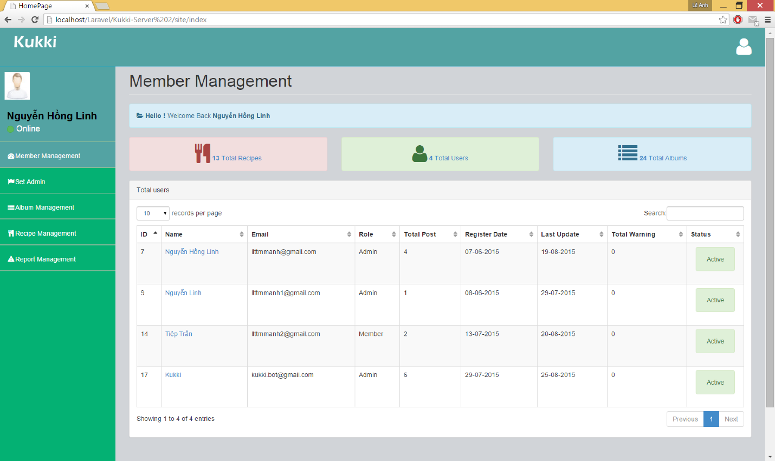

After you login, this is your main screen or is the Member Management screen. In this screen, website has a sidebar with 5 sections which direct to 5 other page, a list member of Kukki’s mobile application and 3 button with the label is the numbers of recipe, album and user.

#### Ban/Unban Member

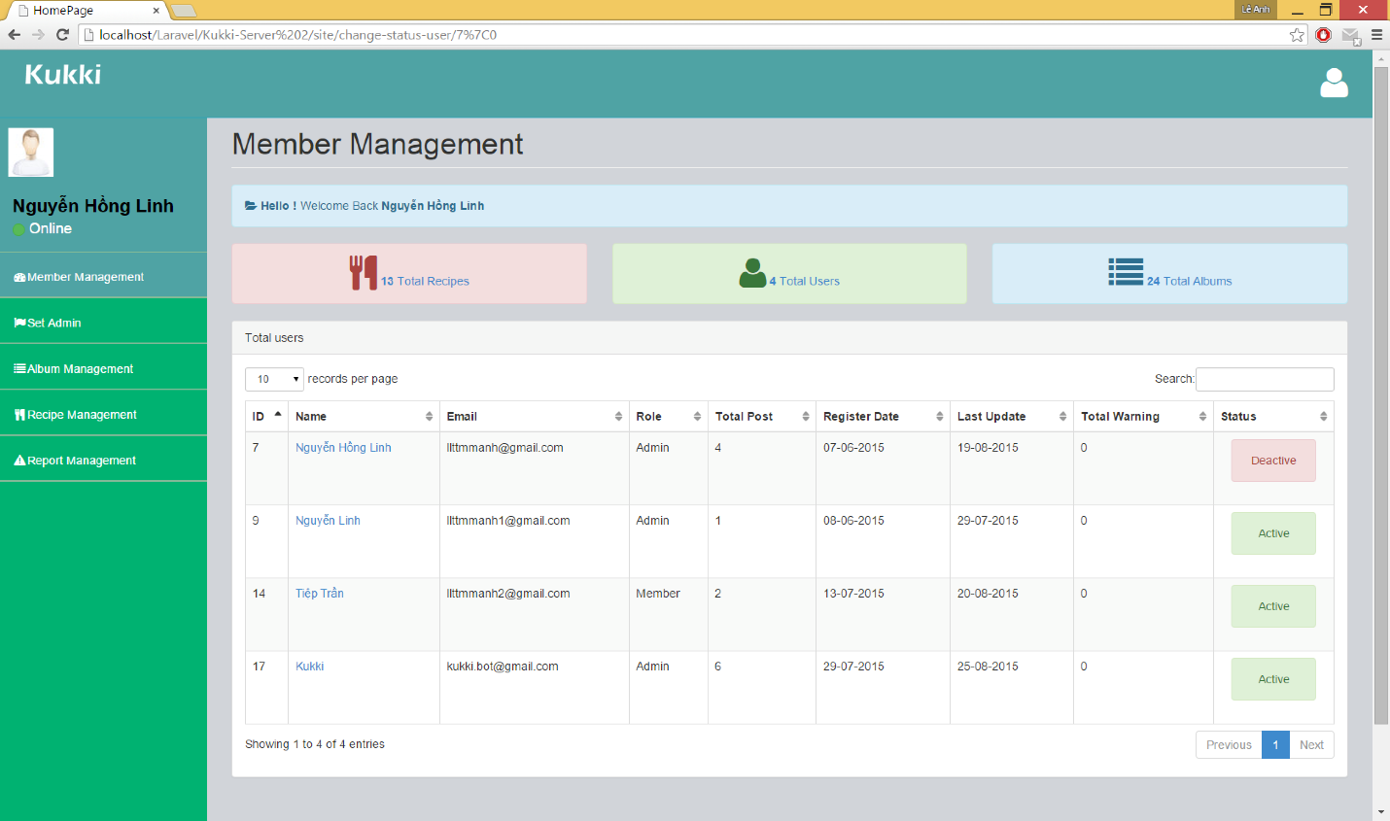

* Banned member
  + Click on button “Active” in column Status.
  + The button change from “Active” to “Deactive”.



* Unbanned member
  + Click on button “Deactivate” in column Status.
  + The button change from “deactivate” to “Active”

#### View Member profile

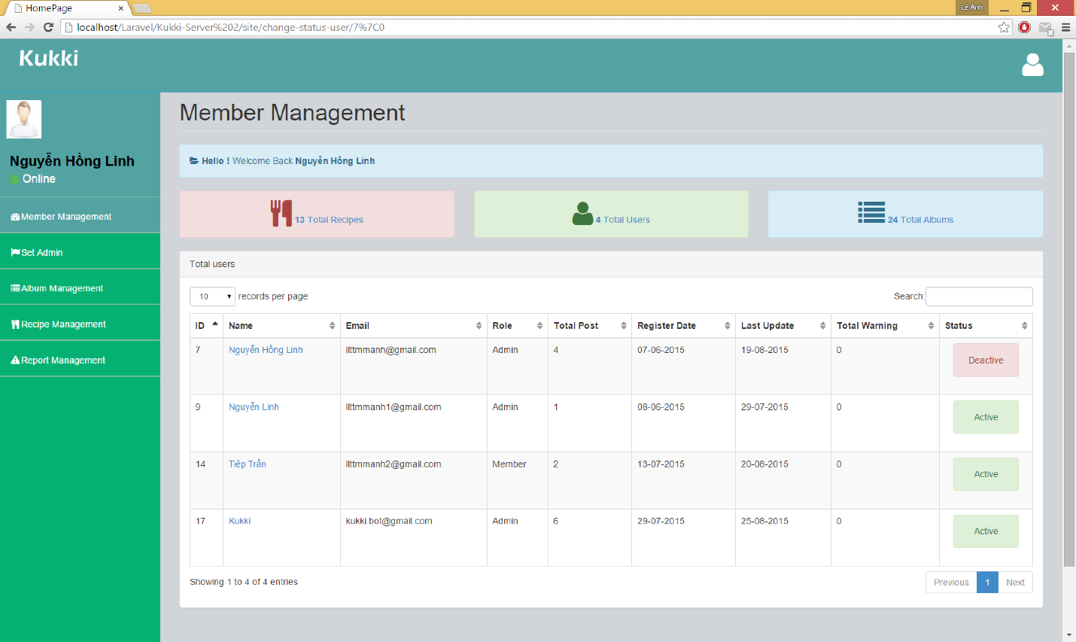

Step 1:

* From this page, click on the name of member which display as hyperlink in the table.

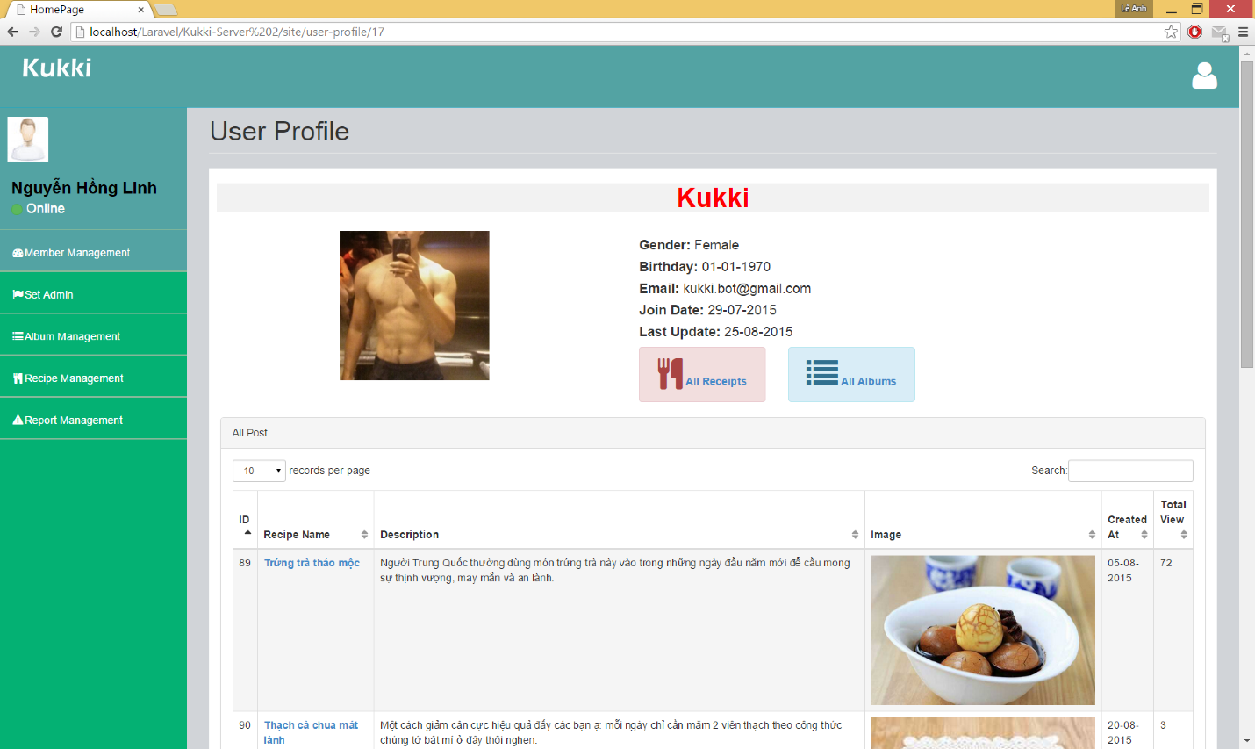

This is the member profile page. Website display member information and list recipe of member.

#### View Member‘s recipe or album

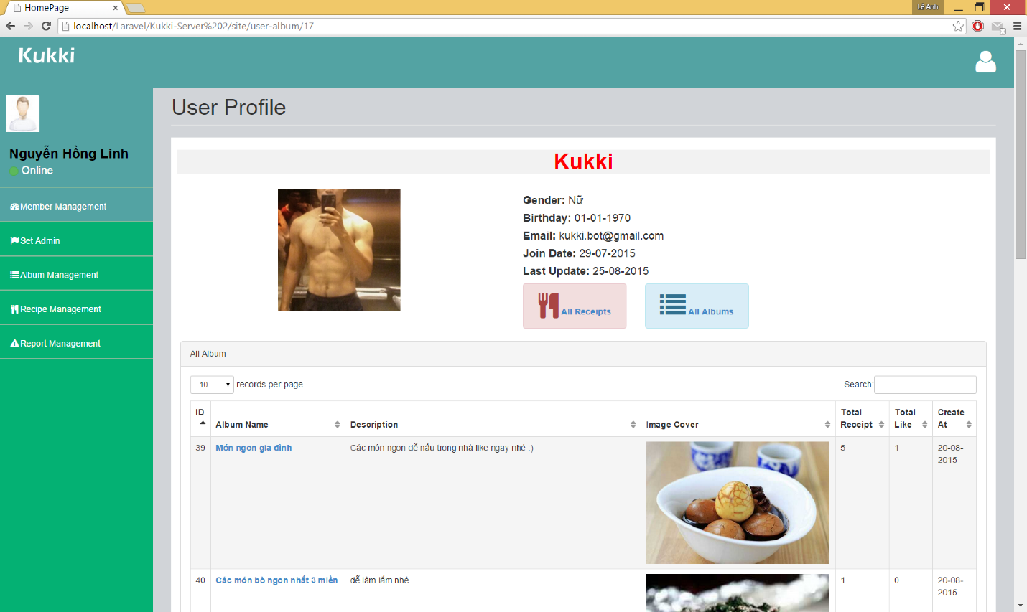

View member’s album

* + Click button “All albums”.



View member’s recipe

* + Click button “All recipes”.

#### Set Admin

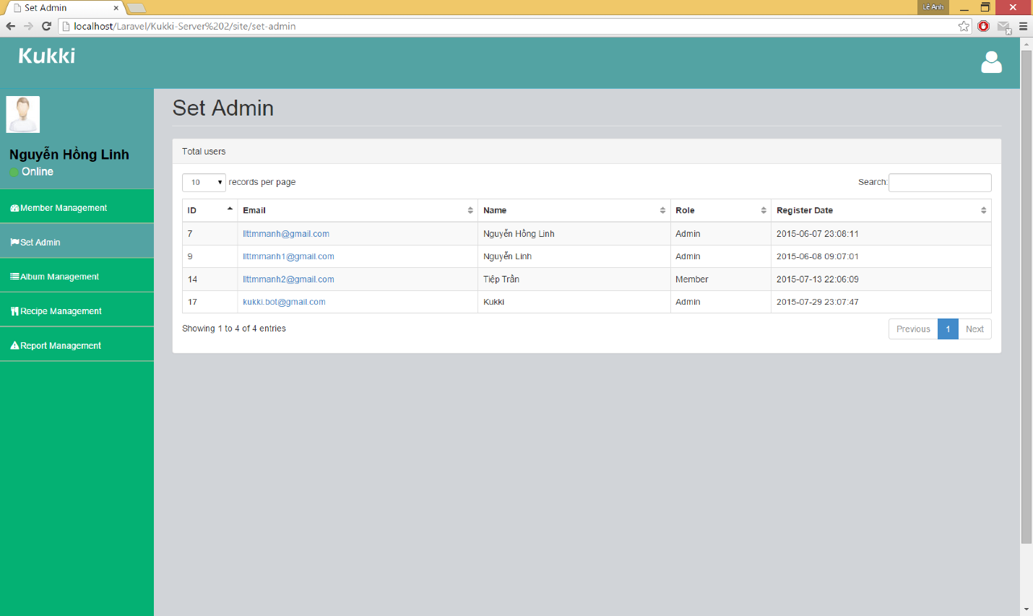

Step 1:

* Click on the email which display as hyperlink in the table.

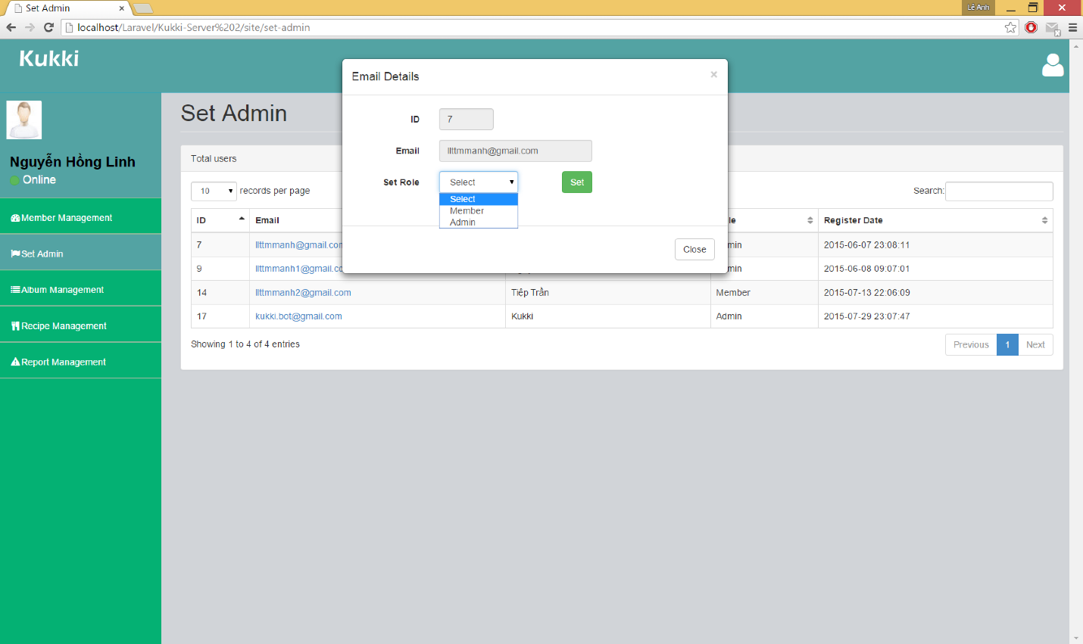

The popup show up.

Step 2:

* Select role “Admin” or “Member” in drop down list

Step 3:

* Click on button Set.

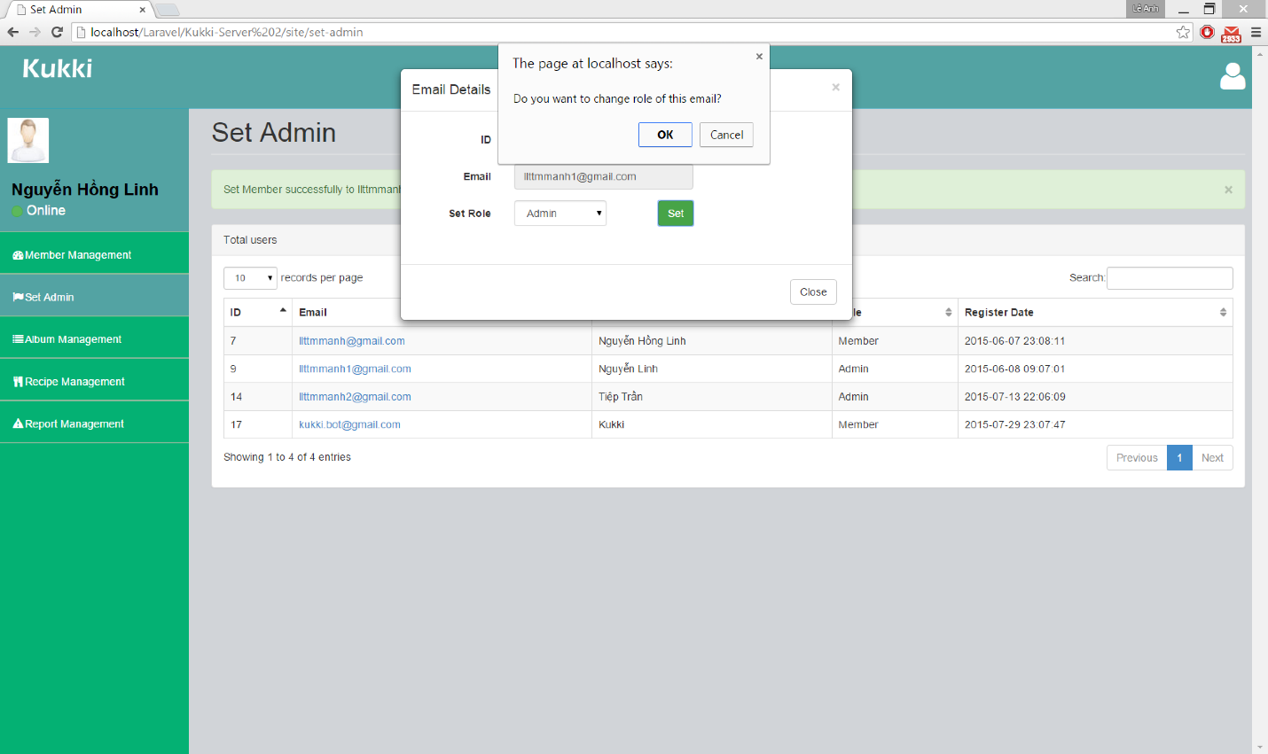

Website display alert with message: “Do you want to change role of this email?”

Step 4:

* Click on Ok.

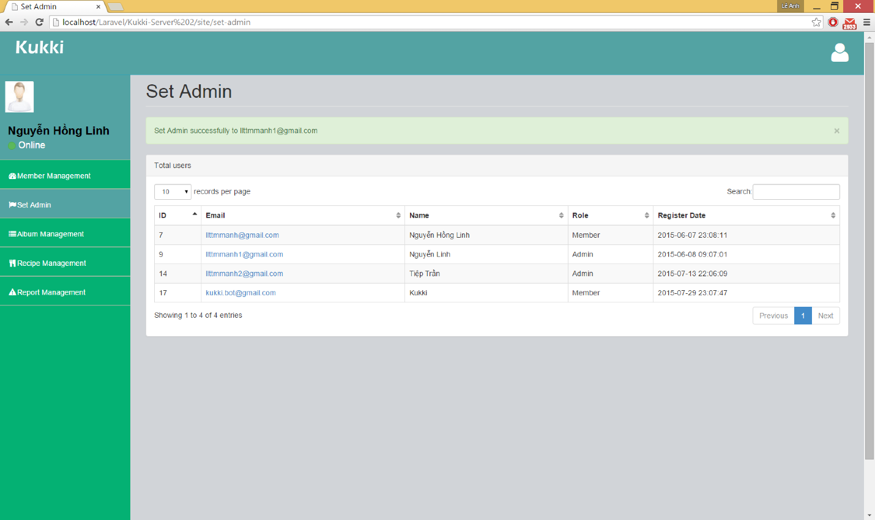

Website display message: “Set admin successfully to …@gmail.com”

#### Album Management

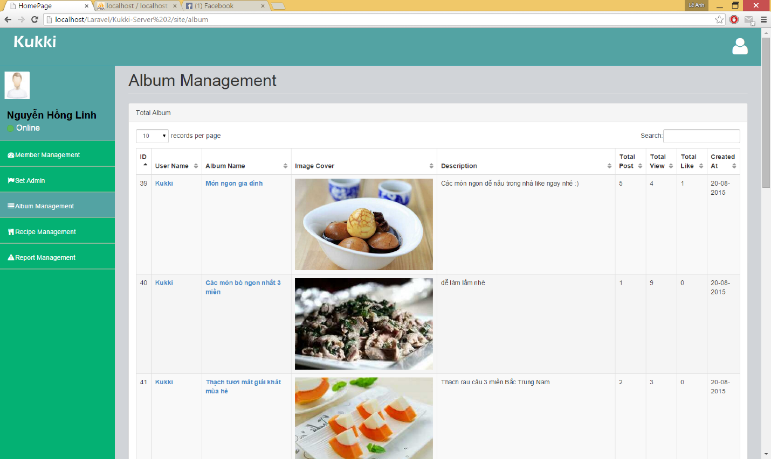

Step 1:

* Click on Album Management sector on sidebar.

1. Album Details



Step 1:

* Click on album name which display as hyperlink in the table.

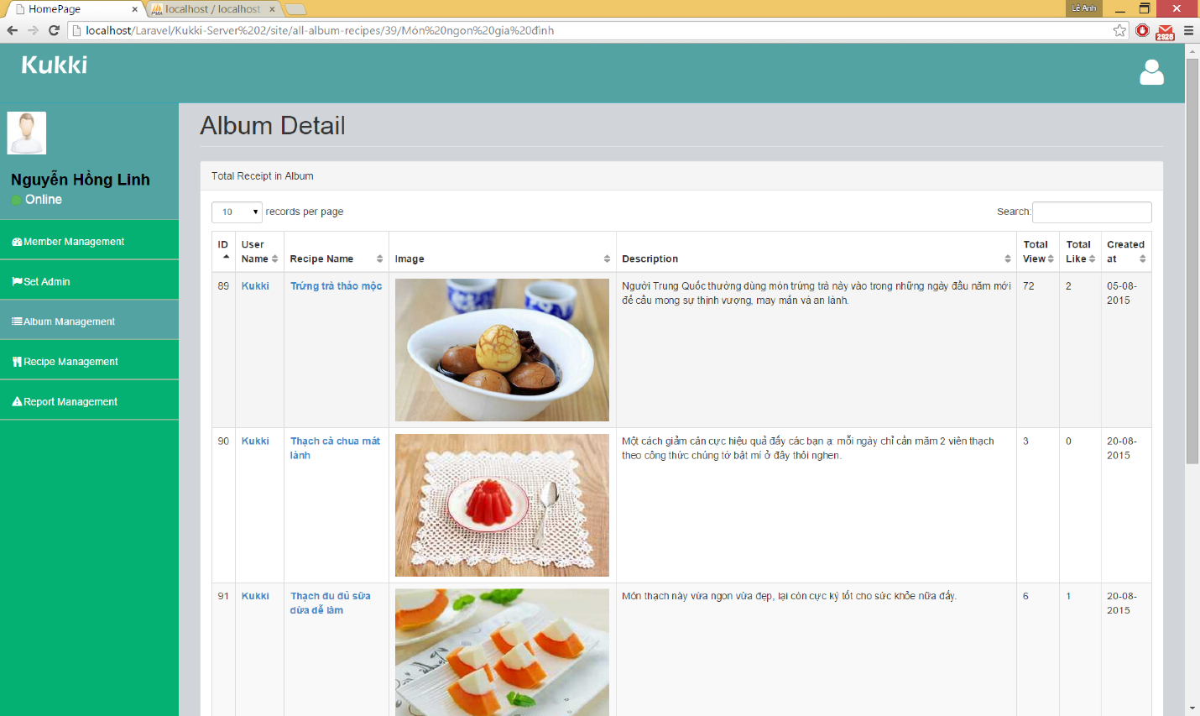

Website display Album Detail page with list recipe in album.

#### Recipe Management

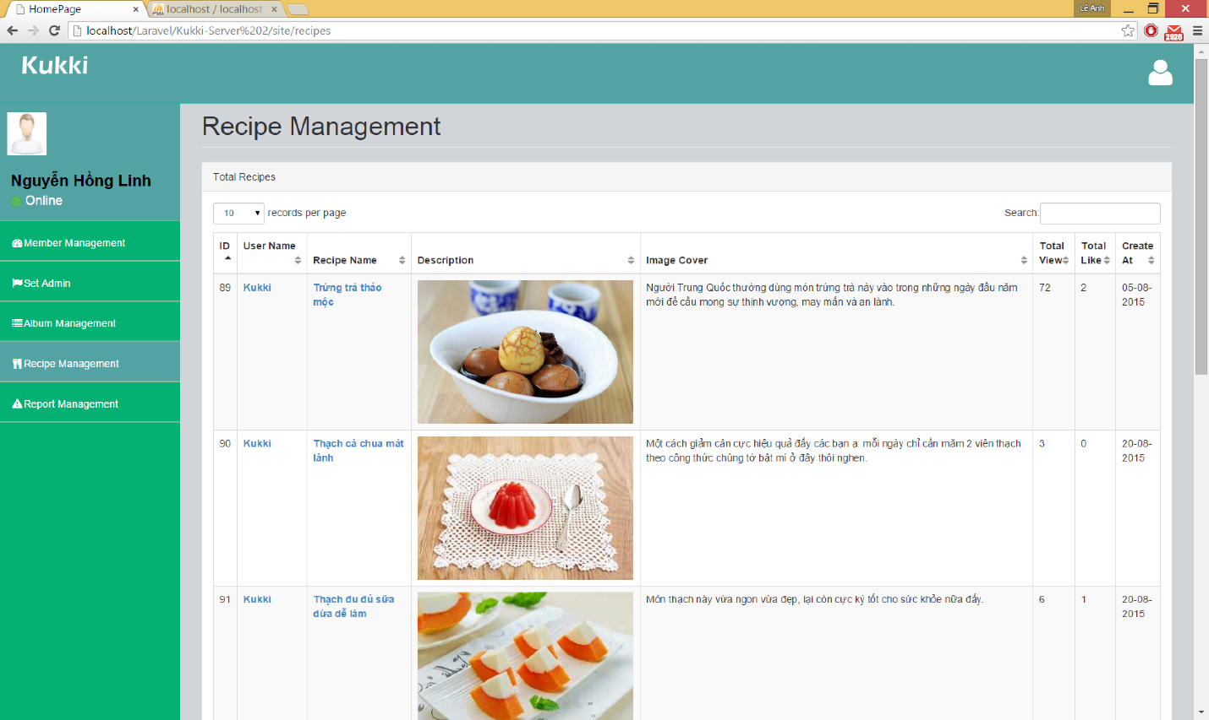

Step 1:

* Click on Recipe Management sector on sidebar.

1. Recipe Details.



Step 1:

* Click on Recipe Name which display as hyperlink in the table.

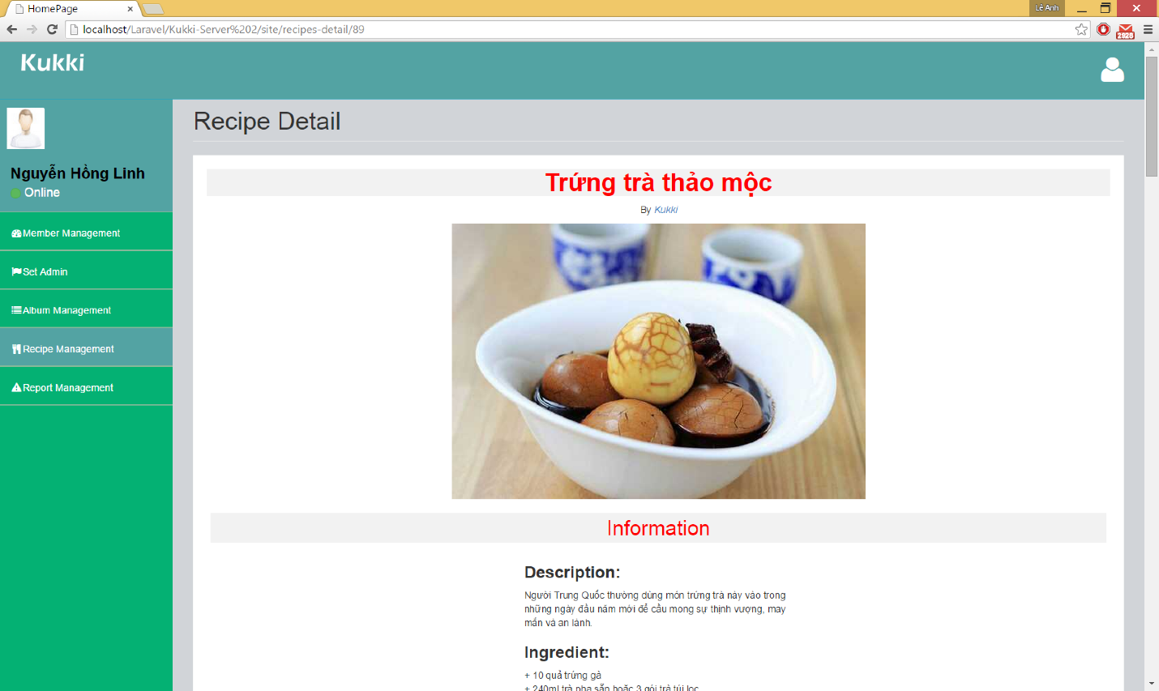

Website display Recipe Detail page with all information of recipe.

## **6.2 Installation guide**

#### **6.2.1 Laravel framework Setup environment**

* **Laravel Framework**
  + Download at http://laravel.com/docs/4.2
  + Install
* **Notepad++**
  + Download at <http://notepad-plus-plus.org/download/v6.7.html>
  + Install
* **WAMP installation**
* Download WAMP 2.4 at http://sourceforge.net/projects/wampserver/files/WampServer%202/Wampserver%202.4/ (For Window).

#### **6.2.1 Android**

* **JDK installation**
  + Download at <http://www.oracle.com/technetwork/java/javase/downloads/jdk8-downloads-2133151.html>
  + Install
* **Android Studio**
  + Download at https://developer.android.com/sdk/index.html#top
  + Install